

SMART CAMPUS PLACEMENT SYSTEM
Placement-probability prediction, skill-gap feedback and company-role recommendation with a calibrated hybrid XGBoost and kNN model
A project report submitted in partial fulfilment of the requirements for the award of the degree of
BACHELOR OF TECHNOLOGY
in
COMPUTER SCIENCE AND ENGINEERING
Submitted by
Mopidevi Bhagyasri | 23K91A05F9
Pamulaparthi Harsha Vardan Reddy | 23K91A05J0
Mohammad Faruk Baba | 23K91A05F3
Prahalladh Terati | 23K91A05J8
Batch C5 (CSE-C)
Under the esteemed guidance of
S Usha Devi
[DESIGNATION]
DEPARTMENT OF COMPUTER SCIENCE AND ENGINEERING
TKR COLLEGE OF ENGINEERING & TECHNOLOGY (AN AUTONOMOUS INSTITUTION)
[COLLEGE ADDRESS]
Academic year [ACADEMIC YEAR]

CERTIFICATE
This is to certify that the project report entitled "Smart Campus Placement System" is a bonafide record of the work carried out by Mopidevi Bhagyasri (23K91A05F9), Pamulaparthi Harsha Vardan Reddy (23K91A05J0), Mohammad Faruk Baba (23K91A05F3), Prahalladh Terati (23K91A05J8), in partial fulfilment of the requirements for the award of the degree of Bachelor of Technology in Computer Science and Engineering, during the academic year [ACADEMIC YEAR], under my supervision.

Project Guide | Head of the Department | Principal
S Usha Devi | [HOD NAME] | [PRINCIPAL NAME]
[DESIGNATION] | Department of Computer Science and Engineering | TKR College of Engineering & Technology

External Examiner: [NAME AND SIGNATURE]
Place: [PLACE]
Date: [DATE]

DECLARATION
We hereby declare that the project report entitled "Smart Campus Placement System", submitted to the Department of Computer Science and Engineering, TKR College of Engineering & Technology, in partial fulfilment of the requirements for the award of the degree of Bachelor of Technology in Computer Science and Engineering, is a record of original work carried out by us under the guidance of S Usha Devi, [DESIGNATION]. The results embodied in this report have not been submitted to any other university or institution for the award of any degree or diploma.

Mopidevi Bhagyasri 23K91A05F9
Pamulaparthi Harsha Vardan Reddy 23K91A05J0
Mohammad Faruk Baba 23K91A05F3
Prahalladh Terati 23K91A05J8

Place: [PLACE]
Date: [DATE]

ACKNOWLEDGEMENT
We express our sincere gratitude to our project guide, S Usha Devi, [DESIGNATION], for valuable guidance, encouragement and constructive suggestions throughout this project.
We thank [HOD NAME], Head of the Department of Computer Science and Engineering, for providing the facilities and support needed to complete this work, and [PRINCIPAL NAME], Principal, TKR College of Engineering & Technology, for the encouragement given to us.
We thank the project coordinators and all faculty and staff members of the department for their help, and our families and friends for their constant support.
We also acknowledge the authors of the base papers and the developers of the open-source software used in this project (scikit-learn, XGBoost, SHAP, pandas, NumPy, Flask, FastAPI, React and Vite).

Mopidevi Bhagyasri
Pamulaparthi Harsha Vardan Reddy
Mohammad Faruk Baba
Prahalladh Terati

ABSTRACT
Campus placement decides the early careers of engineering students, yet placement cells usually store student records in spreadsheets and shortlist by hand. Students learn where they stand only when a shortlist is published, and they receive no statement of which skill to improve. This project presents the Smart Campus Placement System, a web application that estimates the probability that a student is placed at a chosen company and role, explains the gaps against that company's requirements, recommends alternative company-role pairs, and gives placement officers and recruiters a dashboard and a shortlist. It adapts to placements the hybrid framework that a recent admission-prediction paper proposed: a Platt-calibrated XGBoost model, a k-nearest-neighbour model that refines borderline cases, SHAP explanations and feasibility-filtered recommendation. A FastAPI service with a React interface, and the original Flask application, serve the same Python core.
No real placement records were available, so the system is trained and evaluated on 3,000 synthetic students and an invented table of 30 companies; every result below therefore describes this generated data and not real students. On a held-out test set of 450 students, calibrated XGBoost reaches 80.67% accuracy (ROC-AUC 0.8928, Brier score 0.1352), and the hybrid defined in the base paper reaches 84.00%. That gain depends on the true test labels, which the paper's residual rule uses to choose the cases to refine; the form that can run when a student is scored reaches 80.89% (borderline cases only) and 80.89% (blended serving rule), a difference of about one student in 450. Over five random splits the means are 0.8138 ± 0.0115 for calibrated XGBoost and 0.8151 ± 0.0149 for the serving rule, and Logistic Regression is as good (0.8231 ± 0.0194). For 60 test students rated below 0.5 for their own target, the recommender raises the estimated probability from 0.22 to 0.64 on average, an estimate that was not checked against real outcomes. A prediction takes about 66 ms, a recommendation about 5.4 s. 46 automated checks and a 15-check smoke test pass. The system has no authentication or database, and a pilot with real placement data, access control and caching of the models are the main future steps.
Keywords: campus placement, placement prediction, educational data mining, XGBoost, probability calibration, k-nearest neighbours, SHAP, company recommendation, FastAPI, React.

TABLE OF CONTENTS
CERTIFICATE i
DECLARATION ii
ACKNOWLEDGEMENT iii
ABSTRACT iv
TABLE OF CONTENTS v
LIST OF FIGURES viii
LIST OF TABLES ix
LIST OF ABBREVIATIONS xi
CHAPTER 1: INTRODUCTION 1
1.1 Domain and Background 1
1.2 Motivation 2
1.3 Problem Statement 2
1.4 Need for the Proposed System 3
1.5 Objectives 3
1.6 Scope of the Project 4
1.7 Contributions 4
1.8 Limitations and Assumptions 5
1.9 Organisation of the Report 6
CHAPTER 2: LITERATURE SURVEY 7
2.1 Overview 7
2.2 Analysis of the Declared Base Paper 7
2.3 Analysis of the Technique Paper 8
2.4 Related Work 10
2.5 Datasets and Algorithms Used in This Project 13
2.6 Strengths and Limitations of the Surveyed Approaches 14
2.7 Sources Named in the Batch Survey That Could Not Be Verified 14
2.8 Research Gap 15
2.9 Summary of the Chapter 16
CHAPTER 3: FEASIBILITY STUDY 17
3.1 Technical Feasibility 17
3.2 Economic Feasibility 18
3.3 Operational Feasibility 18
3.4 Schedule Feasibility 19
3.5 Legal, Ethical and Data Feasibility 19
3.6 Risk Analysis 20
3.7 Advantages and Constraints 20
CHAPTER 4: SYSTEM REQUIREMENTS AND ANALYSIS 22
4.1 Existing System and its Limitations 22
4.2 Proposed System and its Advantages 22
4.3 Functional Requirements 23
4.4 Non-functional Requirements 23
4.5 Data Requirements 24
4.6 Hardware Requirements 25
4.7 Software Requirements 25
4.8 User Roles 25
4.9 Constraints and Assumptions 25
4.10 Analysis Summary 26
CHAPTER 5: SYSTEM DESIGN 27
5.1 Design goals 27
5.2 System architecture 27
5.3 High-level workflow 28
5.4 Data flow diagrams 29
5.5 UML diagrams 31
5.6 Database design 32
5.7 Module design 34
5.8 Algorithm design 35
5.9 API design 36
5.10 User interface design 37
CHAPTER 6: METHODOLOGY AND SOFTWARE IMPLEMENTATION 39
6.1 Overall methodology 39
6.2 Dataset 39
6.3 Pre-processing and feature engineering 41
6.4 Algorithm choice and justification 42
6.5 Mathematical formulation 42
6.5A Explainability and worked example 43
6.6 Model training, configuration and the label-dependence of the hybrid 44
6.7 Application architecture 45
6.8 API design 46
6.9 Security and error handling 47
6.9A Front-end implementation 47
6.10 Installation and execution 47
CHAPTER 7: SYSTEM TESTING 49
7.1 Testing strategy 49
7.2 Unit testing 49
7.3 Integration testing 50
7.4 Functional testing 51
7.5 Validation and edge cases 51
7.6 Security testing 52
7.7 End-to-end smoke test 52
7.8 Performance testing 53
7.9 Behaviours observed rather than asserted 53
7.10 User acceptance: a walkthrough against the objectives 54
7.11 The limits of the testing done 54
CHAPTER 8: RESULTS AND OUTPUT SCREENS 55
8.1 Experimental setup and protocol 55
8.2 Output screens 55
8.3 Model performance 59
8.4 Confusion matrices 60
8.5 The hybrid model: what the gain really is 61
8.6 Decision-threshold analysis 62
8.7 Calibration 62
8.8 Stability over five random splits 63
8.9 Explainability: which features matter 64
8.10 Recommendation results 65
8.11 Comparison with the base papers 65
8.12 Sample inputs and outputs 66
8.13 Success and failure analysis 67
8.14 Limitations of the results 67
8.15 Objectives versus outcomes 68
CHAPTER 9: CONCLUSION 69
9.1 Summary 69
9.2 Objectives achieved 69
9.3 Key findings 70
9.4 Practical applications 70
9.5 Known limitations 71
9.6 Lessons learned 71
CHAPTER 10: FUTURE SCOPE 72
10.1 Improvements to the models and the data 72
10.2 Additional features 72
10.3 Scalability and deployment 73
10.4 Further research 73
10.5 Suggested roadmap 73
REFERENCES 74
APPENDIX A: IMPORTANT CODE 76
A.1 Feature construction (`src/preprocess.py`, lines 26-55) 76
A.2 Calibration and the residual hybrid (`src/hybrid_model.py`, lines 93-122) 76
A.3 Serving-time prediction (`src/recommend.py`, lines 70-79) 77
A.4 Company-role recommendation: filters and scoring (`src/recommend.py`, lines 81-111) 77
A.5 The prediction endpoint (`backend/main.py`, lines 188-201) 78
APPENDIX B: INSTALLATION AND USER GUIDE 79
B.1 Requirements 79
B.2 Installation and start 79
B.3 Retraining the models (optional) 79
B.4 Using the screens 80
B.5 Running the tests and measurements 80
B.6 Troubleshooting 80
APPENDIX C: ADDITIONAL SCREENS 81

LIST OF FIGURES
Figure 1: System architecture of the Smart Campus Placement System: presentation, application and core layers with the file stores. 27
Figure 2: High-level workflow from data generation to recruiter shortlist. 28
Figure 3: Level 0 data flow diagram: the system as one process with three external entities and four data stores. 29
Figure 4: Level 1 data flow diagram: six processes, three external entities and four data stores. 29
Figure 5: Level 2 data flow diagram of process 4, Recommend company-role pairs. 30
Figure 6: UML class diagram: request models, API module, core modules and the trained artefacts. 31
Figure 7: Sequence diagram of POST /api/predict, the main flow of the system. 31
Figure 8: Use-case diagram with three user roles and one offline developer role. 32
Figure 9: Entity-relationship diagram of the logical data model (CSV and pickle files). 33
Figure 10: Flowchart of the hybrid placement probability computed at serving time. 35
Figure 11: Training pipeline of src/generate_dataset.py, preprocess.py and hybrid_model.py. 35
Figure 12: Flowchart of recommend() in src/recommend.py. 36
Figure 13: Eligibility screen with a real prediction (Microsoft, SDE). 38
Figure 14: Officer dashboard overview. 38
Figure 15: Landing page, dark theme: headline, terminal status panel and counters strip. 56
Figure 16: Landing page, light theme (same content). 56
Figure 17: Eligibility screen: Microsoft, SDE, CGPA 8.4, aptitude 84, technical 79, one internship, three projects give 22.2 % and NEEDS IMPROVEMENT. 56
Figure 18: Recommendation screen: base probability 10.8 % (Google, SDE), average gain +78.8 pt, match rate 100 %, top pick ValueLabs QA Engineer 89.9 %. 57
Figure 19: Officer dashboard: counters, model comparison chart, placed rate by branch. 57
Figure 20: Dashboard SHAP tab: mean absolute SHAP value of all 24 features. 57
Figure 21: Recruiter screen: CGPA >= 7.5, aptitude >= 65, all branches; 1,394 matches, top 50 shown. 58
Figure 22: Companies screen: 30 companies with tier, type, cutoffs, package, location, hiring rate (page 1 of 3). 58
Figure 23: Command palette opened with the slash key and the query "hyd". 58
Figure 24: Activity log drawer: UI events and API calls with status and latency. 58
Figure 25: Accuracy, F1 and ROC-AUC of the models on the held-out test set (seed 42). 59
Figure 26: Histogram of predicted placement probabilities on the test set. 60
Figure 27: PCA of the test set: correct placed, correct not placed, misclassified. 60
Figure 28: Confusion matrices of calibrated XGBoost, the hybrid with the paper rule, and the hybrid with the serving rule. 60
Figure 29: Precision, recall, F1 and accuracy of calibrated XGBoost as the decision threshold moves from 0.30 to 0.70. 62
Figure 30: Reliability diagram of raw and Platt-calibrated XGBoost on the test set. 63
Figure 31: Test accuracy of four models on each of the five random splits. 63
Figure 32: Mean absolute SHAP value of the ten most influential features (retrained XGBoost, test set). 64
Figure 33: Estimated gain (top-1 alternative minus original target) for the 60 students. 65
Figure 34: Accuracy, F1 and ROC-AUC of the models on the held-out test set (seed 42). 69
Figure 35: Landing page, light theme: hero text, live boot log, and the counters read from the API (3,000 students, 59.7% placed, hybrid AUC 0.8968, 30 companies). 81
Figure 36: Landing page, dark theme (the default): the same content with the theme switched. 81
Figure 37: Companies board: the first page of 30 companies sorted by package, with tier, type, CGPA, aptitude and technical cut-offs, package, location and hiring rate. 82
Figure 38: Command palette after typing "hyd": companies located in Hyderabad with tier and package; Enter opens the selected company. 82
Figure 39: Activity log drawer: real API calls of the session with their status codes and durations (for example GET /stats 200 in 122 ms). 83

LIST OF TABLES
Table 1: Abbreviations used in this report xi
Table 2: Mapping of the admission framework [2] to placement (as implemented) 2
Table 3: Objectives and their status 4
Table 4: Chapters of this report 6
Table 5: From admissions [2] to placement (this project) 10
Table 6: Comparison of the surveyed work 12
Table 7: Algorithms used and why 13
Table 8: Approach families compared 14
Table 9: Sources recorded in the batch survey 14
Table 10: Technical feasibility by component 17
Table 11: Cost drivers 18
Table 12: Project phases 19
Table 13: Main risks and responses 20
Table 14: Advantages and constraints 20
Table 15: Limitations of the existing system 22
Table 16: Advantages over the existing system 23
Table 17: Functional requirements 23
Table 18: Non-functional requirements 24
Table 19: Student table (data/placement_dataset.csv, 3,000 rows, 19 columns) 24
Table 20: Company table (data/companies.csv, 30 rows) 24
Table 21: Hardware 25
Table 22: Software (versions measured on the build machine) 25
Table 23: User roles 25
Table 24: Data dictionary of data/placement_dataset.csv (3,000 rows, 19 columns, no missing values) 32
Table 25: Data dictionary of data/companies.csv (30 rows, 9 columns) 33
Table 26: Module breakdown 34
Table 27: Endpoints of backend/main.py 36
Table 28: Screens of the React application 37
Table 29: Properties of the generated dataset 40
Table 30: The 24 model features 41
Table 31: Classifiers and the reason for including each 42
Table 32: Training configuration 44
Table 33: Residual rules compared (seed 42, 450 test rows, shipped models) 44
Table 34: Width of the borderline band (label-free kNN replacement) 45
Table 35: Input validation and errors 47
Table 36: Software environment used for this work 47
Table 37: Test layers and results 49
Table 38: Unit test cases (scripts/edge_tests.py) 50
Table 39: Integration test cases 50
Table 40: Functional test cases 51
Table 41: Validation and edge-case test cases 51
Table 42: Security test cases 52
Table 43: Response time of the API (milliseconds) 53
Table 44: Acceptance walkthrough against the batch objectives 54
Table 45: Test-set metrics, seed 42 (n = 450) 59
Table 46: Confusion matrices on the test set (seed 42; rows are the truth, 0 = not placed, 1 = placed) 60
Table 47: Why the paper rule cannot be used at serving time (seed 42) 61
Table 48: Effect of the width of the borderline band (kNN label replaces the XGBoost label; seed 42) 61
Table 49: Five-seed study (test accuracy, F1, ROC-AUC) 63
Table 50: Mean absolute SHAP value of the eight most influential features (XGBoost, 450 test students) 64
Table 51: Recommendation results for 60 students rated below 0.5 for their own target 65
Table 52: Comparison with the base papers 66
Table 53: Sample requests and responses (real API output) 66
Table 54: Objectives of the batch against what was achieved 68
Table 55: Objectives and their status 69
Table 56: A sequence in which the work above could be done 73
Table 57: User guide 80
Table 58: Common problems 80

LIST OF ABBREVIATIONS
Table 1: Abbreviations used in this report
Abbreviation | Expansion
API | Application Programming Interface
AUC | Area Under the Curve
CGPA | Cumulative Grade Point Average
CORS | Cross-Origin Resource Sharing
CPU | Central Processing Unit
CSV | Comma-Separated Values
CV | Cross-Validation
DFD | Data Flow Diagram
DSA | Data Structures and Algorithms
ER | Entity-Relationship
F1 | Harmonic mean of precision and recall
FN / FP | False Negative / False Positive
HTTP | Hypertext Transfer Protocol
JSON | JavaScript Object Notation
kNN | k-Nearest Neighbours
LPA | Lakhs Per Annum
ML | Machine Learning
PCA | Principal Component Analysis
REST | Representational State Transfer
ROC | Receiver Operating Characteristic
SHAP | SHapley Additive exPlanations
SPA | Single-Page Application
SVM | Support Vector Machine
TN / TP | True Negative / True Positive
UI | User Interface
UML | Unified Modeling Language
XGBoost | Extreme Gradient Boosting

CHAPTER 1: INTRODUCTION
This chapter introduces the domain of the project, the motivation for building the Smart Campus Placement System, the problem it addresses, the objectives set for it, the scope that was actually delivered, the contributions, and the limitations and assumptions that govern every result reported later. It closes with a map of the rest of the report.

1.1 Domain and Background
Campus placement is the process through which companies recruit final-year students directly from their college. For most engineering students it is the first and often the only route to a job, and for the college the placement record is one of the most visible measures of the quality of its programmes. A placement season is a sequence of eligibility checks, aptitude tests, technical rounds and interviews, run by a placement cell that has to match hundreds of students with dozens of recruiters, each of whom publishes its own cut-offs for marks, backlogs and test scores.
Colleges already keep the raw material for a better process. Every student has an academic record (CGPA, school percentages, backlogs), scores from aptitude and technical tests, a count of projects, internships and certifications, and, for earlier batches, an outcome: placed or not placed. Educational data mining is the field that turns such records into decisions, and supervised machine learning (ML) is its main tool: a classifier learns from past students which combinations of attributes were followed by a placement, and then estimates the probability for a student whose outcome is not yet known [1].
Two recent papers frame this project. The declared base paper, Prasanna Kumari et al. [1], builds a placement-prediction web application on a synthetic student dataset with Logistic Regression, Random Forest and Gradient Boosting, and adds batch prediction, skill-gap analysis and report generation. The technique on which the code of this project is built comes from Heidari Fard and Tabrizi [2], who predict graduate admission with XGBoost [3], calibrate the probabilities with Platt scaling [4], refine borderline cases with a local k-nearest-neighbour model [7], explain the model with SHAP [5] and recommend alternative universities and programmes. A placement is structurally the same decision as an admission: a student with a profile applies to an organisation and either is or is not accepted. The Smart Campus Placement System therefore carries the admission framework over to placements, with companies in place of universities and job roles in place of programmes.
Table 2: Mapping of the admission framework [2] to placement (as implemented)
Base paper [2] (admission) | This project (placement)
University | Company (30 companies in three tiers)
Programme | Job role (eight roles; four searched by the recommendation module)
QS world rank | Company tier (1 dream, 2 core, 3 mass recruiter)
Applicant GPA and its proximity to a university requirement | CGPA and its proximity to the company cut-off, with a tolerance that depends on the tier
Programme admission rate | Company hiring rate
Programme x QS rank interaction | CGPA x tier interaction, plus gap features against CGPA, aptitude and technical cut-offs
Country and budget filters | Location preference and minimum package
Accepted or rejected | Placed or not placed

The mapping is a design choice of this project, not a result: the base paper never claims that placements behave like admissions. What it does supply is a tested recipe (calibrate, refine borderline cases locally, recommend only feasible alternatives, explain with SHAP) that fits the structure of the placement decision.

1.2 Motivation
Four observations motivate the work. They come from the batch problem statement and from how placement cells are described in the base paper [1].
• Data is stored but not used. Placement cells keep student records in spreadsheets; none of the predictive signal in them is exploited before the season starts.
• Students learn where they stand too late. A student who is below a company's cut-off usually finds out when the shortlist is published, when there is no time left to improve.
• Shortlisting is manual. Recruiters ask for lists filtered by CGPA, aptitude and branch, and the cell prepares them by hand in different ways for different recruiters.
• Feedback is generic. "Improve your skills" does not say which skill, against which company, or by how much.
An early, probability-based estimate addresses the first two: it can be produced before the season, for every student and every company, and re-computed when a student improves. A recommender that searches companies and roles where the estimated probability is higher turns a rejection into a concrete next step. Dashboards and a filter for recruiters address the third and fourth.

1.3 Problem Statement
The batch problem statement lists four weaknesses of current practice:
• Placement cells store student data but perform no predictive analysis on it.
• Students receive no early indication of readiness while there is still time to improve.
• Shortlisting is manual, slow and inconsistent across recruiters.
• No feedback identifies which specific skills a student should acquire next.
Taken together, and written as a task for software, the problem addressed by this project is:
Given a student's academic record, skill and aptitude scores and a target company and role, estimate the probability that the student is placed, explain which gaps against the company's requirements hold it back, recommend company-role alternatives where the estimated probability is higher, and give placement officers and recruiters dashboards and shortlists - through a web application that a placement cell can run on an ordinary PC, with accuracy reported honestly on the data actually available.
Research gap. The literature surveyed for this project (Chapter 2) predicts placement, but stops at a yes or no or at a list of weak attributes. It rarely calibrates its probabilities, rarely explains them per company, and does not turn a low probability into alternative company-role targets. Closing that gap, with an honest measurement of what the added components are worth, is the aim of this project.

1.4 Need for the Proposed System
The batch documents summarise the need in one sentence: a system that predicts placement readiness early, recommends suitable companies, and tells each student which skills to close. Three properties follow from it. The system must give a probability, not only a yes or no, because a probability can be ranked, compared across companies and calibrated against what actually happened [8], [9]. It must be explainable, because a placement officer who cannot say why a student was marked "needs improvement" cannot act on the result [5]. And it must be cheap to run: a placement cell has an ordinary PC, not a cluster, and the whole system here trains in about three seconds and answers a prediction request in about 66 milliseconds on a six-core desktop processor (Chapter 8).

1.5 Objectives
The six objectives are those of the batch document 6.OBJECTIVES&PROBLEM STATEMENT. The table states, for each, how it was addressed and whether it was met. "Partly" and "Not met" are used where the work fell short; Chapter 8 gives the evidence.
Table 3: Objectives and their status
No. | Objective | How it was addressed | Status
O1 | Collect student academic records, technical skills, aptitude scores and historical placement outcomes. | No real placement data was available. A deterministic generator (src/generate_dataset.py, seed 42) produced 3,000 synthetic students and a table of 30 companies. | Partly (synthetic)
O2 | Clean and encode the data and address imbalance between placed and unplaced students. | Frequency encoding, standardisation and six engineered gap features (24 features). No missing values; classes are 59.7% placed, so no resampling was applied; a stratified split keeps the ratio. | Met
O3 | Train and compare classifiers to predict placement eligibility for each student. | Six baselines, a Platt-calibrated XGBoost and two hybrid variants were trained and compared on a held-out test set, plus a five-seed repetition. | Met
O4 | Recommend suitable companies by matching student profiles against recruiter requirements. | A company-role recommender ranks the 30 companies against a student profile using calibrated probabilities and feasibility filters (hybrid, company-only and role-only lists). | Met (gains are model estimates)
O5 | Identify the skill gaps that most reduce a student's placement probability. | Rule-based skill-gap tips against the company's cut-offs for each prediction, and a SHAP ranking of the features that move the probability most. | Met (rules, global SHAP)
O6 | Provide dashboards for placement officers and evaluate using accuracy, precision and recall. | An officer dashboard (metrics, SHAP, PCA, probability histogram, branch placement rates) and a recruiter shortlist; accuracy, precision, recall, F1, ROC-AUC and Brier score are reported. | Met

1.6 Scope of the Project
In scope. (i) Generation and preparation of a placement dataset; (ii) training, calibration and evaluation of the classifiers; (iii) placement-probability prediction with skill-gap tips for one student, one company and one role; (iv) company-role recommendation; (v) an officer dashboard and a recruiter shortlist; (vi) two interfaces over the same ML code: the original Flask application and a FastAPI service with a React front end; (vii) tests, measurements and documentation.
Out of scope. Real placement records, integration with a college information system, login and roles, storage in a relational database (the batch description names MySQL; this implementation reads CSV files and pickled models and uses no database), batch prediction from an uploaded file, generated reports and e-mail, and any longitudinal follow-up of what happened to recommended students.

1.7 Contributions
1. Placement adaptation of a published hybrid framework. The admission framework of [2] is mapped to placement: company for university, role for programme, company tier for QS rank, CGPA proximity for GPA proximity, company hiring rate for programme admission rate, and gaps against company cut-offs as features.
2. A working calibrated predictor with explanations. Calibrated XGBoost probabilities, a kNN local model for borderline cases, SHAP importance and rule-based skill-gap tips, served through a validated API.
3. A three-strategy company-role recommender with feasibility filters, returning the original-target probability, the average gain and the match rate.
4. Dashboards and a recruiter shortlist for placement officers and recruiters, in a React application and the original Flask application.
5. An honest evaluation. Besides the paper's metrics, the project measures what the paper's residual rule hides: it selects residual cases with the true labels, so its gain cannot be had at serving time. A label-free version scores 0.8089 against 0.8067 for calibrated XGBoost (Chapter 8).
6. Reproducible tooling. Scripts for the experiments, 46 automated checks, diagrams and screenshots, all re-runnable.

1.8 Limitations and Assumptions
The following limitations apply to everything in this report and are repeated where they matter.
• The data is synthetic. All records are produced by a generator whose labels follow a logistic rule with noise. Models can recover that rule, so accuracy is not evidence about real students. Even Logistic Regression reaches 0.8289 accuracy and the highest AUC (0.9106).
• The company table is invented. The 30 companies, their cut-offs, packages and hiring rates are plausible values, not recruiter requirements.
• The hybrid gain depends on the labels of the test set in the form defined by the base paper; the deployable form gains almost nothing on this data.
• No authentication, database or rate limiting. Every endpoint is public on localhost.
• Recommendation gains are model estimates that were never checked against real outcomes, and the recommender is slow (about 5 seconds per request).
• One machine, one dataset. All measurements come from a single CPU-only desktop and one generated dataset.
Assumptions made: a student's profile is the set of 13 attributes in the form (CGPA, school percentages, four test scores, counts of projects, internships, certifications and backlogs, branch, degree); a placement is a binary outcome for one target company and role; the company table is current; and the probability threshold for "placement ready" is 0.5.

1.9 Organisation of the Report
Table 4: Chapters of this report
Chapter | Content
1 Introduction | Domain, motivation, problem, objectives, scope, contributions, limitations
2 Literature Survey | The two base papers, related work by theme, datasets and algorithms, research gap
3 Feasibility Study | Technical, economic, operational and schedule feasibility
4 System Requirements and Analysis | Existing and proposed system, requirements, hardware, software, user roles
5 System Design | Architecture, workflow, data flow diagrams, UML, database design, modules, user interface
6 Methodology and Software Implementation | Data, pre-processing, algorithms, formulation, API, security, installation
7 System Testing | Strategy, unit, integration, functional, security, validation, performance, limits
8 Results and Output Screens | Output screens, model performance, comparison with the base papers, failure analysis
9 Conclusion | Summary, objectives achieved, findings, applications, limitations
10 Future Scope | Improvements, features, scalability, further research
References, Appendices A-C | Reference list, important code, installation and user guide, additional screens

CHAPTER 2: LITERATURE SURVEY

2.1 Overview
This chapter reviews the work on which the Smart Campus Placement System builds and against which it has to be judged. It begins with the two papers that shape the project: the paper named as the batch base paper, a placement-prediction web application published in IJETMS in 2026 [1], and the arXiv paper on hybrid XGBoost-plus-kNN prediction with a recommendation module [2], whose technique the code actually implements. Both are analysed in detail. Related work is then grouped by theme: classical classifiers for placement and employability, ensemble methods, placement platforms and matching, and educational data mining in general. The chapter then describes the datasets and algorithms that the present project uses, summarises strengths and limitations, lists the sources named in the batch literature survey that could not be verified, and ends with the research gap that this project addresses.
A note on method. A number is quoted from a paper only when we read it in the paper itself or in its abstract on the publisher's page. Where only a title and a venue are known, no result is stated. The declared base paper [1] reports no accuracy, F1 or AUC at all, and this chapter says so rather than filling the gap.

2.2 Analysis of the Declared Base Paper
The batch documents name as base paper "Student placement prediction system using machine learning" by Prasanna Kumari, Punith, Srinath, Koushik and Gourav of Vidya Jyothi Institute of Technology, Hyderabad, published in the International Journal of Engineering Technology and Management Sciences, volume 10, issue 3 (May-June 2026), pages 47-51 [1]. It is a five-page application paper in plain language rather than a research study with measurements.

What the paper does
• It builds a web application that predicts a student's placement chances from academic scores, technical skills, communication ability, internships, projects and extracurricular activities.
• Because real records are hard to obtain, it generates a synthetic dataset of student records to stand in for real scenarios. The size of the dataset is not stated.
• Pre-processing handles missing values, encodes categorical variables and scales numeric ones; feature engineering is mentioned without detail.
• Logistic Regression, Random Forest and Gradient Boosting are trained on an 80:20 train-test split and compared on accuracy, precision, recall and ROC-AUC (the design section adds F1); the best model is tuned further and deployed.
• The application is built with Streamlit and offers individual prediction, batch prediction from an uploaded CSV file, interactive charts, skill-gap analysis, model-performance views, an automatically generated PDF report and e-mail delivery of that report through SMTP.
The design section divides the system into five layers - data, processing, model, application and output - and the objectives list seven goals, among them predicting placement from several factors rather than one, helping students see strengths and weaknesses, supporting batch prediction and helping colleges understand placement trends [1].

What the paper does not report
The results section of the paper states the 80:20 split and names the three algorithms and four metrics, and then ends; it contains no table, no figure and no figure of merit. No accuracy, precision, recall, F1 or AUC value is given, the winning model is not named, the number of students in the synthetic dataset is not given, and the generating process is not described. The introductory literature section says that earlier studies reached "around 90% or more" accuracy with careful preprocessing and tuning, but cites no specific study for that figure. The conclusion lists real-time data and more advanced models as future work [1].
For this project that has two consequences. First, there is no numeric baseline to compare against: any comparison with [1] can be a comparison of scope and design, not of accuracy. Second, the paper's own method shares a weakness with ours that deserves stating early - the data are synthetic. Whatever accuracy a model reaches on synthetic records measures how well it recovers the rule that generated them, not how well it would predict real placements.

2.3 Analysis of the Technique Paper
The code of this project is built on a second paper, recorded in the batch folder as the technique source: "A hybrid machine learning approach for graduate admission prediction and combined university-program recommendation" by Heidari Fard and Tabrizi, arXiv:2603.29881, February 2026 [2]. It solves a problem of the same shape - predict an outcome for an applicant and a target, then recommend better targets to those predicted to fail - in the domain of graduate admissions. Mapping admissions to placement is direct: the applicant becomes the student, the university becomes the company, the program becomes the role.

Data and set-up
The authors scraped about 34,000 self-reported records from GradCafe, kept those from 2021 onwards, removed outcomes other than accepted or rejected, and arrived at about 13,000 applicants with 15 features, enriched with QS ranking indicators; 51% were accepted and 49% rejected. Categorical variables were frequency-encoded, numeric ones standardised, and an interaction feature between program and QS rank was added after a decision-tree analysis. The data were split 70/15/15 (9,100/1,950/1,950) with a fixed seed, and XGBoost hyper-parameters were tuned with 9-fold cross-validation [2].

Hybrid residual refinement
Single models plateaued at 0.68-0.73 accuracy on this data: the test accuracy of logistic regression and the decision tree was 0.6944, random forest 0.7344, SVM 0.6954, kNN 0.6774 and XGBoost 0.7241. The authors observed that misclassified applicants sit near the decision boundary and proposed a residual set R, the applicants for whom XGBoost is wrong or only weakly confident (predicted probability between 0.4 and 0.6), for which a local kNN model (k = 9) replaces the XGBoost decision. The hybrid reached 0.8723 accuracy (an SVM-based variant 0.8749), and Platt-scaled probabilities gave a Brier score of 0.1864 [2].

Recommendation module
For applicants predicted to be rejected, the paper recommends alternative universities, alternative programs and the combination of both. Candidates must pass feasibility filters - a maximum GPA difference that depends on the QS rank, an affordability rule and a country preference - and are ranked by predicted acceptance probability with a GPA proximity bonus. On 6,028 rejected applicants about 93% were matched, and the hybrid university-program strategy raised the mean predicted acceptance probability by 0.704 (university-only 0.687, program-only 0.142); the abstract summarises the gain as 70% [2]. SHAP ranks the degree type, GPA and program discipline as the main drivers.

A point the paper leaves open
The residual set is defined with the true labels (Equation 1 of the paper selects applicants whose prediction is wrong). The reported 0.8723 therefore uses information that is not available when a new applicant arrives. The authors do not report a variant that selects residuals by the confidence band alone. This project measures exactly that difference on its own data (Chapter 8); here it is enough to note that the paper's headline figure should be read with that caveat.

How the technique paper maps onto placement
The project keeps the structure of [2] and replaces its domain objects. The table lists each element of the paper and what stands in for it here; the choices follow the project README and the code in src/.
Table 5: From admissions [2] to placement (this project)
Technique paper [2] | This project
University / program | Company / role
QS rank (university quality) | Company tier (1 dream, 2 core, 3 mass recruiter)
Applicant GPA and its distance to the university's level | CGPA and its gap to the company's CGPA cut-off; aptitude and technical gaps
Program admission rate | Company hiring rate
Program x QS rank interaction | CGPA x tier interaction
Maximum allowed GPA difference by QS rank (0.10-0.25) | Maximum allowed CGPA difference by tier (0.6 / 1.0 / 1.5)
Country and budget filters | Location preference and minimum package
Platt scaling, Brier score, SHAP, PCA, 70/15/15 split, 9-fold CV | The same, on 3,000 synthetic students
University-only, program-only and hybrid recommendation | Company-only, role-only and hybrid company-role recommendation

2.4 Related Work

2.4.1 Classical classifiers for placement and employability
Most published placement work compares standard classifiers on a small table of student attributes. Thangavel, Bkaratki and Sankar describe a placement analyser that uses decision-tree classifiers on historical student data and, instead of a yes-no answer, predicts one of five statuses: Dream Company, Core Company, Mass Recruiter, Not Eligible or Not Interested [21]. The three-way company grouping is the same idea that the present project encodes as company tiers. Khandale and Bhoite compare logistic regression, SVM, kNN, decision trees, random forests and the ensemble techniques bagging, boosting and voting; their abstract reports about 78% accuracy for XGBoost and AdaBoost [22].
Baffa, Miyim and Dauda study employability prediction from 218 Computer Science graduates of one Nigerian university between 2016 and 2021, using CGPA, a work-experience scheme score, union group and gender; a random forest is reported to reach 98% accuracy and an F1 of 0.99 against logistic regression and a decision tree [15]. The very high figure on 218 records from one department illustrates a recurring problem: small single-site datasets give optimistic and non-transferable results.

2.4.2 Ensemble methods
A second group reports higher accuracy through ensembles. Ambili and Abraham apply a stacking ensemble to 20 student attributes and report 90.21% accuracy [16]. Gupta et al. present ML-CPC, an exploratory analysis followed by supervised classifiers and an ensemble, with accuracy 0.9524, precision 0.8667, recall 1.0 and F1 0.9286 on their recruitment data [17]. Pathak et al. train a voting classifier on a public Kaggle placement dataset with hyper-parameter search and cross-validation and report, on an unseen test set, accuracy 0.8923, precision 0.9430, recall 0.8567, F1 0.8978 and AUC 0.9433 in under a second of training time [18]. Kumar et al. compare logistic regression, random forest and XGBoost on academic scores, projects, internships, certificates and aptitude results, find that XGBoost performs best, and serve the model through a React and MongoDB application [19]. These results are not comparable with one another or with ours: the datasets differ in size, source and label rule, and none of the papers reports a calibration measure.

2.4.3 Placement platforms and matching
Beyond prediction, Sanjana et al. propose a broader placement ecosystem in which an SVM predicts placement (87.4% accuracy on an 80:20 split of data whose size is not given) and a Deep Q-Network optimises scheduling and job matching, with reported gains of 28% fewer scheduling conflicts and up to 21% better matching accuracy [20]. The thrust is the same as that of this project - to move from a verdict to guidance - but the evidence is thin because the data are not described. Recommendation in general is surveyed by Schafer, Konstan and Riedl, who classify recommendation applications in electronic commerce by their inputs, technology and degree of personalisation [13]; the filter-then-rank pattern of the technique paper [2] and of this project is one of the simple, transparent members of that family.

2.4.4 Educational data mining
The field in which all of the above sit is educational data mining. Romero and Ventura survey the tasks to which data mining has been applied in education, among them predicting student performance and providing feedback to instructors and students [23]. Placement prediction is a late-stage instance of the same activity: it turns records of past cohorts into decision support for the next one.

2.4.5 Calibration, residual refinement and explanation
Two methodological threads matter for this project. Platt scaling fits a sigmoid to a classifier's scores to obtain probabilities [4]; Niculescu-Mizil and Caruana show that boosted trees and other margin-based learners produce distorted probabilities that calibration improves [9], and the Brier score measures the result [8]. SHAP assigns each feature a contribution to an individual prediction with game-theoretic guarantees [5]. Both are used by the technique paper [2] and are carried into this project because a recommendation module that ranks options by probability needs probabilities that can be trusted and a placement officer needs reasons.
Table 6: Comparison of the surveyed work
Work | Approach | Data | Reported result | Limitation
Prasanna Kumari et al. 2026 [1] (declared base paper) | Logistic Regression, Random Forest and Gradient Boosting on student attributes; Streamlit app with batch CSV prediction, skill-gap analysis, PDF report and e-mail | Synthetic student records (size not stated); 80:20 split | No accuracy, F1 or AUC is reported in the paper | No numeric evaluation; no company recommendation; synthetic data
Heidari Fard and Tabrizi 2026 [2] (technique base) | XGBoost with Platt calibration; kNN / SVM refinement of residual (misclassified or borderline) cases; university-program recommendation with feasibility filters; SHAP | 13,000 real GradCafe admission records, 2021-2025, enriched with QS rankings | XGBoost 0.7241 accuracy; XGBoost + kNN hybrid 0.8723; Brier 0.1864; recommendation raised mean acceptance probability by 65.1% | Residual set uses true labels; US-centric self-reported data; admissions, not placements
Thangavel et al. 2017 [21] | Decision-tree classifiers on historical student data; predicts one of five placement statuses (Dream, Core, Mass Recruiter, Not Eligible, Not Interested) | Historical student records (size not read) | Abstract only: identifies students needing technical and interpersonal support | Categorical status, no probability; no company-level recommendation
Khandale and Bhoite 2019 [22] | Logistic, SVM, kNN, decision tree, random forest, bagging, boosting and voting compared | Past placed / unplaced student records | About 78% accuracy for XGBoost and for AdaBoost (abstract) | Moderate accuracy; full results table not read
Baffa et al. 2023 [15] | Logistic regression, decision tree and random forest for graduate employability from CGPA, work-experience score, union group and gender | 218 Computer Science graduates, 2016-2021, one university | Random forest 98% accuracy, F1 0.99 | Tiny single-department dataset; six variables
Ambili and Abraham 2024 [16] | Stacking ensemble on 20 student attributes to predict campus placement | Student database records (size not stated in the abstract) | 90.21% accuracy | No calibration, explanation or recommendation
Gupta et al. 2024 [17] (ML-CPC) | Exploratory analysis plus supervised classifiers and an ensemble to predict placement | A recruitment dataset (size not named in the abstract) | Accuracy 0.9524, precision 0.8667, recall 1.0, F1 0.9286 | Dataset size unstated; single split
Pathak et al. 2025 [18] | Voting classifier with hyper-parameter search and cross-validation | Public Kaggle placement dataset | Accuracy 0.8923, precision 0.9430, recall 0.8567, F1 0.8978, AUC 0.9433 | Public tabular benchmark; no recommendation layer
Kumar et al. 2025 [19] | Logistic regression, random forest and XGBoost on academics, projects, internships, certificates and aptitude; React + MongoDB application | Student profiles (size not read) | XGBoost best on accuracy and recall (values not in the abstract) | Numbers not available from the abstract
Sanjana et al. 2025 [20] | SVM for placement prediction plus a Deep Q-Network for scheduling and job matching | Dataset size not stated; 80:20 split | 87.4% accuracy (SVM); 21% better job-matching accuracy and 28% fewer scheduling conflicts (DQN) | Data not described; no calibration

The numbers in the table are those stated by each paper's abstract or results; they come from different data and are not a league table.

2.4.6 Which attributes the literature uses
The attribute lists in the surveyed placement papers overlap heavily, which is useful: it shows what a placement predictor is expected to see. The declared base paper [1] uses academic scores, technical skills, communication ability, internships, projects and extracurricular activities. Kumar et al. add certificates and aptitude test results [19]. Baffa et al., working with a different kind of institution, use CGPA, a work-experience scheme result, union group and gender [15]. The technique paper [2], in the admissions setting, relies on the applicant's GPA and on quality indicators of the target (rank, faculty-student ratio, citations, international ratio).
One design decision follows from this: the project deliberately does not use gender or similar personal attributes as predictors, because a placement-readiness tool that scores students on such attributes would be hard to defend. The target's requirements enter the model as gap features, so that the same student receives different probabilities for different companies.

2.5 Datasets and Algorithms Used in This Project

Dataset
The surveyed work uses student attribute tables (academic scores, skills, internships, certifications), admissions records or small institutional samples. Real placement records are personal and rarely shared, and the declared base paper [1] itself uses synthetic data. This project does the same and says so: it generates 3,000 synthetic students and a table of 30 invented companies with CGPA, aptitude and technical cut-offs, package, location and hiring rate, using a fixed random seed. The student's label is drawn from a logistic score of the gaps to the company's cut-offs, internships, projects, backlogs and a tier penalty, plus noise. The design copies the structure of the technique paper's data (a student-by-target table with target-quality features) without copying its content.

Algorithms
Table 7: Algorithms used and why
Algorithm | Role in this project | Source
Logistic Regression | Linear baseline; also reveals how linear the synthetic label rule is | standard
Decision Tree, Random Forest | Threshold-style rules; random forest reduces variance | [10]
SVM with RBF kernel | Non-linear margin classifier; baseline and local residual model | [11]
kNN (k = 9) | Baseline and local model that refines borderline cases | [7]
XGBoost (100 trees, depth 8) | Main global model; handles interactions between gap features | [3]
Platt scaling (sigmoid, 3-fold) | Turns scores into probabilities used for ranking and the 0.4-0.6 band | [4], [9]
Brier score | Quality of the probabilities | [8]
SHAP, PCA | Global explanation of drivers; view of where errors fall | [5]
Filter-then-rank recommendation | Feasibility filters, proximity bonus, three strategies | [2], [13]

Gradient boosting [12] and LightGBM [14] are the other tree-ensemble options mentioned by the technique paper; the code contains a LightGBM branch that is skipped when the library is not installed, as it was on the machine used for this work.

2.6 Strengths and Limitations of the Surveyed Approaches
Table 8: Approach families compared
Family | Strengths | Limitations for this project's goals
Single classifiers [15], [21], [22] | Simple, fast, interpretable; easy to deploy | Verdict only; accuracy depends heavily on a small dataset; no probability quality check
Ensembles and voting [16]-[19] | Higher reported accuracy; robust to noise | Opaque; results not comparable across datasets; no recommendation or explanation
Calibrated hybrid with residual refinement [2] | Reliable probabilities; local correction near the boundary | Residual set defined with true labels; designed for admissions
Placement platforms [1], [19], [20] | Usable interfaces, reports, matching ideas | Evidence thin; synthetic or undescribed data; no numeric result in [1]

• Strength common to the field: most placement attributes (CGPA, backlogs, aptitude, internships) are cheap to collect and carry real signal.
• Limitation common to the field: small, single-institution or synthetic data, and evaluation on one random split, so that reported accuracies of 78% to 98% cannot be ranked.
• Limitation common to the field: accuracy is almost the only measure reported; calibration, per-student explanation and the usefulness of advice are rarely examined.

2.7 Sources Named in the Batch Survey That Could Not Be Verified
The batch literature survey (5.LITERATURE SURVEY.docx) lists the declared base paper and four further titles with a year and a venue only. Searches by exact title found no matching record for any of them, so their authors, content and results are unknown to us and nothing is quoted from them. They are listed in the reference list under a clear "unverified" mark and are not cited in the text. Of the alternatives named in the batch folder, EduPredict (ICICAT 2025) was not found, a Springer chapter is recorded there as paywalled and was not read, and a 2025 Foundry Journal paper was not examined.
Table 9: Sources recorded in the batch survey
Title as recorded | Year | Source as recorded | Status
Excelling through Placement Process | 2025 | Campus to Corporate | Not found; not cited
Campus Placement Prediction And Analysis Using Machine Learning | 2025 | Int. J. of Research Publication and Reviews | Not found; not cited
Student Placement Package Prediction By Regression Analysis | 2024 | Int. J. of Research Publication and Reviews | Not found; not cited
Predictive Analysis of Campus Placement of Student Using Machine Learning Algorithms | 2024 | Journal of IoT and Machine Learning | Not found; not cited

The ten references of the declared base paper were checked only in part. Two of them were located and match their description there: Ambili and Abraham on ensemble-based employability prediction, 2024 [16], and Baffa, Miyim and Dauda on predicting students' employability, 2023 [15]. A search for El Mrabet and Ait Moussa's paper on academic orientation did not return the paper itself. The remaining entries were not examined and are not used here.

2.8 Research Gap
Putting the surveyed work side by side shows what is missing. The placement literature predicts a verdict from a small table of attributes and, at best, wraps it in a web page; the declared base paper [1] adds reports and e-mail but no measured result and no recommendation. The one paper that combines a strong hybrid model with calibrated probabilities and a feasibility-filtered recommendation [2] works on admissions, on a data set that is not about placements, with a residual rule that depends on the labels.
1. Prediction for a specific company and role, not a generic placed or not placed verdict, with probabilities that are calibrated and therefore usable for ranking.
2. Actionable guidance: the skill gaps against the target company's cut-offs, and company-role alternatives where the estimated probability is higher - the gap named in the batch survey.
3. A recommendation module with explicit feasibility rules (CGPA distance by company tier, aptitude margin, backlog rule, package and location preferences) rather than an opaque score.
4. Role-specific interfaces for students, placement officers (metrics, SHAP, PCA, branch statistics) and recruiters (shortlisting), over code that is separable from the interface.
5. An honest evaluation: a stated protocol, repeated splits, and a test of whether the hybrid rule of [2] still helps when the residual set cannot use the labels.
The Smart Campus Placement System addresses these five points. What it cannot close is the data gap: like [1], it runs on synthetic records, so its accuracy figures describe the method on controlled data and make no claim about real placement outcomes. Chapter 8 reports the results and Chapter 9 states this limit again.

2.9 Summary of the Chapter
• Two papers shape the project: the declared base paper [1], an application paper that reports no numeric result, and the technique paper [2], which supplies the hybrid residual model, calibration and the recommendation pattern and reports 0.8723 accuracy on 13,000 real admission records.
• Eight further works on placement and employability were read at abstract level or better [15]-[22]; they report accuracies between about 78% and 98% on small or undescribed data, and none reports calibration or a recommendation that is evaluated.
• Four titles named in the batch survey and one alternative base paper could not be verified and are not used.
• The research gap is a calibrated, company-specific placement predictor with feasibility-filtered recommendations and role-based interfaces, evaluated honestly - the scope of this project.

CHAPTER 3: FEASIBILITY STUDY
A feasibility study asks whether the proposed system can be built, whether it is worth building and whether it can be used. This chapter answers the three questions for the Smart Campus Placement System from what was actually built and measured, and adds a plan of the work. No monetary figures are given: the project had no budget line, and an invented rupee estimate would be decoration rather than evidence. The cost discussion is therefore in terms of what was and was not needed.

3.1 Technical Feasibility
The technology needed is mature, free and runs on an ordinary desktop. The whole system was built and measured on one machine: Intel Core i5-12500 (6 cores, 12 threads), 15.7 GB of memory, Windows 11 Pro, no graphics processor. The table lists the technology, its role and the evidence that it is sufficient.
Table 10: Technical feasibility by component
Component | Technology (measured version) | Evidence that it is feasible
Data preparation | pandas 3.0.5, numpy 2.5.3 | 3,000 students and 30 companies load and encode in well under a second
Classifiers | scikit-learn 1.9.0, xgboost 3.4.1 | All six baselines, calibration and both local models train in about 3 s on the CPU (one full seed)
Explainability | shap 0.52.0 | TreeExplainer ranks 24 features over 450 test rows in seconds
Serving API | FastAPI 0.159.1, uvicorn 0.54.0, pydantic 2.14.1 | Prediction answers in 66 ms on average on localhost
Original UI | Flask 3.1.3 | Five server-rendered pages kept working over the same src/ code
Web interface | React 19.3, Vite 8.3, Tailwind 4.3, three.js 0.186 | Six screens plus command palette and activity log, built and screenshotted at 1440x900
Interpreter | Python 3.14.7, Node 24.19.0 | Same interpreter ran training, tests and the server

Two technical risks were found and handled. First, the pickled company table was written with a newer pandas and needs pyarrow to load, so pyarrow was added to requirements.txt. Second, pickled scikit-learn models are tied to the library version; the shipped models loaded and reproduced models/metrics.json exactly under scikit-learn 1.9.0, but a different version should be expected to need retraining, which takes seconds. One technical weakness remains: the recommendation request reloads the four model files for every candidate and takes about 5.4 seconds, which is acceptable for a single student but would not scale to a whole batch without caching.
Data is the real technical constraint. A genuine placement dataset needs several batches of real student records and a signed data-protection arrangement with the college, which was not available. A synthetic generator was used instead. It makes the system buildable and testable, but it limits what can be claimed about accuracy (Section 1.8).

3.2 Economic Feasibility
The system is economically feasible because it consumes almost nothing that has to be bought.
Table 11: Cost drivers
Item | What was needed | Cost consequence
Software licences | Python, scikit-learn, XGBoost, SHAP, pandas, FastAPI, Flask, React, Vite, Tailwind, three.js, Recharts (all open source) | None
Hardware | One existing desktop PC; no GPU, no server, no cloud account | None beyond equipment the team already had
Data | Synthetic, generated in seconds; no purchase, no survey | None; but real data would need collection effort and consent
Effort | Four students and a guide over the project term; the largest effort was the interface and the evaluation, not the models | The dominant cost, as in most student projects

The benefit side is qualitative and was not measured in this project: less time spent by the placement cell on manual shortlisting, earlier guidance for weaker students, and a recruiter list produced in one call (a shortlist request takes 28 ms). Whether these benefits materialise depends on a pilot with real data, which is listed as future work (Chapter 10).

3.3 Operational Feasibility
Operational feasibility asks whether the intended users can run and use the system. Three groups were considered.
• Students need a browser. The eligibility screen has one form, a company selector and a result card with a probability bar, a cut-off comparison and tips, so no training is needed.
• Placement officers use the dashboard: four headline tiles, a model comparison chart, branch placement rates and tabs for the model table, SHAP, PCA errors and probabilities.
• Recruiters use one filter form (minimum CGPA, minimum aptitude, branch) and receive up to 50 candidates, sortable and exportable as CSV from the table.
Installation is one double-click on run.bat, which creates the virtual environment, installs packages, trains the models if they are missing, installs the front-end packages and starts both servers (Appendix B). The original Flask application remains available with python app.py, so a college that does not want Node.js can still use the system. Operational limits are that there is no login, so the system suits one trusted machine or a college network, not the open internet, and that students must enter their own scores, because there is no connection to the college record system.

3.4 Schedule Feasibility
The work divides naturally into phases that depend on each other in the order shown. The table gives the phases, what each produced and the share of effort it took in this project (estimated by the team from the order of the work, not recorded by a time sheet).
Table 12: Project phases
Phase | Activity | Output | Share of effort
1 | Literature survey, choice of the base papers, mapping admission to placement | Survey table, mapping table | 10%
2 | Synthetic dataset and company table | placement_dataset.csv, companies.csv | 10%
3 | Pre-processing and feature engineering | preprocess.py, preprocess.pkl | 10%
4 | Training, calibration, hybrid model, plots | hybrid_model.py, five pickles, metrics.json | 15%
5 | Recommendation module | recommend.py | 10%
6 | Original Flask application | app.py, five templates | 10%
7 | FastAPI layer and React front end | backend/main.py, six screens | 20%
8 | Testing, measurement, diagrams, screenshots, documents | 46 checks, experiments, this report | 15%

Phases 2 to 4 are strictly sequential, because each reads the files written by the one before. Phases 6 and 7 can run in parallel once phase 5 exists, because both only call src/recommend.py. The schedule was feasible because the ML code is small (508 lines in src/) and the interface work reused a component kit; the risk in the plan was the late discovery that the hybrid gain depends on labels, which belongs to the evaluation phase and is the reason evaluation was given its own phase.

3.5 Legal, Ethical and Data Feasibility
A placement-prediction system handles personal academic data and influences opportunities, so feasibility includes more than code. Four points were considered.
• Personal data. Real use would involve marks, test scores and placement outcomes of identifiable students. The prototype avoids the issue by using generated records; a deployment would need the college's data-protection approval, a stated purpose, access control (not present today) and a retention rule.
• Fairness. A model trained on past placements learns past hiring patterns. In the generator the branch effect is small (placed rates 58.5% to 60.8% across six branches), but real data could encode bias by branch, gender or school background. The tool is designed as decision support: the label is a probability with an explanation, and a placement officer decides.
• Transparency. Students are shown which cut-offs they miss and why, not only a score, and the officer can see which features matter most (SHAP).
• Misuse. A low probability must not be used to bar a student from applying. The recommendation module suggests alternatives; it does not restrict choices.
The data itself is feasible to obtain in principle, because colleges already hold it, but not within this project. This is why the evaluation is reported as a measurement on synthetic data and why the conclusions in Chapters 9 and 10 call for a pilot on real records.

3.6 Risk Analysis
Table 13: Main risks and responses
Risk | Likelihood / impact | Response in this project
Synthetic data misread as real performance | High / high | Stated in the abstract, Chapter 1 and every results chapter; no claim of real-world accuracy
Hybrid gain overstated | Found / medium | Measured separately with and without test labels (Chapter 8)
Library or pickle incompatibility | Medium / medium | requirements.txt, pyarrow added, retraining takes seconds, shipped models verified to reproduce the metrics
Slow recommendation request | Found / low for one user | Documented; caching named as the fix
No access control | Certain / high if exposed | Documented; the prototype is meant for localhost or a trusted network
Out-of-range or unseen input | Medium / low | Pydantic ranges, 404 for unknown company; unseen categories accepted and listed as a limitation

3.7 Advantages and Constraints
Table 14: Advantages and constraints
Advantages | Constraints
Probability, not only yes/no, so students can be ranked and compared | Synthetic data: accuracy says little about real placements
Explained by cut-off gaps and SHAP, so the officer can act | Company table is invented and static
Runs on one ordinary PC; trains in seconds | No authentication, database or rate limiting
Two interfaces over the same code; the original keeps working | Recommendation takes about 5 seconds per request
Open-source stack; no licence cost | Hybrid gain depends on test labels (Chapter 8)
Reproducible scripts and tests | Recommendation gains are model estimates, never checked against outcomes

Conclusion of the study. The system is technically, economically, operationally and schedule-wise feasible as a prototype on synthetic data. A deployment on real data would be feasible only after a data-sharing agreement, authentication and caching of the model artefacts.

CHAPTER 4: SYSTEM REQUIREMENTS AND ANALYSIS
This chapter analyses the problem as it stands, states what the proposed system must do and how well, and lists the hardware, software and people involved. Requirement identifiers (FR for functional, NR for non-functional) are used again in Chapters 5 and 7.

4.1 Existing System and its Limitations
In the situation described by the batch documents and by the base paper [1], placement information is kept in spreadsheets and registers. The placement cell publishes company cut-offs, collects student details, filters lists by hand for each recruiter and announces results. Student-facing tools, where they exist, only store and display information.
Table 15: Limitations of the existing system
No. | Limitation | Consequence
L1 | No prediction from past data | Readiness is discovered when the shortlist is published
L2 | No company-level matching | Students apply to companies whose cut-offs they cannot meet, or ignore companies they could clear
L3 | Manual, inconsistent shortlisting | Different lists for different recruiters; slow turnaround
L4 | Generic feedback | No statement of which gap (CGPA, aptitude, technical, internship) to close
L5 | No dashboards | The officer cannot see readiness by branch or which factors matter
L6 | No audit of accuracy | No measure of how good any estimate was

The declared base paper [1] improves on this with a prediction application, but it reports no numerical evaluation, offers skill-gap analysis rather than company recommendation, and relies on a synthetic dataset of unstated size. The technique paper [2] gives a stronger modelling approach for a neighbouring problem. Neither is a placement system with recommendation.

4.2 Proposed System and its Advantages
The proposed system is a web application with a machine-learning core. A student enters a profile and picks a company and role; the system returns a calibrated placement probability, a label ("placement ready" at or above 0.5, otherwise "needs improvement"), a comparison of the profile with the company's cut-offs and tips. A recommendation module searches the 30 companies and four roles for the five company-role pairs with the highest estimated probability that pass feasibility filters. Officers see model quality, SHAP importance and placement rates; recruiters filter the student table.
Table 16: Advantages over the existing system
Limitation | How the proposed system answers it
L1 No prediction | Calibrated XGBoost probability for every student-company-role combination, with a kNN local model for borderline cases
L2 No matching | Company-role recommendation with CGPA, aptitude and backlog feasibility filters and a location preference
L3 Manual shortlisting | One API call returns up to 50 students for the recruiter's CGPA, aptitude and branch filters
L4 Generic feedback | Tips generated from the gaps against the chosen company's cut-offs, and the cut-off panel on the result card
L5 No dashboards | Officer dashboard: metrics, model comparison, SHAP, PCA of errors, probability histogram, branch rates
L6 No audit | Accuracy, precision, recall, F1, ROC-AUC, Brier score, confusion matrices, five-seed repetition, 46 automated checks

4.3 Functional Requirements
Each requirement names the endpoint or module that implements it. All were implemented and tested (Chapter 7).
Table 17: Functional requirements
ID | Requirement | Implemented by
FR1 | Accept a student profile (13 attributes), a target company and a role, and return a placement probability in [0, 1] | POST /api/predict, predict_for()
FR2 | Label the result "placement ready" at probability >= 0.5, otherwise "needs improvement" | predict() in backend/main.py
FR3 | Return skill-gap tips from the profile's gaps against the company's CGPA, aptitude and technical cut-offs and the number of internships | _tips()
FR4 | Reject out-of-range input with an error and unknown companies with 404 | Pydantic models, _company_row()
FR5 | Recommend the top five company-role pairs, with the original-target probability, average gain and match rate, plus company-only and role-only lists | POST /api/recommend, recommend()
FR6 | Apply feasibility filters (CGPA proximity by tier, aptitude margin, backlogs for Tier 1, minimum package) and a location preference | recommend(), delta_max_cgpa()
FR7 | Show model metrics (nine models, nine-fold CV, Brier score, residual rate) | GET /api/metrics
FR8 | Show the SHAP, PCA and probability-histogram plots | GET /api/plots/{name}
FR9 | Show dataset statistics: students, placed rate, mean CGPA, placed rate by branch | GET /api/stats
FR10 | Shortlist students by minimum CGPA, minimum aptitude and branch, top 50 by CGPA then technical score, with the total number of matches | POST /api/recruiter/shortlist
FR11 | List the 30 companies with tier, cut-offs, package, location, type and hiring rate; offer the lists of branches, roles and locations | GET /api/companies, GET /api/meta
FR12 | Report service health and whether the trained models are present | GET /api/health
FR13 | Train, calibrate and save the models and write the metrics and plots | src/hybrid_model.py
FR14 | Keep the original Flask pages working over the same core | app.py, templates/
FR15 | Provide a search and keyboard navigation (command palette, g e/r/d/u/c, g l) and a persistent dark and light theme | frontend/src/components/ui/

4.4 Non-functional Requirements
Targets were set before measurement; the last column states the measured value from Chapter 7 and whether the target was met.
Table 18: Non-functional requirements
ID | Requirement | Target | Measured / status
NR1 | Prediction latency | Under 200 ms on the build machine | mean 66 ms, p95 110 ms - met
NR2 | Shortlist latency | Under 200 ms | mean 28 ms - met
NR3 | Recommendation latency | Under 2 s | mean 5.4 s - not met
NR4 | Training time on a CPU | Under 1 minute | about 3 s for one full seed - met
NR5 | Input validation | No out-of-range value reaches the model | 6 of 6 validation checks of invalid input pass - met
NR6 | Reproducibility | Same seed gives the same data and split | Shipped models reproduce metrics.json exactly - met
NR7 | Portability | Runs on Windows with Python 3.10+ and Node 20+ | Run on Windows 11, Python 3.14 - met on one machine only
NR8 | Security | No code execution from input; restricted cross-origin access | 9 of 9 security checks pass; no authentication - partly met
NR9 | Usability | One screen per task, visible loading, empty and error states | Implemented in the interface; no user study was done
NR10 | Maintainability | Small modules, tests, scripts to re-run everything | 508 lines of ML code, 46 checks, six scripts - met

4.5 Data Requirements
The system needs two tables. The student table has one row per student and target company; the company table has one row per company. The schema below is what the code reads; the ranges are those observed in the generated data.
Table 19: Student table (data/placement_dataset.csv, 3,000 rows, 19 columns)
Column | Type | Observed range / values
CGPA | float | 5.80 - 9.35 (mean 7.83)
Tenth_Percent, Twelfth_Percent | float | 45.0 - 93.8 and 40.3 - 89.2
Aptitude_Score, Technical_Score, Communication_Score, DSA_Score | float | 27.6 - 98.0, 26.2 - 100, 20.0 - 90.6, 10.0 - 100
Projects, Internships, Certifications | int | 0 - 6, 0 - 4, 0 - 6
Backlogs | int | 0 - 4
Branch | category | CSE, IT, ECE, EEE, MECH, CIVIL
Degree_Type, Student_Type | category | BTech / MTech; Regular / Lateral
Placement_Year | int | 2023 - 2026
Target_Company, Target_Role, Target_Tier | category, category, int | 30 companies, 8 roles, tier 1 - 3
Placed | 0 / 1 (label) | 1,791 placed, 1,209 not placed

Table 20: Company table (data/companies.csv, 30 rows)
Column | Meaning
Company, Tier | Name; 1 dream, 2 core, 3 mass recruiter
CGPA_Cutoff, Apt_Cutoff, Tech_Cutoff | Eligibility thresholds used for gap features, feasibility filters and tips
Package_LPA, Location, Company_Type | Offer in lakhs per annum, city, MNC / Startup / Core
Hiring_Rate | Historic share of applicants hired (0.12 - 0.55)

Both tables are synthetic. A real deployment would replace them with an export from the college's records and the recruiters' published criteria, keeping the same column names so that no code changes.

4.6 Hardware Requirements
Table 21: Hardware
Item | Build and measurement machine | Practical minimum (not tested)
Processor | Intel Core i5-12500 (6 cores, 12 threads) | Any recent dual-core CPU
Memory | 15.7 GB | 4 GB
Graphics processor | none (CPU only) | Not needed
Disk | About 2 MB of model files; the front-end dependencies need several hundred MB | 1 GB free
Display | 1440x900 used for screenshots | Any; the layout is responsive

The minimum column is an estimate from the size of the files and was not tested; only the build machine was measured.

4.7 Software Requirements
Table 22: Software (versions measured on the build machine)
Layer | Software | Version
Operating system | Windows 11 Pro | 10.0.26200
Language | Python (virtual environment .venv) | 3.14.7
ML | scikit-learn / xgboost / shap | 1.9.0 / 3.4.1 / 0.52.0
Data | pandas / numpy / pyarrow | 3.0.5 / 2.5.3 / >= 14 (required)
API | FastAPI / uvicorn / pydantic | 0.159.1 / 0.54.0 / 2.14.1
Original UI | Flask | 3.1.3
Front end | Node.js, React, Vite, Tailwind CSS, three.js | 24.19.0, 19.3, 8.3, 4.3, 0.186
Front-end libraries | react-router, Recharts, framer-motion, GSAP, axios (ranges declared in package.json) | ^7.18, ^3.10, ^14.5, ^3.15, ^1.20
Charts and plots | matplotlib | 3.11.1
Browser | Google Chrome (driven by Playwright for screenshots) | not recorded

4.8 User Roles
Table 23: User roles
Role | Goal | Screens and endpoints | Authentication
Student | Learn the chance of placement at a company and what to improve | Eligibility, Recommendations, Companies | None
Placement officer | Judge model quality and readiness of the batch | Officer dashboard, Companies | None
Recruiter | Obtain a filtered candidate list | Recruiter shortlist | None
Developer / administrator | Regenerate data, retrain, run tests and scripts | Command line (src/, scripts/) | Operating-system access

The roles are a design distinction only: the application has no accounts, so any user of the interface can use every screen. Role separation by login is future work.

4.9 Constraints and Assumptions
• The data is synthetic and the company table invented (Section 1.8).
• Categorical inputs unseen in training (for example a branch the model has not seen) are accepted and encoded with frequency zero rather than rejected.
• The 0.5 decision threshold and the 0.4-0.6 borderline band are fixed in code.
• The recommender considers four roles per company (the target role, SDE, Data Analyst and QA Engineer), although the data holds eight roles.
• The batch description mentions a MySQL database and HTML/CSS/JavaScript pages; the implementation uses CSV and pickle files, a React application and Flask templates.

4.10 Analysis Summary
The analysis leaves a clear target: a prediction and recommendation service with a small, explainable model, two interfaces and honest evaluation. The requirements above are traced to design elements in Chapter 5 and to tests in Chapter 7. Of the ten non-functional requirements, eight were met in full, one partly (security, because there is no authentication) and one not met (recommendation latency).

CHAPTER 5: SYSTEM DESIGN

5.1 Design goals
The design follows from the requirements of Chapter 4. It must (i) give one prediction function that every interface uses, so that the Flask pages, the JSON API and the React application always agree; (ii) run on one ordinary Windows PC without a GPU or a database server; (iii) answer a single prediction in well under a second; (iv) tell the student not only a probability but the specific gaps behind it; and (v) leave the original Flask application working, so that the new interface is an addition rather than a rewrite.
• Reuse over rewrite. backend/main.py contains no model logic; every endpoint calls predict_for, recommend or pre_comp_cache from src/recommend.py, or reads the same files as the Flask app.
• Files instead of a database. The data are two small read-only tables and a few model files; a database server would add a dependency without a capability.
• Validate at the edge, explain the result. Pydantic ranges give 422, an unknown company 404, a missing model 503; the result carries the cutoff comparison and tips, and the dashboard the SHAP ranking.

5.2 System architecture
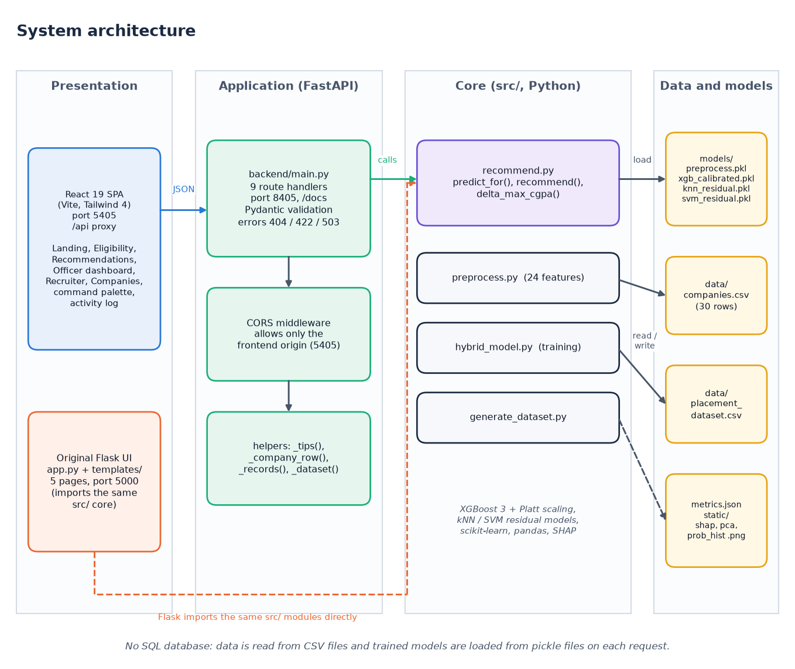
Figure 1: System architecture of the Smart Campus Placement System: presentation, application and core layers with the file stores.
The system has four columns. The presentation column holds the React 19 single-page application (Vite, Tailwind 4, port 5405) and the original Flask pages (app.py and five templates, port 5000). The application column is the FastAPI service backend/main.py (port 8405): nine route handlers, Pydantic validation, a CORS rule that admits only the front-end origin and a few helpers (_tips, _company_row, _records, _dataset). The core column is the src/ package: recommend.py serves predictions and recommendations, preprocess.py builds the 24 features, hybrid_model.py trains and evaluates, generate_dataset.py writes the synthetic data. The data column holds the two CSV tables, the five pickled model files with metrics.json, and three plot images. The FastAPI layer contains no model logic: it imports predict_for, recommend and pre_comp_cache from src/recommend.py, which is the same code the Flask app calls, so the two interfaces cannot drift apart. There is no SQL database; the pickled models are read from disk on each request.
The contract between browser and server is narrow: JSON in both directions. In development the Vite server proxies /api to port 8405, so the interface never needs to know the API address and CORS is not exercised; the API nevertheless allows the two front-end origins (localhost:5405 and 127.0.0.1:5405) and no others.

5.3 High-level workflow
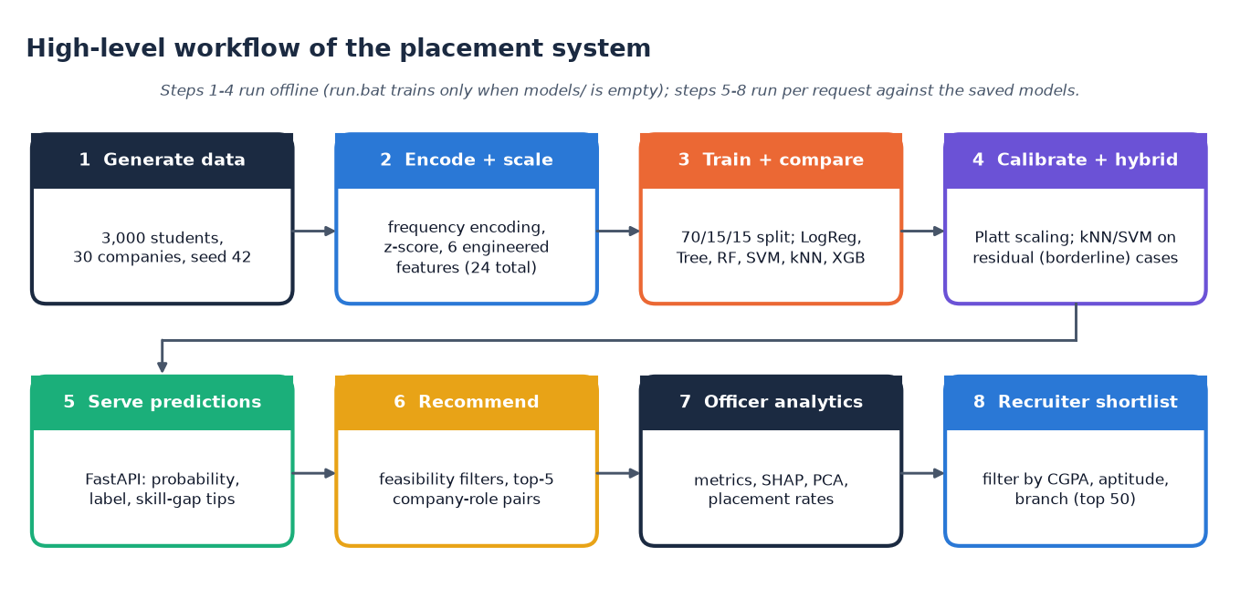
Figure 2: High-level workflow from data generation to recruiter shortlist.
Training (data generation, encoding, split, calibration, residual models) runs offline; every request then loads the saved models. run.bat retrains only when the model files are missing.

5.4 Data flow diagrams

5.4.1 Level 0
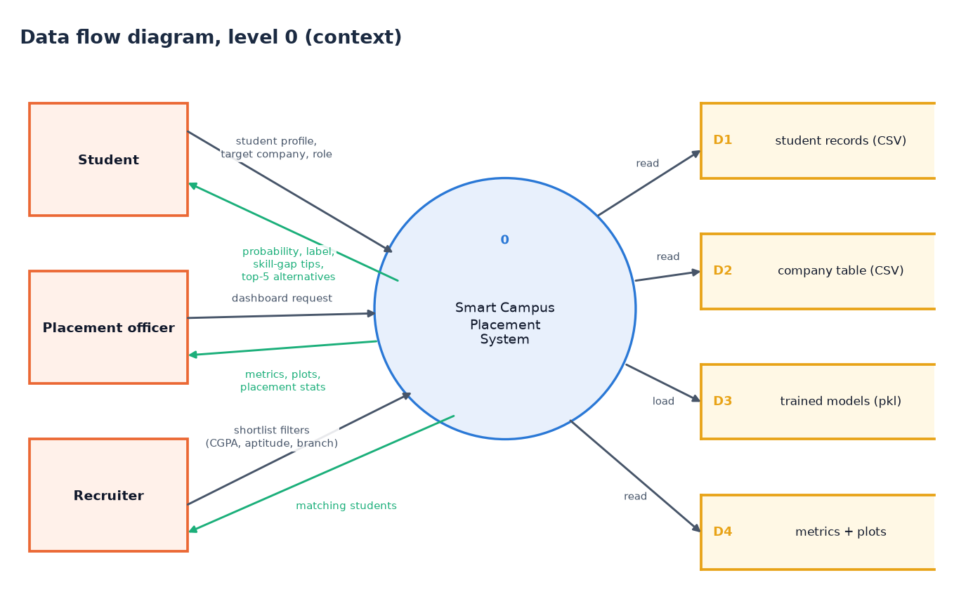
Figure 3: Level 0 data flow diagram: the system as one process with three external entities and four data stores.
A student, a placement officer and a recruiter exchange profiles, filters and results with one process that only reads four stores: student records (D1), companies (D2), models (D3), metrics and plots (D4).

5.4.2 Level 1
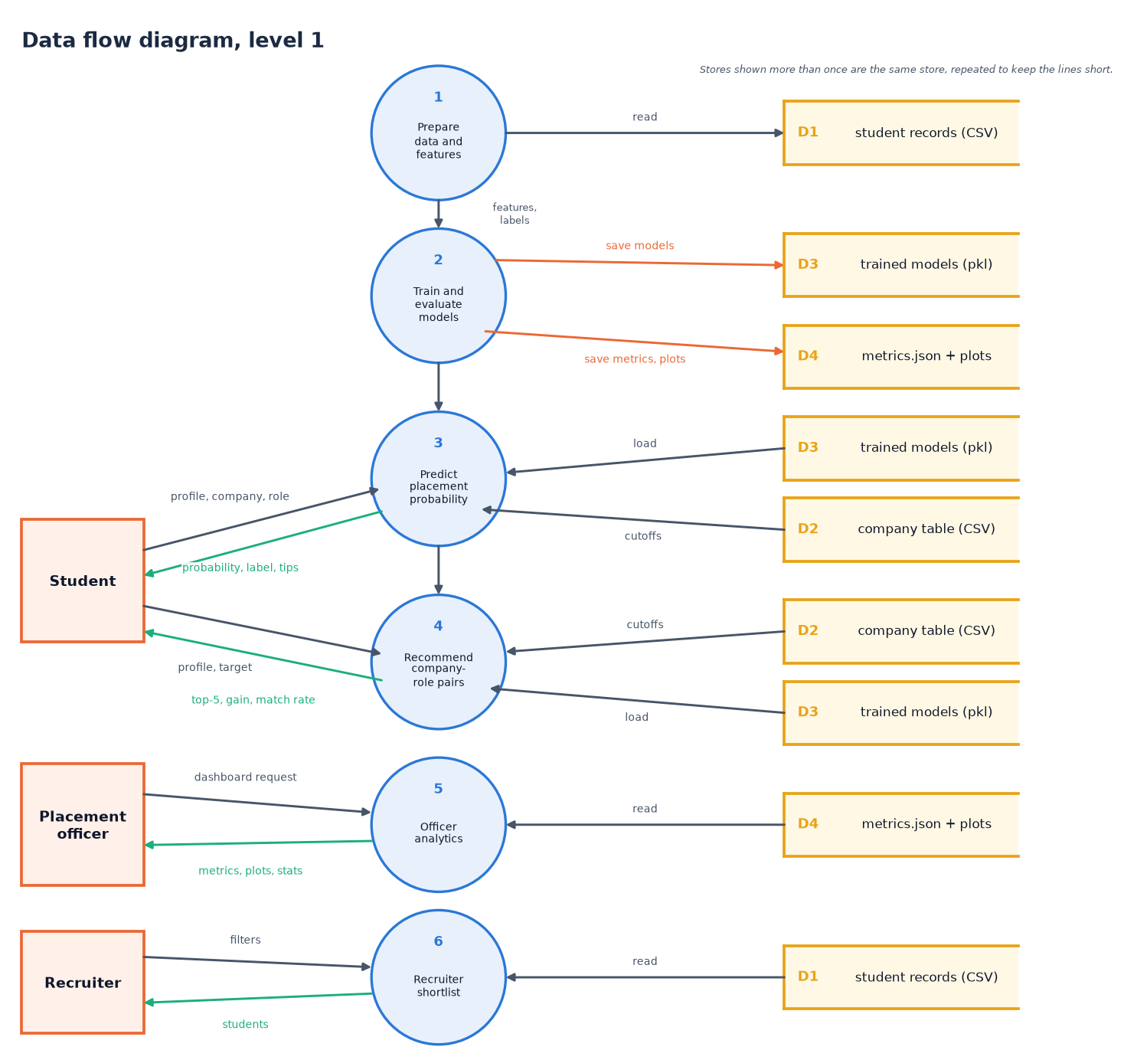
Figure 4: Level 1 data flow diagram: six processes, three external entities and four data stores.
Processes 1 and 2 (prepare data, train and evaluate) run offline; processes 3 to 6 (predict, recommend, officer analytics, recruiter shortlist) run per request. Repeated stores are the same store.

5.4.3 Level 2: recommending company-role pairs
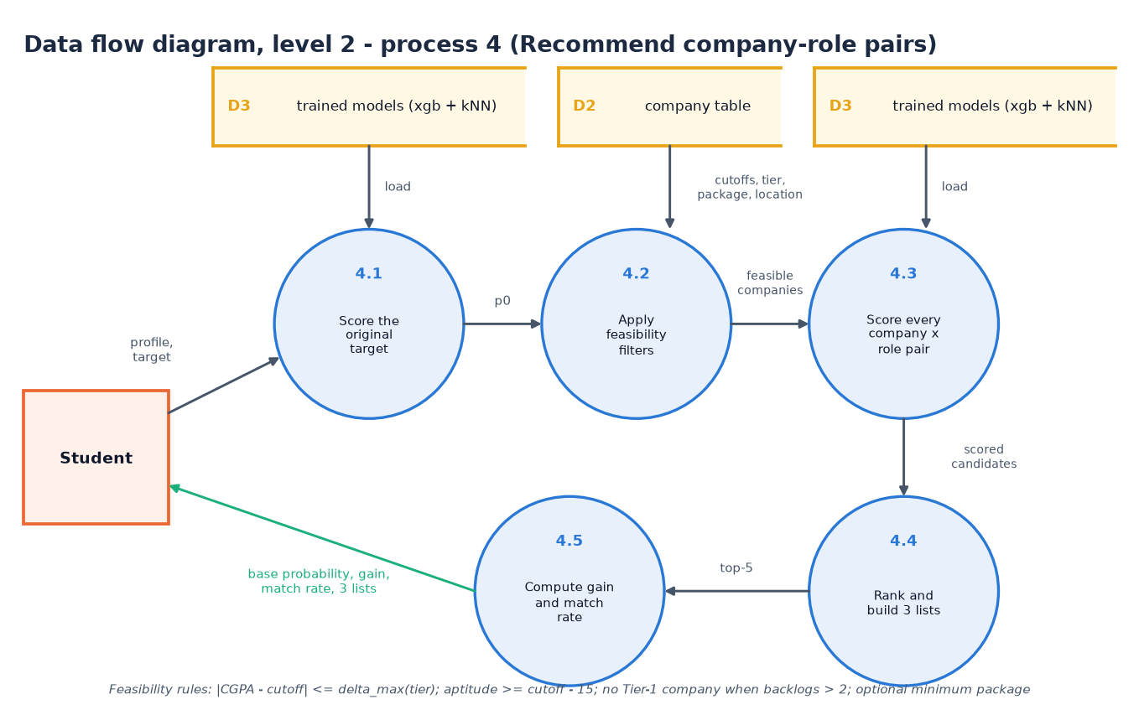
Figure 5: Level 2 data flow diagram of process 4, Recommend company-role pairs.
Process 4 is the most complex request, so it is decomposed. 4.1 scores the student's original target to obtain the base probability p0. 4.2 applies the feasibility filters to the 30 companies: the CGPA gap must not exceed delta_max of the company tier, aptitude must be at least the cutoff minus 15, a student with more than two backlogs is not offered Tier-1 companies, and an optional minimum package is honoured. 4.3 scores every feasible company with four roles (the target role, SDE, Data Analyst, QA Engineer). 4.4 ranks the candidates by score and builds the three lists, and 4.5 computes the average gain and the match rate. The trained models (D3) are read by 4.1 and 4.3, the company table (D2) by 4.2.

5.5 UML diagrams

5.5.1 Class diagram
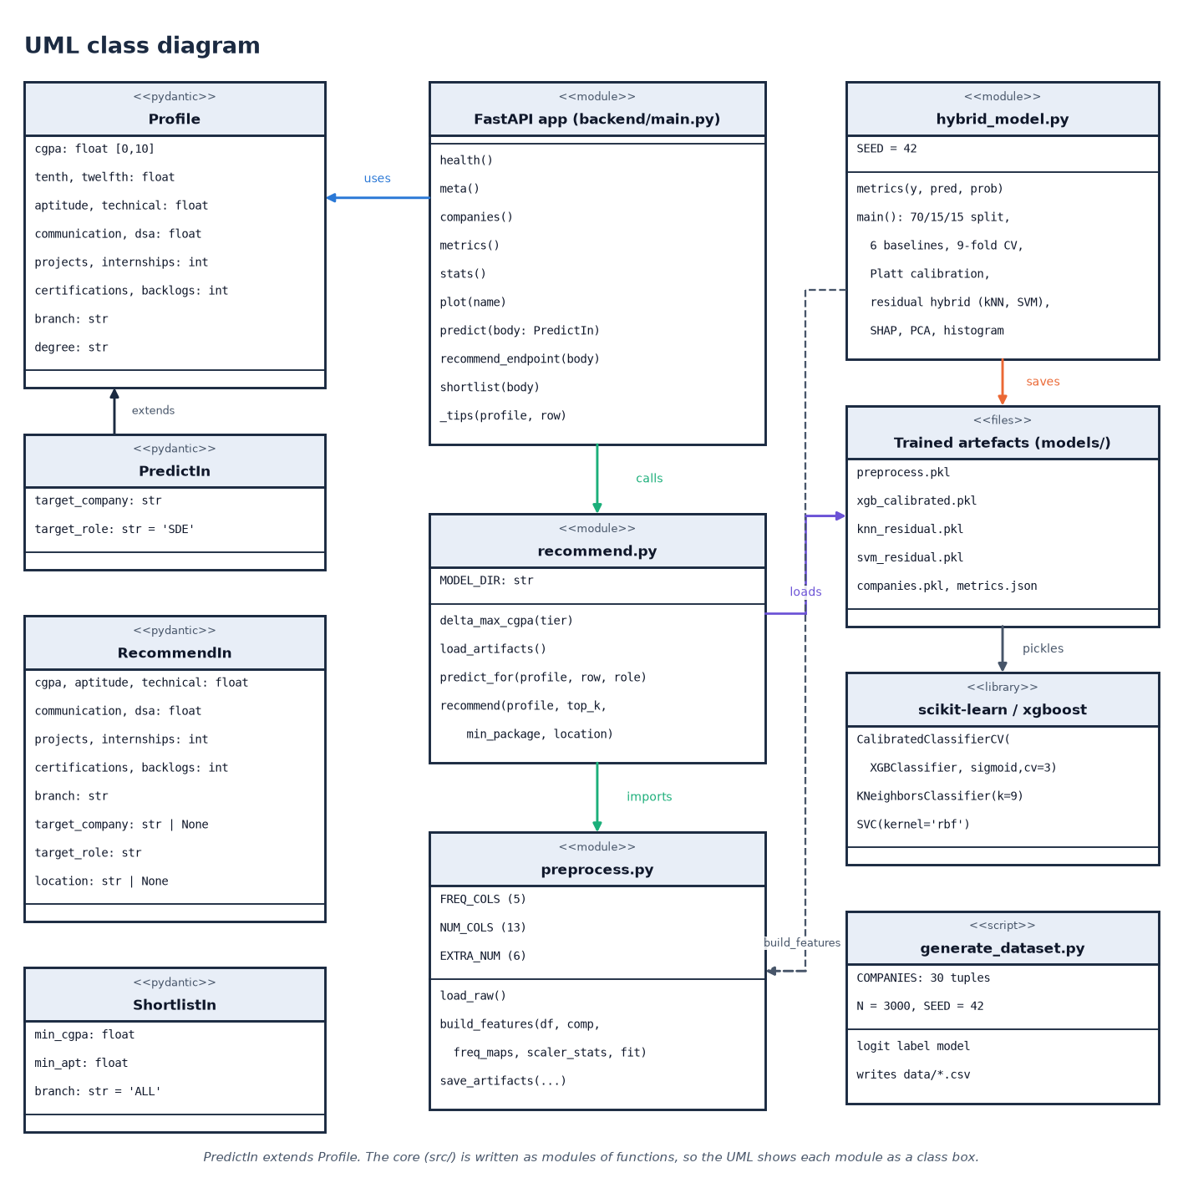
Figure 6: UML class diagram: request models, API module, core modules and the trained artefacts.
The code is modules of functions plus four Pydantic classes, so modules are drawn as class boxes; PredictIn extends Profile, the API calls recommend.py, which imports preprocess.py and loads the pickled artefacts.

5.5.2 Sequence diagram
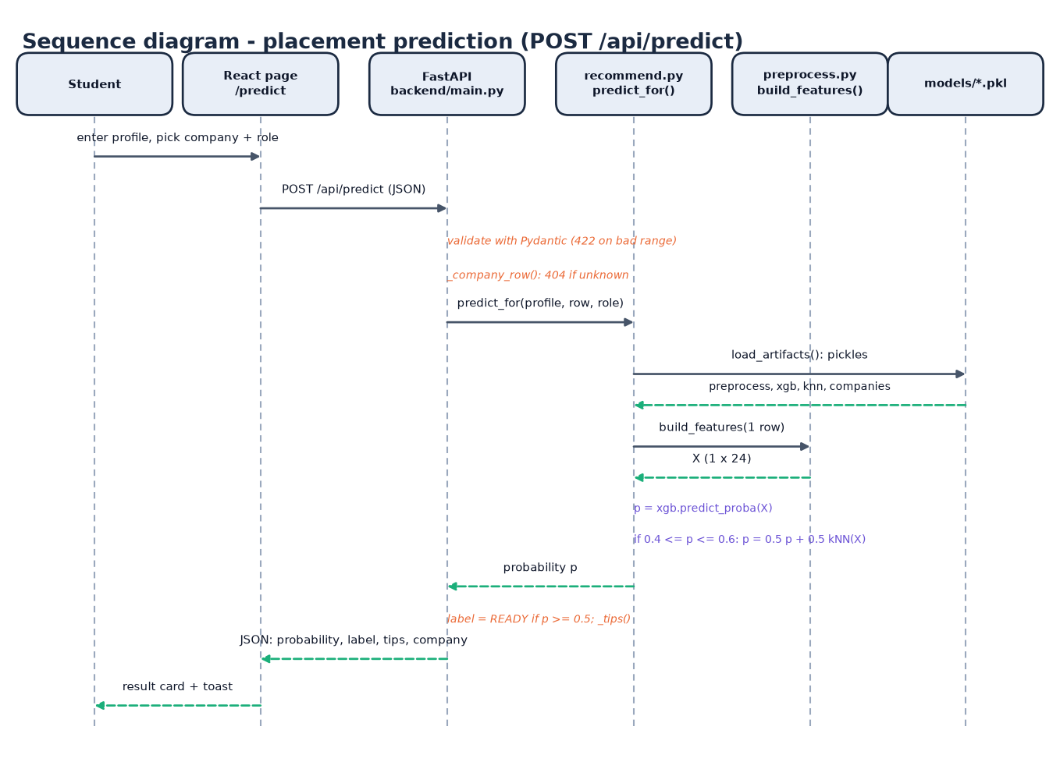
Figure 7: Sequence diagram of POST /api/predict, the main flow of the system.
The student enters a profile on the Eligibility page and picks a company and a role. The page posts JSON to /api/predict. FastAPI validates the body with Pydantic (422 on a bad range) and looks the company up (404 if unknown). predict_for loads the four pickles, build_features turns the single row into a 1 x 24 vector, the calibrated XGBoost model gives a probability and, when the probability lies between 0.4 and 0.6, it is averaged with the kNN probability. The endpoint labels the result PLACEMENT READY at 0.5 or above, adds the skill-gap tips and returns JSON; the page shows a result card and a toast.

5.5.3 Use-case diagram
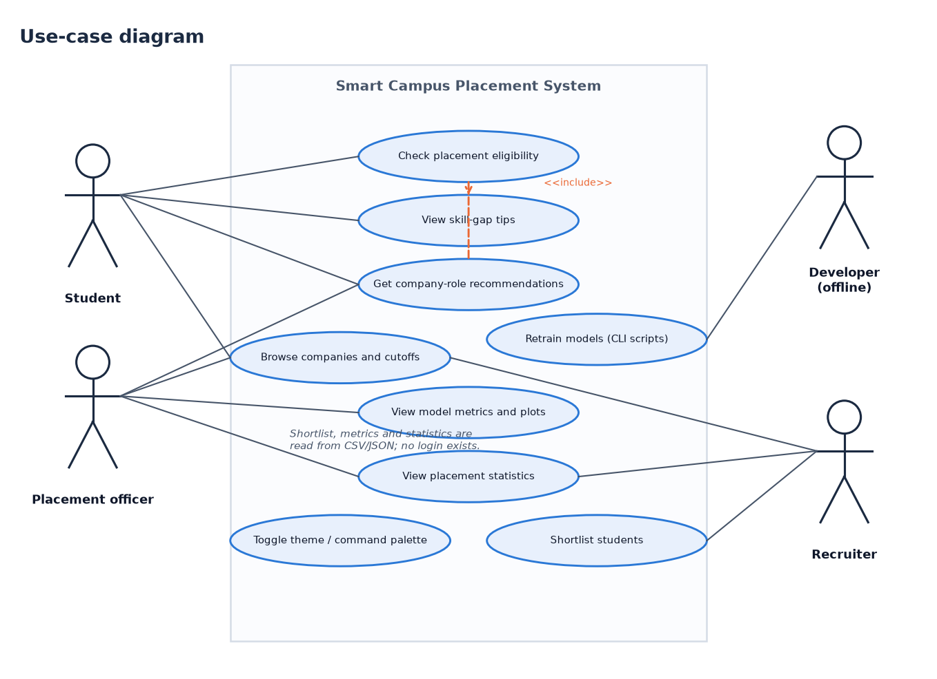
Figure 8: Use-case diagram with three user roles and one offline developer role.
Students check eligibility, read tips and get recommendations; officers view metrics, plots and statistics; recruiters shortlist students. The developer role is offline (retraining scripts). There is no login.

5.6 Database design
A design chapter normally describes a database, so we state it plainly: this system has no SQL database. The batch description mentions MySQL, but the implemented system stores its data in files, for three reasons. The data are two small tables (3,000 and 30 rows) that are never modified while the application runs; the models are pickles that must be loaded as a whole; and the users are anonymous, so there are no accounts to store. The logical data model is therefore described by the data dictionary below and drawn as an entity-relationship diagram. Moving to MySQL would be a natural extension (Chapter 10).
Table 24: Data dictionary of data/placement_dataset.csv (3,000 rows, 19 columns, no missing values)
Column | Type | Observed range | Meaning
CGPA | float | 5.80 - 9.35 | Cumulative grade point average out of 10
Tenth_Percent | float | 45.0 - 93.8 | Class 10 percentage
Twelfth_Percent | float | 40.3 - 89.2 | Class 12 percentage
Aptitude_Score | float | 27.6 - 98.0 | Quantitative and logical aptitude test score
Technical_Score | float | 26.2 - 100 | Technical (core subject) test score
Communication_Score | float | 20.0 - 90.6 | Communication assessment score
DSA_Score | float | 10.0 - 100 | Data-structures and algorithms assessment score
Projects, Internships, Certifications | int | 0-6, 0-4, 0-6 | Counts of completed projects, internships and certifications
Backlogs | int | 0 - 4 | Number of failed subjects still pending
Branch | text | 6 values | CSE, IT, ECE, EEE, MECH, CIVIL
Degree_Type, Student_Type | text | 2 + 2 values | BTech / MTech; Regular / Lateral entry
Placement_Year | int | 2023 - 2026 | Year of the placement season
Target_Company | text (FK) | 30 values | Company the student applied to; must exist in companies.csv
Target_Role | text | 8 values | SDE, Data Analyst, ML Engineer, QA Engineer, DevOps, Support Engineer, Embedded Engineer, Design Engineer
Target_Tier | int | 1, 2, 3 | Tier of the target company (copied from the company table)
Placed | int (label) | 0 / 1 | 1 = placed (1,791 rows, 59.7%), 0 = not placed (1,209 rows)

Table 25: Data dictionary of data/companies.csv (30 rows, 9 columns)
Column | Type | Observed range | Meaning
Company | text (PK) | 30 names | Company name, for example Google, Infosys, L&T
Tier | int | 1, 2, 3 | 1 = dream (7 companies), 2 = core (15), 3 = mass recruiter (8)
CGPA_Cutoff | float | 6.0 - 8.5 | Minimum CGPA the company usually asks for
Apt_Cutoff, Tech_Cutoff | int | 55 - 85, 50 - 85 | Aptitude and technical score cutoffs
Package_LPA | float | 4.0 - 28.0 | Offered package in lakhs per annum
Location | text | 7 values | Bangalore, Hyderabad, Chennai, Pune, Mumbai, Noida, Mysore
Company_Type | text | 3 values | MNC, Startup, Core
Hiring_Rate | float | 0.12 - 0.55 | Share of applicants normally hired; lower for dream companies

Both tables are synthetic: the student records were generated by src/generate_dataset.py and the company values are plausible but invented, not real recruiter requirements. Section 6.2 describes the generator.
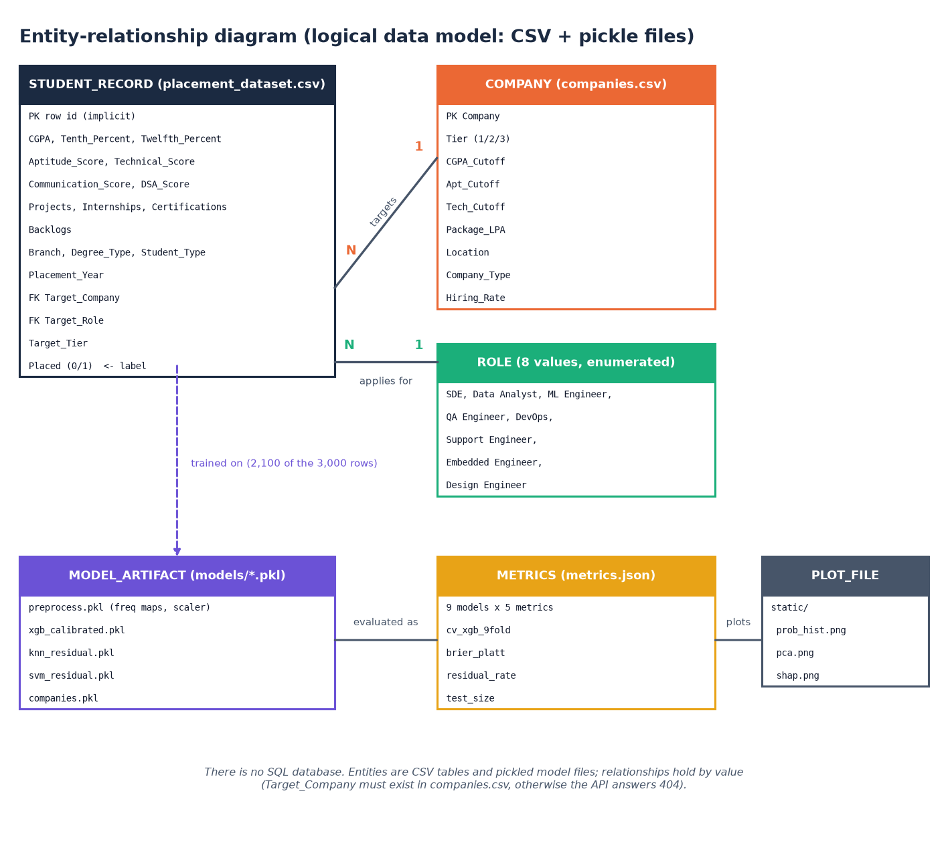
Figure 9: Entity-relationship diagram of the logical data model (CSV and pickle files).
Persistent files: the two CSV tables (277 KB and 1.4 KB), five pickles in models/ (xgb_calibrated 1.49 MB, knn_residual 0.42 MB, svm_residual 0.20 MB, preprocess 2.7 KB, companies 4.3 KB), metrics.json and three PNG plots in static/.

5.7 Module design
The table below lists the modules with their sizes (lines, measured with wc -l) and responsibilities. The training and serving core is small: 508 lines in four files. The API layer is 221 lines, the original Flask application 140 lines plus five templates, and the React interface about 3,000 lines of JavaScript.
Table 26: Module breakdown
Module | Lines | Responsibility | Key names
src/generate_dataset.py | 121 | Company table (30 tuples), synthetic students and the logit label model; writes data/*.csv | COMPANIES, SEED = 42
src/preprocess.py | 69 | Frequency encoding, z-score, six engineered features; saves preprocess.pkl | build_features, load_raw
src/hybrid_model.py | 186 | Split, six baselines, 9-fold CV, Platt calibration, residual hybrid, SHAP/PCA/histogram plots | main, metrics
src/recommend.py | 132 | Single-row features, calibrated probability with kNN blend, feasibility filters, three recommendation lists | predict_for, recommend, delta_max_cgpa
backend/main.py | 221 | Nine FastAPI endpoints, Pydantic models, CORS, tips, error mapping | predict, recommend_endpoint, shortlist
app.py + templates/ + static/style.css | 140 + 99 + 12 | Original Flask interface: five pages and POST /api/predict | predict, recommend_page, dashboard
frontend/src | 3,017 | Six React pages, UI kit, charts, three.js backdrop, activity log, command palette | Predict.jsx, Recommend.jsx, api.js
scripts/ | 1,256 | Smoke test, edge tests, experiments, diagrams and screenshot capture written or kept for this work | smoke_test.py, edge_tests.py
run.bat | 70 | Creates .venv, installs packages, trains if needed, installs npm packages, starts both servers | -

Dependencies run in one direction only: interfaces call src/recommend.py, which calls src/preprocess.py; the training script uses preprocess.py and writes the files that recommend.py loads. No module in src/ imports Flask, FastAPI or React.

5.8 Algorithm design

5.8.1 Hybrid prediction
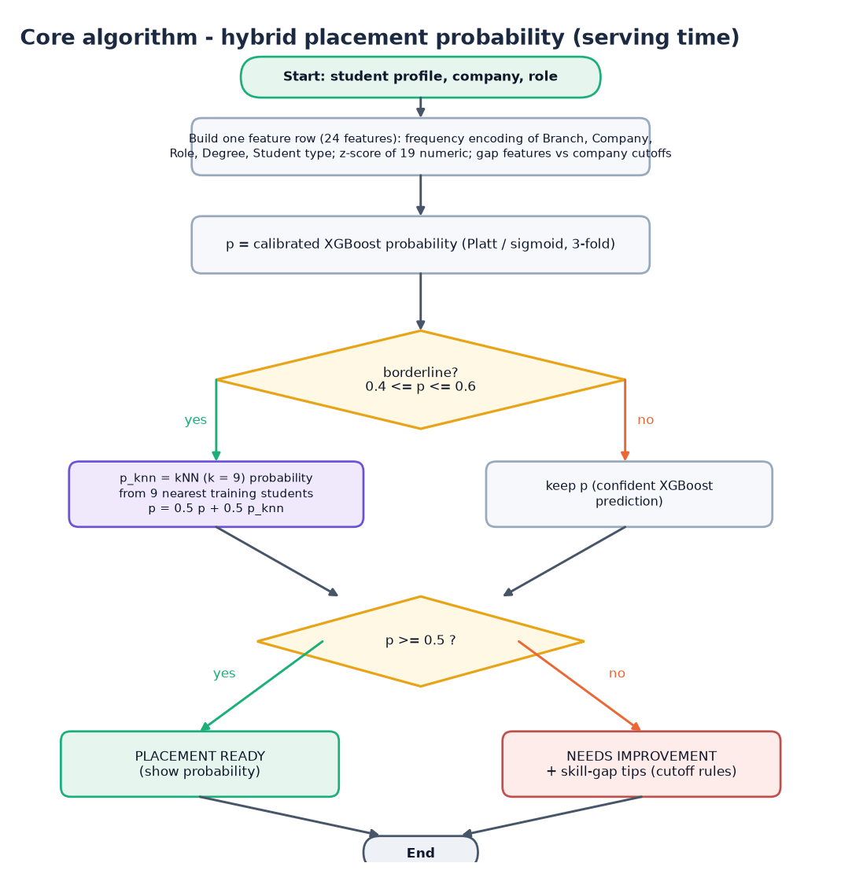
Figure 10: Flowchart of the hybrid placement probability computed at serving time.
A 24-value feature row gives the calibrated XGBoost probability p; if 0.4 <= p <= 0.6 it is averaged with the kNN probability; p >= 0.5 is labelled PLACEMENT READY, otherwise NEEDS IMPROVEMENT with tips.

5.8.2 Training pipeline
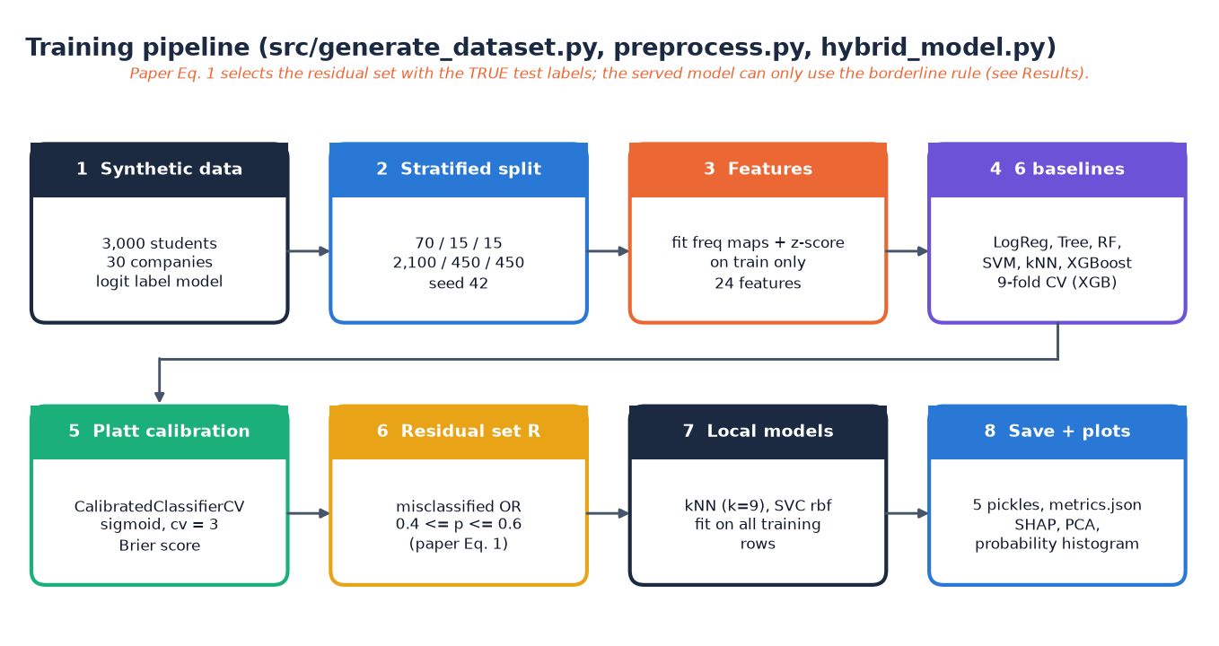
Figure 11: Training pipeline of src/generate_dataset.py, preprocess.py and hybrid_model.py.
The residual set of Equation 1 in the technique paper [2] uses the true labels of the evaluated rows, which a deployed system does not have (Section 6.6).

5.8.3 Recommendation
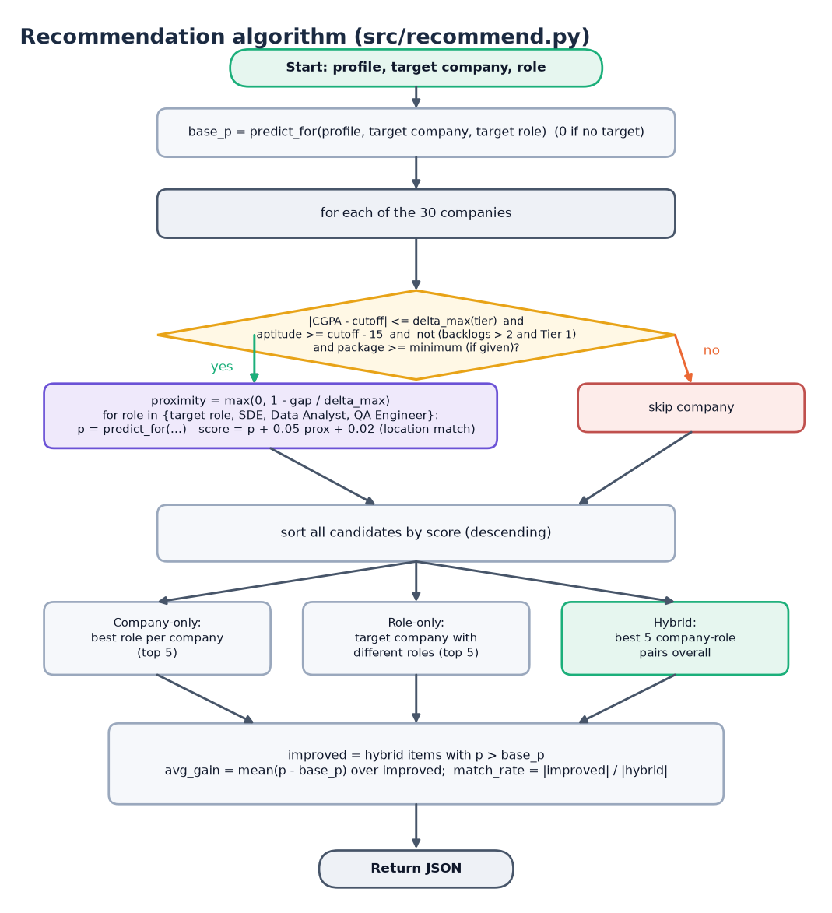
Figure 12: Flowchart of recommend() in src/recommend.py.
Each feasible company is scored for four roles with score = p + 0.05 x proximity + 0.02 x location bonus; the sorted candidates give the company-only, role-only and hybrid lists, and the gain and match rate are computed over hybrid items that beat the base probability.
Three design choices deserve a reason. The probability is calibrated (Platt scaling) because the recommender ranks companies by probability and a ranking is only meaningful if probabilities are comparable [4, 9]. The local model is applied only in the borderline band, where the global model is least certain [2]. The recommender is filtered before it is scored, so that it never suggests a company whose CGPA requirement is far from the student's or a Tier-1 company for a student with more than two backlogs.

5.9 API design
The nine endpoints below are the whole server interface; the interactive documentation is generated at /docs by FastAPI. Request bodies use Pydantic models, so type and range errors are reported per field.
Table 27: Endpoints of backend/main.py
Method | Path | Request and response | Errors
GET | /api/health | status, models_ready (true when all four model files exist) | -
GET | /api/meta | branches (6), degrees (2), predict_roles (6), recommend_roles (4), locations (6), companies (30 names) | -
GET | /api/companies | All 30 company rows: Company, Tier, CGPA_Cutoff, Apt_Cutoff, Tech_Cutoff, Package_LPA, Location, Company_Type, Hiring_Rate | -
GET | /api/metrics | Content of models/metrics.json: results per model, cv_xgb_9fold, brier_platt, residual_rate, test_size | 503 file missing
GET | /api/stats | total, placed_rate, avg_cgpa, by_branch placed rates | 503 dataset missing
GET | /api/plots/{name} | PNG of prob_hist, pca or shap | 404 other name or file missing
POST | /api/predict | In: profile (11 numbers, branch, degree) + target_company + target_role. Out: placement_probability, eligible, label, company, role, company_detail, tips | 404 unknown company, 422 out of range or wrong type
POST | /api/recommend | In: 9 numbers, branch, optional target_company, target_role, location. Out: base_prob, company_only, role_only, hybrid, avg_gain, match_rate | 404 unknown company, 422
POST | /api/recruiter/shortlist | In: min_cgpa, min_apt, branch (or ALL). Out: total_matches, students (at most 50, sorted by CGPA then Technical_Score) | 422 out of range

Two request models are shared: Profile (cgpa 0-10, tenth, twelfth, aptitude, technical, communication, dsa 0-100, projects, internships, certifications, backlogs 0-20, branch, degree) is extended by PredictIn with a company and a role; RecommendIn repeats the numeric fields without tenth, twelfth and degree and makes the company, role and location optional; ShortlistIn carries min_cgpa, min_apt and branch.

5.10 User interface design
The React interface was rebuilt on the Kinetic Mono design kit (version 5): a terminal-inspired look with a monospaced accent font, a dark theme by default and a light theme, a navigation sidebar on desktop that becomes a drawer on small screens, and a slowly moving wire-grid backdrop drawn with three.js. The kit was adapted to this project: the API client, the formatting helpers, the activity log and the chart components were written for the placement data, and the three.js scene falls back to a plain background when WebGL is unavailable or the user prefers reduced motion.
Table 28: Screens of the React application
Screen | Route | Content
Landing | / | Animated hero, live counters, terminal-style log, three.js wire grid, model table and company marquee
Eligibility | /predict | Profile form, company and role pickers, probability, label, cutoff comparison, skill-gap tips
Recommendations | /recommend | Profile form, base probability, average gain, match rate, top pick, chart and three ranked lists
Officer dashboard | /dashboard | Four KPI tiles, model comparison chart, placed rate by branch, tabs: model table, SHAP, PCA, probabilities
Recruiter | /recruiter | Filters, sortable paged table of the top 50 matches, CSV export
Companies | /companies | Searchable, filterable board of the 30 companies

• Theme. Dark and light themes share one set of colour tokens; the choice is stored in the browser and follows the operating-system preference until the user picks one.
• Command palette and shortcuts. / opens a search box that jumps to a company or a screen; g e, g r, g d, g u, g c go to Eligibility, Recommendations, Officer dashboard, Recruiter and Companies; g l opens the activity log; ? lists the shortcuts and Esc closes any overlay.
• Activity log. A terminal-style panel records every API call with its status and time in milliseconds, every error and every navigation (the last 200 events); it is what the screenshots of the log in Appendix C show.
• States. Every data-driven screen has a loading skeleton, an empty state that says what to do, and an error state with a retry button; describeError turns a network failure into "Could not reach the placement API" with the command that starts the backend, a 503 into a pointer to the setup guide, and a 422 into the per-field message.
• Forms and motion. The profile forms validate ranges before sending, using the same ranges as the server; counters, the typewriter headline and the backdrop respect prefers-reduced-motion, and pages are code-split so that three.js and the chart library load only when needed.
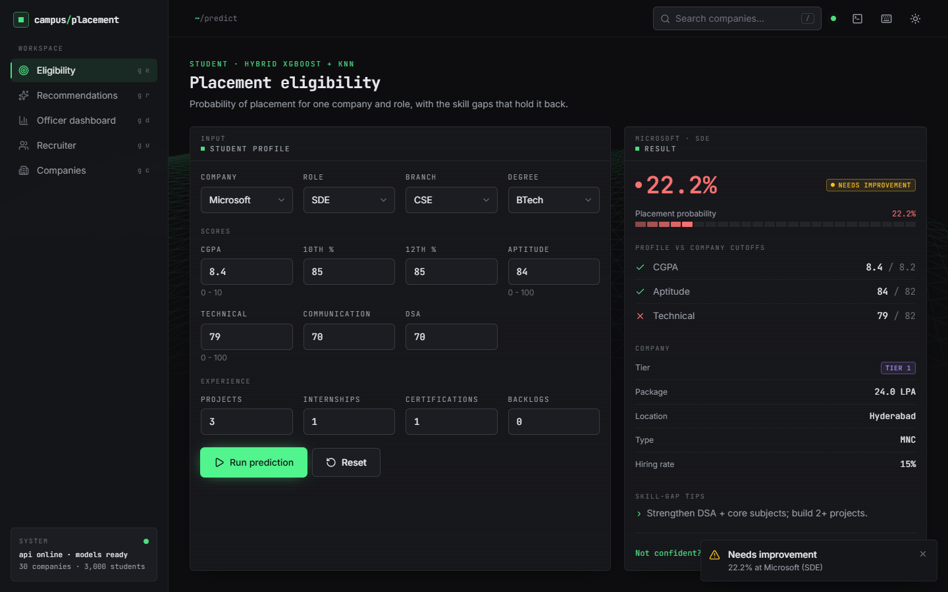  Figure 13: Eligibility screen with a real prediction (Microsoft, SDE). | 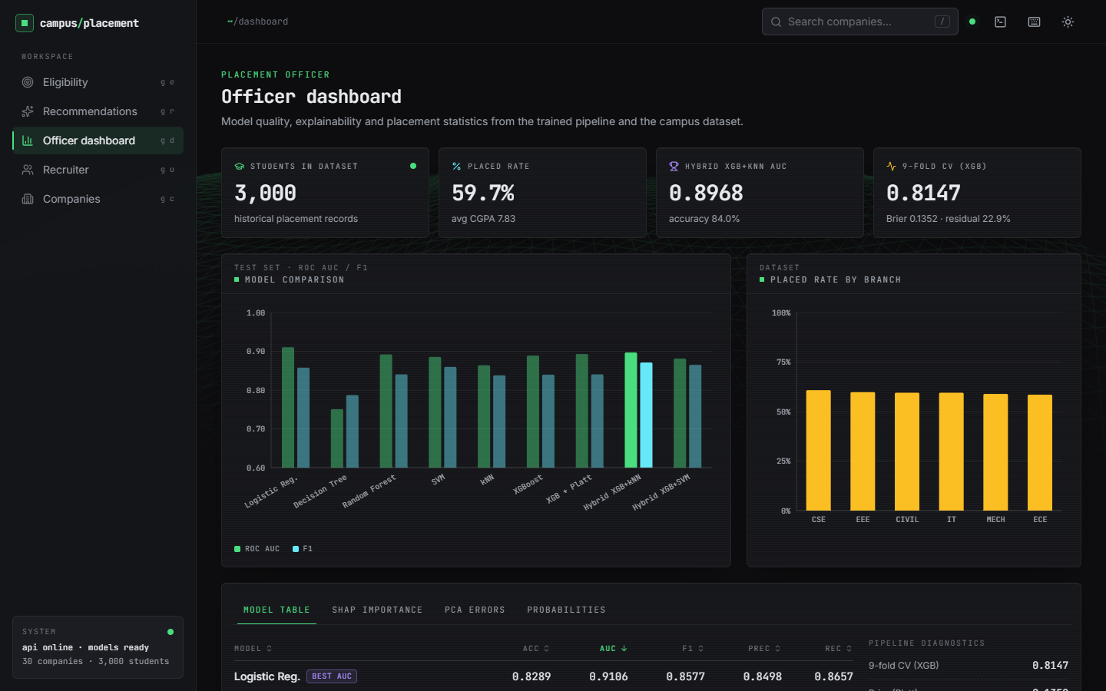  Figure 14: Officer dashboard overview.

CHAPTER 6: METHODOLOGY AND SOFTWARE IMPLEMENTATION

6.1 Overall methodology
The method is a supervised tabular-classification pipeline followed by a ranking step. A student profile and a target company are turned into a vector of 24 features; a calibrated gradient-boosted model returns the probability of placement; a local nearest-neighbour model refines the probability when it is borderline; and a recommendation step repeats the computation over feasible companies and roles to find alternatives with a higher probability. The design is adapted from the technique paper [2], which solved the same two-stage problem for graduate admissions, and extends the declared base paper [1], which predicts placement only. The steps are:
1. Generate 3,000 synthetic student records and a table of 30 companies (Section 6.2).
2. Encode and scale the records into 24 features, fitting the encodings on the training split only (Section 6.3).
3. Split the records 70/15/15 with a stratified split (seed 42): 2,100 training, 450 validation and 450 test rows.
4. Train six baseline classifiers and compare them on the test split; run 9-fold cross-validation for XGBoost on the training split.
5. Calibrate the XGBoost probabilities with Platt scaling (sigmoid, three folds) so that they can be compared across companies.
6. Refine borderline cases with a kNN or SVM model fitted on all training rows (the residual hybrid).
7. Serve predictions through predict_for and recommendations through recommend; explain with cutoff gaps, rule-based tips and a SHAP ranking.

6.2 Dataset
The data are synthetic, and this is the most important fact about the results. No real student records were available for this project, so src/generate_dataset.py draws them from fixed distributions with numpy seed 42. The declared base paper [1] also states that it generated a synthetic dataset, for the same reason. The file data/placement_dataset.csv has 3,000 rows and 19 columns; data/companies.csv has 30 invented but plausible companies (7 Tier-1, 15 Tier-2, 8 Tier-3) with CGPA, aptitude and technical cutoffs, package, location, type and hiring rate.
Academic scores are generated from CGPA with noise so that they correlate, as they do in practice. With N(m, s) denoting a normal draw: CGPA = clip(5.6 + 3.8 Beta(3.5, 2.5), 5, 10); Tenth = 9 CGPA + N(0, 4); Twelfth = 8.6 CGPA + N(0, 5); Aptitude = 40 + 9 (CGPA - 5) + N(0, 9); Technical = 38 + 10 (CGPA - 5) + N(0, 10); DSA = 0.9 Technical + N(0, 10); Communication = 50 + N(0, 12) + 0.1 (Technical - 60). Projects, internships and certifications are Poisson draws (means 1.8, 0.9, 1.5), backlogs are drawn from {0, 0, 0, 0, 1, 1, 2, 3, 4}, the branch, degree type, student type and year from fixed probabilities, the role uniformly from eight roles, and the target company with probability proportional to its hiring rate, so mass recruiters receive more applicants.
The placement label is then drawn from a logistic model of the student's gaps against the target company's requirements. Let g_c = CGPA - CGPA_cutoff, g_a = Aptitude - Apt_cutoff, g_t = Technical - Tech_cutoff, and Skill the skill index of Section 6.3:
z = 1.4 g_c + 0.035 g_a + 0.045 g_t + (Skill - 0.68) + 0.35 Internships + 0.18 Projects + 0.12 Certifications - 0.9 Backlogs + 0.25 [Branch in {CSE, IT}] + tier term - 0.55 + e (1)
where the tier term is -1.6, -0.7 and -0.1 for Tier 1, 2 and 3, e is N(0, 0.8) noise, and Placed is a Bernoulli draw with probability 1 / (1 + exp(-z)).
Table 29: Properties of the generated dataset
Property | Value
Students / companies | 3,000 / 30
Placed / not placed | 1,791 (59.7%) / 1,209 (40.3%)
CGPA mean (sd), min - max | 7.833 (0.704), 5.80 - 9.35
Placed rate by target tier (T1 / T2 / T3) | 9.6% / 49.5% / 81.6%
Placed rate by backlogs 0 / 1 / 2 / 3 / 4 | 72.2% / 61.1% / 52.6% / 38.3% / 33.7%
Placed rate by internships 0 / 1 / 2 / 3 / 4 | 56.8% / 59.2% / 63.2% / 69.2% / 78.6%
Placed rate by branch (range) | 58.5% (ECE) - 60.8% (CSE)
Missing values | 0
Split (train / validation / test) | 2,100 / 450 / 450 (stratified, seed 42)

Because the labels follow a logistic rule plus noise, a model that recovers the rule scores well: that is why even logistic regression reaches high accuracy in Chapter 8. The numbers measure how well each method recovers a known rule from 2,100 examples; they are not evidence of accuracy on real placement records, which are noisier and depend on factors (interview performance, openings, reservations) that are absent here. The class balance of 59.7 % placed is close to the balanced data of the technique paper [2] (51 % accepted), so no resampling is applied, although objective 2 of the project asked to address imbalance: the stratified split keeps the ratio in every part.

6.3 Pre-processing and feature engineering
src/preprocess.py turns each row, together with the company table, into a vector of 24 numbers: 13 standardised numeric columns, 6 engineered columns and 5 frequency-encoded categories. Encodings and scaler are fitted on the training split only and saved in models/preprocess.pkl, so validation, test and live inputs are transformed with training statistics and no information leaks from the test rows.
• Frequency encoding of Branch, Target_Company, Target_Role, Degree_Type and Student_Type: each value is replaced by its relative frequency in the training data, f(v) = count(v) / n. This keeps one column per category instead of one per value, as in the technique paper [2]; a value never seen in training maps to 0.
• Standardisation of numeric columns: z = (x - mean) / (sd + 1e-9), with mean and sd from the training split.
• Engineered features that encode the match between the student and the company, shown below.
Skill = (0.4 Technical + 0.3 Aptitude + 0.15 Communication + 0.15 DSA) / 100 (2)
CGPA_Gap = CGPA - CGPA_Cutoff; Apt_Gap = Aptitude - Apt_Cutoff; Tech_Gap = Technical - Tech_Cutoff (3)
CGPA_x_Tier = CGPA x Tier; Company_Hiring_Rate = Hiring_Rate of the target company (4)
The gap features are the heart of the design: a CGPA of 8.0 is a comfortable margin at Infosys (cutoff 6.0) and a shortfall at Google (cutoff 8.5). The interaction CGPA_x_Tier plays the role of the Program x QS-rank interaction of the technique paper, and Company_Hiring_Rate that of its program admission rate.
Table 30: The 24 model features
Group | Count | Columns
Standardised numeric | 13 | CGPA, Tenth_Percent, Twelfth_Percent, Aptitude_Score, Technical_Score, Communication_Score, DSA_Score, Projects, Internships, Certifications, Backlogs, Placement_Year, Target_Tier
Standardised engineered | 6 | Skill_Index, Company_Hiring_Rate, CGPA_x_Tier, CGPA_Gap, Apt_Gap, Tech_Gap
Frequency-encoded | 5 | Branch, Target_Company, Target_Role, Degree_Type, Student_Type

6.4 Algorithm choice and justification
Six baselines were trained so that the added complexity of the hybrid could be judged against simpler methods, as in the technique paper [2]. All use scikit-learn [6] or XGBoost [3] with seed 42.
Table 31: Classifiers and the reason for including each
Model | Configuration | Why it is included
Logistic regression | max_iter 1000 | Linear, interpretable reference; the label rule is logistic, so it is a strong baseline
Decision tree | defaults | Shows threshold rules (cutoffs) but overfits
Random forest [10] | 200 trees | Variance-reduced tree ensemble
SVM [11] | RBF kernel, probability = True | Non-linear margin classifier; also used as a residual model
kNN [7] | k = 9, uniform | Local similarity; the residual model of the hybrid
XGBoost [3] | 100 trees, depth 8, lr 0.1, subsample 0.8, colsample 0.8, L1 0.1, L2 1.0 | Gradient boosting [12]: the primary model, hyper-parameters taken from the technique paper [2]
XGBoost + Platt [4] | sigmoid, 3-fold | Calibrated probabilities for ranking and residual selection
Hybrid XGB + kNN / SVM | k = 9; RBF SVM | Local refinement of residual cases [2]

XGBoost is the primary model because boosted trees capture threshold rules and interactions (a CGPA just above a cutoff, a backlog with a Tier-1 company) without feature engineering beyond what Section 6.3 provides, and because TreeExplainer makes SHAP values [5] cheap. A LightGBM branch [14] exists in the training script but LightGBM is not installed, so it was not run. Platt scaling [4] was chosen over isotonic regression because it has two parameters and is stable on 2,100 rows [9].

6.5 Mathematical formulation
Calibration. Platt scaling maps the raw XGBoost score f to a probability with two fitted parameters A and B, and the quality of the probabilities is measured by the Brier score [8]:
p = 1 / (1 + exp(A f + B)); Brier = (1/n) sum (p_i - y_i)^2 (5)
Residual hybrid. Let y_i be the true label, p_i the calibrated probability and the hard prediction yhat_i = 1 if p_i >= 0.5. Equation 1 of the technique paper [2] defines the residual set and the hybrid prediction as
R = { i : yhat_i != y_i or 0.4 <= p_i <= 0.6 }; yhat_hybrid_i = yhat_kNN_i if i in R, else yhat_i (6)
The first condition (the prediction is wrong) needs the true label. It can be evaluated on a test set, where it measures what a local model could achieve if the wrong rows were known, but not on a new student. The served model therefore uses only the second condition (Section 6.6).
Serving rule (predict_for in src/recommend.py):
p = p_XGB; if 0.4 <= p <= 0.6: p = 0.5 p_XGB + 0.5 p_kNN; label = READY if p >= 0.5 (7)
Feasibility and ranking. The maximum CGPA gap depends on the company tier, the proximity of a student to a company is one at an exact match and zero at the maximum gap, and each company-role candidate is scored:
delta_max = 0.6, 1.0, 1.5 for Tier 1, 2, 3; Proximity = max(0, 1 - |CGPA - CGPA_Cutoff| / delta_max) (8)
Score = p + 0.05 Proximity + 0.02 [company location = preferred location] (9)
A company is feasible if |CGPA - cutoff| <= delta_max, Aptitude >= Apt_Cutoff - 15, not (Backlogs > 2 and Tier = 1) and, if given, Package >= the minimum. These rules mirror the GPA feasibility filters of the technique paper [2], with tiers instead of QS ranks. For the hybrid list of the five best candidates, with base probability p0:
improved = { c : p_c > p0 }; avg_gain = mean(p_c - p0) over improved; match_rate = |improved| / 5 (10)
Skill-gap tips are rules, not model outputs: a tip is added when CGPA, Aptitude or Technical is below the company cutoff and when the student has no internship; if none applies the message is "Strong profile - apply and prepare for interviews". The global importance of each feature is shown separately by the mean absolute SHAP value [5].

6.5A Explainability and worked example
Global explanations use SHAP [5]: TreeExplainer is applied to the XGBoost model and the mean absolute SHAP value of each feature over the 450 test rows ranks the features. The five largest are CGPA_Gap (1.12), Backlogs (0.88), Tech_Gap (0.50), Apt_Gap (0.40) and CGPA_x_Tier (0.39). The gap features dominate because the generator made the label depend on exactly those gaps (Section 6.2); on real data the ranking would have to be re-examined. The ranking is global: the system does not compute a SHAP explanation for an individual student, and the per-student advice comes from the cutoff rules.
Worked example of the feasibility filter. Take a CSE student with CGPA 7.2, aptitude 65 and technical 65 who targets Google (Tier 1, CGPA cutoff 8.5). The gap is 1.3, which exceeds delta_max = 0.6 for Tier 1, so Google is itself infeasible and the role-only list (which keeps only the target company) is empty. Infosys (Tier 3, cutoff 6.0) has a gap of 1.2, within delta_max = 1.5; its proximity is 1 - 1.2 / 1.5 = 0.2, so a candidate with probability 0.90 scores 0.90 + 0.05 x 0.2 = 0.91, plus 0.02 if the student prefers Mysore. The example shows a property of the design that Chapter 8 returns to: because the score is dominated by the probability, weak profiles are steered to Tier-3 companies, where the probability is highest, regardless of package.
Controls against leakage. Encodings and scaler are fitted on the training split only, the test split is used once for reporting, and cross-validation uses training rows alone. The paper's residual rule is the exception: it looks at test labels by definition and is reported separately (Section 6.6). No hyper-parameter search was run; the hyper-parameters are those of the technique paper [2].

6.6 Model training, configuration and the label-dependence of the hybrid
Table 32: Training configuration
Item | Value
Split | stratified 70 / 15 / 15, seed 42: 2,100 / 450 / 450 (test placed 59.56%)
XGBoost | n_estimators 100, max_depth 8, learning_rate 0.1, subsample 0.8, colsample_bytree 0.8, reg_alpha 0.1, reg_lambda 1.0, eval_metric logloss
Cross-validation | 9-fold stratified on the training split: accuracy 0.8147
Calibration | CalibratedClassifierCV, sigmoid, 3 folds; Brier 0.1352
Local models | kNN k = 9 (uniform), SVC RBF; both fitted on all 2,100 training rows
Hardware / time | CPU only (i5-12500); one full retraining run of all models about 3 s
Artefacts | xgb_calibrated.pkl 1.49 MB, knn_residual.pkl 0.42 MB, svm_residual.pkl 0.20 MB

The shipped model files reproduce models/metrics.json exactly when evaluated on the seed-42 test split; a fresh retraining with the library versions installed for this work differs by at most 0.011 in any metric, which is the run-to-run variation of calibration and tree building.
Why the paper rule cannot be used as stated. In the shipped evaluation the residual set contains every test row that XGBoost gets wrong. On the 450-row test split XGBoost errs on 87 rows; 72 of them lie outside the borderline band and enter the 103-row residual set only because the true label shows they are wrong. The local kNN is then correct on 30.1% of those rows, against 15.5% for XGBoost: a selection effect. A deployed system never knows the label, so it can apply the local model only to the 31 borderline rows. Three versions were therefore measured on the same split:
Table 33: Residual rules compared (seed 42, 450 test rows, shipped models)
Rule | Needs true labels | Accuracy | F1 | ROC-AUC
XGBoost + Platt only | no | 0.8067 | 0.8404 | 0.8928
Hybrid, paper rule (wrong or borderline) | yes | 0.8400 | 0.8710 | 0.8968
Hybrid, label-free (borderline, hard kNN label) | no | 0.8089 | 0.8442 | 0.8954
Hybrid, serving rule (0.5 p + 0.5 p_kNN) | no | 0.8089 | 0.8436 | 0.8939

The gain of the paper rule (0.8067 to 0.8400) disappears under the label-free rule (0.8089, one student more than XGBoost alone). The project keeps the paper rule in its reported metrics, because that is what the technique paper evaluates and what metrics.json contains, but this report states the label-free figure next to it wherever the hybrid is discussed.
Table 34: Width of the borderline band (label-free kNN replacement)
Band | Rows replaced | Accuracy | F1 | ROC-AUC
none | 0 | 0.8067 | 0.8404 | 0.8928
0.45 - 0.55 | 13 | 0.8022 | 0.8379 | 0.8935
0.40 - 0.60 | 31 | 0.8089 | 0.8442 | 0.8954
0.35 - 0.65 | 45 | 0.8067 | 0.8444 | 0.8967
0.30 - 0.70 | 73 | 0.8067 | 0.8455 | 0.8941
0.20 - 0.80 | 133 | 0.8067 | 0.8449 | 0.8886

Widening the band changes accuracy by at most 0.4 points. The served band 0.40 - 0.60 is the one prescribed by the technique paper; the sweep shows that no other width would have been measurably better.
The decision threshold was left at 0.5. Accuracy is flat between 0.793 and 0.807 over thresholds 0.30 to 0.70, while precision rises from 0.776 to 0.869 and recall falls from 0.918 to 0.791; a placement cell that prefers not to miss placeable students could lower the threshold.
Platt scaling lowers the Brier score only slightly, from 0.1379 to 0.1352; logistic regression is better calibrated still (0.1180). The mean predicted probability on the test split (0.592) matches the observed placed rate (0.596).

6.7 Application architecture
A request travels from the React page through the Vite proxy to FastAPI, which validates it and calls src/recommend.py. For every prediction predict_for calls load_artifacts(), which reads four pickle files (preprocessing, calibrated XGBoost, kNN and the company table) from disk, builds a one-row feature vector and returns the probability. The core of the function is:
def predict_for(profile, company_row, role):
pre, xgb, knn, comp = load_artifacts()
X = _row_features(profile, company_row, role, pre)
p = float(xgb.predict_proba(X)[0, 1])
# residual refinement: if borderline, blend with kNN (paper Fig.8)
if 0.4 <= p <= 0.6:
pk = float(knn.predict_proba(X)[0, 1])
p = 0.5 * p + 0.5 * pk
return round(p, 4)

Reloading the pickles on every call keeps the code simple and the server stateless, but it costs time: one prediction takes a mean of 66 ms over HTTP, and a recommendation, which calls predict_for once per feasible company and role (up to 4 x 30 times), takes a mean of 5.4 s. Caching the loaded artefacts in the module would remove most of this and is the first improvement listed in Chapter 10; it was not done because it changes the shared core code that the Flask interface also uses.
The skill-gap tips are produced in the API layer by _tips, which applies the same four rules as the Flask route:
def _tips(profile, row):
tips = []
if profile['cgpa'] < float(row['CGPA_Cutoff']):
tips.append('CGPA ... below <company> cutoff ... - target Tier-2/3 companies.')
if profile['aptitude'] < float(row['Apt_Cutoff']):
tips.append('Improve aptitude (target 75+) via weekly mock tests.')
if profile['technical'] < float(row['Tech_Cutoff']):
tips.append('Strengthen DSA + core subjects; build 2+ projects.')
if profile['internships'] == 0:
tips.append('Get at least 1 internship - strongly boosts probability.')
if not tips:
tips.append('Strong profile - apply and prepare for interviews.')
return tips

6.8 API design
The endpoint list is in Section 5.9. A prediction request and response look as follows (values from a real call with a strong CSE profile and target Infosys, role SDE; fields not shown are omitted):
POST /api/predict
{ "cgpa": 8.4, "tenth": 88, "twelfth": 86, "aptitude": 82, "technical": 84, "communication": 75,
"dsa": 80, "projects": 3, "internships": 1, "certifications": 2, "backlogs": 0,
"branch": "CSE", "degree": "BTech", "target_company": "Infosys", "target_role": "SDE" }

200 { "placement_probability": 0.9032, "eligible": true, "label": "PLACEMENT READY",
"company": "Infosys", "role": "SDE", "company_detail": { "Tier": 3, "CGPA_Cutoff": 6.0, ... },
"tips": ["Strong profile - apply and prepare for interviews."] }

POST /api/recommend returns base_prob, the three lists company_only, role_only and hybrid (each item has company, role, tier, package, location, prob, score and proximity), avg_gain and match_rate. POST /api/recruiter/shortlist filters the student table with the thresholds and returns total_matches and at most 50 rows; total_matches was added to the response of the Flask page so that the interface can say "1394 candidates match" while showing only the top 50. The React client keeps one axios instance with a 60 s timeout; an interceptor logs every call, its status and its duration to the activity log.

6.9 Security and error handling
Table 35: Input validation and errors
Situation | Behaviour | HTTP
Number outside its range (CGPA 14, aptitude -5, backlogs 99) | Pydantic rejects the request; the page shows the field message | 422
Text where a number is required | Rejected by Pydantic | 422
Missing required field (target_company) | Rejected by Pydantic | 422
Unknown company name | _company_row raises | 404
Unknown plot name or path-traversal text in the plot name | Only three names are allowed | 404
Model or data file missing | Clear message naming the command to run | 503
Model raises on unseen values | Caught and returned as Prediction failed: ... | 422
Foreign browser origin | No CORS header is returned | -

The security posture is that of a local teaching prototype, and the limits should be read plainly. There is no authentication and no authorisation: any client that can reach the port can read the student table through the shortlist endpoint, so the server must not be exposed to an untrusted network. There is no database, so SQL injection is not possible; a test with a SQL-injection string, a script tag, a path-traversal name and a 100 kB company name all returned 404 and nothing was executed (Chapter 7). There is no rate limiting, no HTTPS and no audit log. An unseen branch or role value is accepted and encoded with frequency 0 instead of being rejected. The pickled model files are loaded with pickle, which is safe only for files the operator trained; they must not be replaced by files from an untrusted source.

6.9A Front-end implementation
The React application rests on four shared pieces: api.js (axios client whose interceptors feed the activity log and turn failures into a message and a hint), lib/useFetch.js (data, error, loading and reload for every GET), lib/profile.js (field ranges, defaults and validation mirroring the server) and lib/theme.jsx (theme and colour tokens, so charts and the three.js backdrop re-tint). Pages are lazy-loaded; the Recruiter page sorts and pages the 50 returned rows in the browser and exports them as CSV, and the dashboard tabs show the PNG files served by /api/plots/{name}.

6.10 Installation and execution
Table 36: Software environment used for this work
Component | Version
Operating system / hardware | Windows 11 Pro; Intel Core i5-12500 (6 cores, 12 threads); 15.7 GB RAM; none (CPU only)
Python and packages | Python 3.14.7; scikit-learn 1.9.0; xgboost 3.4.1; pandas 3.0.5; numpy 2.5.3; shap 0.52.0
Back end | FastAPI 0.159.1; uvicorn 0.54.0; pydantic 2.14.1; Flask 3.1.3 (original interface)
Front end | Node 24.19.0; React 19.3; Vite 8.3; Tailwind 4.3; three.js 0.186; Recharts, framer-motion, GSAP

One-command start. Python 3.10 or newer and Node.js 20 or newer are required. Running run.bat in 8.ProjectCode (i) reads the ports from .env (backend 8405, frontend 5405), (ii) creates .venv and installs requirements.txt if the packages are missing, (iii) generates the data and trains the models only if models/xgb_calibrated.pkl is absent, (iv) runs npm install in frontend/ if needed, and (v) opens two windows, one for uvicorn backend.main:app --port 8405 and one for npm run dev, and the browser at http://localhost:5405.
python -m venv .venv
.venv\Scripts\python.exe -m pip install -r requirements.txt
.venv\Scripts\python.exe src\generate_dataset.py # data/*.csv
.venv\Scripts\python.exe src\preprocess.py # models/preprocess.pkl
.venv\Scripts\python.exe src\hybrid_model.py # models, metrics.json, plots
.venv\Scripts\python.exe -m uvicorn backend.main:app --port 8405
cd frontend && npm install && npm run dev # http://localhost:5405
python app.py # original Flask UI, port 5000

The checks are run with python scripts/smoke_test.py (15 checks against the running API) and python scripts/edge_tests.py (46 checks); python scripts/capture_screens.py records the screens with Playwright. Typical problems are a missing pyarrow (the pickled company table needs it under pandas 3; it is in requirements.txt), a port already in use (change .env) and "Could not reach the placement API" when the backend window is not running.
Implementation notes. The front end is built into code-split chunks (three.js, charts, motion and GSAP are separate bundles) with npm run build; npm run preview serves the build on 5405 with the same /api proxy. All ports come from .env, so the system can run beside other projects on the same PC.

CHAPTER 7: SYSTEM TESTING

7.1 Testing strategy
Testing covers five layers: small functions of the core (src/) are tested directly; every API endpoint is called over HTTP against the running FastAPI server; the main user-facing behaviours are checked as functional cases; invalid and hostile inputs are sent to the API; and response times are measured. All checks are scripts in the repository and can be re-run with one command (scripts/edge_tests.py and scripts/smoke_test.py, with the backend running on port 8405). Before this documentation work the project contained only the smoke test; the 46 checks of edge_tests.py were written for it. They test behaviour, not prediction quality: prediction quality is measured separately on held-out data (Chapter 8).
A guiding choice was to record what the system does, and not only to assert what we hoped it would do. Where the behaviour is a limitation rather than a requirement (for example an unknown branch name being accepted), the check is recorded as an observation and is listed in Section 7.9 and in the limitations of Chapter 9.
Table 37: Test layers and results
Layer | What it covers | How | Result
Unit | Tier tolerance, feature matrix, company table, determinism, monotonic behaviour, recommender filters | scripts/edge_tests.py, direct import of src/ | 10 of 10 pass
Integration | Every GET endpoint, the three plot images, counts of companies and students | Live HTTP calls to 127.0.0.1:8405 | 8 of 8 pass
Functional | Prediction of a strong and a weak profile, recommendation, location preference, recruiter shortlist | Live HTTP calls | 6 of 6 pass
Validation and edge cases | Out-of-range and wrongly typed fields, missing fields, boundary profiles, unknown values, empty shortlists | Live HTTP calls | 13 of 13 pass
Security | Injection-style strings, path traversal, CORS, oversized input, undefined routes | Live HTTP calls | 9 of 9 pass
End-to-end smoke test | Every endpoint the React front end calls, with success and failure cases | scripts/smoke_test.py | 15 of 15 checks pass
Performance | Response times of six endpoints; latency of the model call (Section 7.8) | scripts/edge_tests.py | Measured

In total 46 of 46 checks pass and 0 fail in edge_tests.py, and 15 of 15 smoke-test checks pass. No failure was found, so no defect list is given; the observed limitations are collected instead in Section 7.9.

7.2 Unit testing
The unit checks import the real modules and use the real trained models; no mocks are used, because the behaviour under test (probability from a pickled model) cannot be separated from the model. They verify the contracts that the rest of the system relies on: the feature matrix has a fixed shape, predictions are deterministic and bounded, and the probability moves in the direction the domain expects.
Table 38: Unit test cases (scripts/edge_tests.py)
ID | Test | Input | Expected result | Observed | Result
U1 | Tier tolerance | delta_max_cgpa(1), (2), (3) | 0.6, 1.0, 1.5 | 0.6, 1.0, 1.5 | Pass
U2 | Feature matrix | build_features on 25 rows with the saved encoders | Shape (25, 24), no NaN | (25, 24) | Pass
U3 | Company table | companies.csv | 30 rows; tiers {1, 2, 3} | 30 rows; tiers {1, 2, 3} | Pass
U4 | Determinism | predict_for twice, same profile, Infosys SDE | Equal values in [0, 1] | both 0.9047 | Pass
U5 | Effect of CGPA | CGPA 6.0 then 9.0, same profile otherwise, Infosys | Probability rises | 0.883 -> 0.905 | Pass
U6 | Effect of backlogs | 0 then 4 backlogs, Infosys | Probability falls | 0.905 -> 0.892 | Pass
U7 | Weak profile at a dream company | CGPA 7.0, aptitude 60, technical 60, Google | Probability below 0.5 | 0.126 | Pass
U8 | Recommender output size and order | recommend(..., top_k=5), CGPA 7.2, 3 backlogs, target Google | At most 5 items, sorted by score | 5 items, sorted | Pass
U9 | Tier-1 exclusion | Same call with 3 backlogs | No Tier-1 company in the list | ['Infosys', 'ValueLabs', 'Infosys', 'ValueLabs', 'Infosys'] | Pass
U10 | CGPA feasibility filter | Same call, CGPA 7.2 | Every pick within the tier tolerance of its cutoff | All picks within tolerance | Pass

U5 and U6 show a small effect because the test profile is strong and Infosys has a low cutoff, so the probability is near its ceiling; the direction is what is asserted.

7.3 Integration testing
Integration checks call the running FastAPI application over HTTP on 127.0.0.1 (the default host name localhost adds about two seconds per call on this machine because of an IPv6 fall-back, so it was not used for timing). They verify that the API, the core modules, the data files and the model files work together.
Table 39: Integration test cases
ID | Test | Input | Expected result | Result
I1 | Health | GET /api/health | 200; models_ready is true | Pass
I2 | Meta | GET /api/meta | 30 company names and 6 branches | Pass
I3 | Companies | GET /api/companies | 30 rows with cutoffs, package, location | Pass
I4 | Metrics | GET /api/metrics | 9 models with 5 metrics each, 9-fold CV and Brier score | Pass
I5 | Statistics | GET /api/stats | 3,000 students, placed rate, per-branch rates | Pass
I6 | Probability histogram | GET /api/plots/prob_hist | 200 and a PNG signature | Pass
I7 | PCA plot | GET /api/plots/pca | 200 and a PNG signature | Pass
I8 | SHAP plot | GET /api/plots/shap | 200 and a PNG signature | Pass

7.4 Functional testing
Functional checks follow what a user does: ask whether a student is ready, ask for alternatives, and shortlist candidates. The expected results come from the domain (a strong student at a Tier-3 company should be ready; a weak student at a Tier-1 company should not) and from the documented rules of src/recommend.py.
Table 40: Functional test cases
ID | Test | Input | Expected result | Observed | Result
F1 | Strong profile | CGPA 8.4, aptitude 82, technical 84, 1 internship; Infosys, SDE | PLACEMENT READY | probability 0.9032 | Pass
F2 | Weak profile | CGPA 6.2, aptitude 50, technical 45, no internship; Google | NEEDS IMPROVEMENT with at least 3 tips | probability 0.1212 | Pass
F3 | Recommendation | CGPA 7.2, aptitude 65, technical 65; target Google SDE; location Hyderabad | 5 hybrid options and a company-only list | base=0.1085 gain=0.7833 | Pass
F4 | Role-only list at an infeasible target | Same request | Observed behaviour, not a requirement | role_only=0 items (Google fails the CGPA filter) | Pass
F5 | Location preference | Same request, location Hyderabad | At least one Hyderabad option in the top 5 | At least one Hyderabad option | Pass
F6 | Recruiter shortlist | CGPA >= 8.5, aptitude >= 70, CSE | At most 50 rows, all CSE, sorted by CGPA | 138 matches in total | Pass

F4: when the target company is out of reach the role-only strategy returns nothing, because the filter removes the company before roles are tried; the hybrid and company-only lists still work.

7.5 Validation and edge cases
The API validates every field with Pydantic ranges (CGPA 0 to 10, scores 0 to 100, counts 0 to 20). Boundary values are accepted and values outside the range are refused with HTTP 422; an unknown company is refused with 404.
Table 41: Validation and edge-case test cases
ID | Test | Input | Expected result | Observed | Result
V1 | CGPA above range | cgpa = 14 | 422 | HTTP 422 | Pass
V2 | Negative score | aptitude = -5 | 422 | HTTP 422 | Pass
V3 | Wrong type | cgpa = "abc" | 422 | HTTP 422 | Pass
V4 | Missing field | no target_company | 422 | HTTP 422 | Pass
V5 | Unknown company | Nope Inc | 404 | HTTP 404 | Pass
V6 | Count above range | backlogs = 99 | 422 | HTTP 422 | Pass
V7 | All-zero profile | every score and count 0; Infosys | Accepted; probability below 0.5 | accepted; 0.1394 | Pass
V8 | All-maximum profile | CGPA 10, all scores 100, 20 projects, 20 internships; Google | Accepted; probability above 0.5 | accepted; 0.7993 | Pass
V9 | Unknown branch | branch = ROBOTICS | Observation only | HTTP 200 (accepted; unseen category maps to frequency 0) | Pass
V10 | Unknown role | target_role = Astronaut | Observation only | HTTP 200 | Pass
V11 | Impossible shortlist filter | CGPA >= 10, aptitude >= 100 | 200 and an empty list | 200, empty list | Pass
V12 | Unknown shortlist branch | branch XYZ | 0 matches | 0 matches | Pass
V13 | Shortlist CGPA above range | min_cgpa = 11 | 422 | 422 | Pass

V9 and V10 are the weaknesses of the validation layer: branch and role are free strings, and an unseen value is accepted and given frequency 0 (limitation L8). V8 shows that even a perfect profile reaches only about 0.80 at Google because the Tier-1 penalty is built into the data.

7.6 Security testing
The application has no login, no database and no file upload, so the attack surface is small: the JSON body of three POST endpoints, the name path parameter of the plot endpoint and the browser origin. The checks send hostile values to these and confirm that nothing is executed, echoed or read from the disk.
Table 42: Security test cases
ID | Test | Input | Expected result | Result
S1 | SQL-injection-style value | company = '; DROP TABLE students;-- | 404; nothing executed (there is no database) | Pass
S2 | Script tag | company = <script>alert(1)</script> | 404; not returned as HTML | Pass
S3 | Path traversal | GET /api/plots/..%2Fapp.py | 404 | Pass
S4 | Dotted traversal | GET /api/plots/../../app.py | 404 | Pass
S5 | CORS, own origin | Origin: http://localhost:5405 | Origin echoed in the response | Pass
S6 | CORS, foreign origin | Origin: http://evil.example | No allow-origin header | Pass
S7 | Oversized value | 100,000-character company name | 404, no crash | Pass
S8 | Undefined route | GET /api/admin | 404 | Pass
S9 | Authentication and rate limiting | Observation | None exists (documented limitation) | Observed

The plot endpoint is safe because it looks the name up in a fixed dictionary of three entries and never builds a path from user input. S9 is not a pass: every endpoint is public and unlimited, which is acceptable for a single-user demonstration on one PC but not for a deployment (Chapter 10).

7.7 End-to-end smoke test
scripts/smoke_test.py was written with the React front end and exercises every endpoint the front end calls, including the error cases. Run against the live server it printed 15 PASS lines and ALL PASSED.
The 15 checks are: health (models ready); meta (at least 30 companies, CSE present); companies (same count, cutoffs present); metrics (hybrid result and cross-validation present); stats (3,000 rows, six branches); the three plots (each a PNG) and an unknown plot name (404); predict (probability in [0, 1], tips present), an unknown company (404) and CGPA 14 (422); recommend (5 hybrid items and all summary fields); and the shortlist (CSE and CGPA >= 8.5) with an impossible filter (empty list).

7.8 Performance testing
Response times were measured sequentially (one request at a time) on the development PC (Intel Core i5-12500 (6 cores, 12 threads), 15.7 GB RAM, no GPU) over 127.0.0.1. The first call of each endpoint was not discarded, so the maximum includes warm-up.
Table 43: Response time of the API (milliseconds)
Endpoint | n | Mean | Median | 95th pct | Max
GET /api/health | 50 | 5.4 | 3.0 | 4.7 | 104.6
GET /api/metrics | 50 | 6.1 | 3.5 | 21.3 | 27.2
GET /api/stats | 30 | 21.2 | 19.0 | 31.6 | 38.7
POST /api/predict | 50 | 65.7 | 55.7 | 109.5 | 147.4
POST /api/recruiter/shortlist | 30 | 28.1 | 25.8 | 38.7 | 46.8
POST /api/recommend | 8 | 5381.6 | 5062.0 | 5708.2 | 8073.9

The metadata and statistics endpoints answer in 3 to 30 ms and the prediction endpoint in a median of 56 ms. In process, predict_for takes a mean of 66.0 ms (p50 55.6, p95 116.7, n = 100); almost all of it is the loading of four pickle files, since the function reloads the artefacts on every call.
Recommendation is slow. POST /api/recommend took a mean of 5.4 s (median 5.1 s) over 8 calls. In process, over 60 students the mean was 3.49 s (median 3.61, 95th percentile 6.41, maximum 13.87). The reason is structural: for each feasible company the recommender evaluates up to four roles, and each evaluation calls predict_for, which loads the pickles again. A request therefore performs from a few dozen to over a hundred model loads. The user interface shows a progress state during the wait, and the result is correct, but the delay is noticeable. Caching the loaded artefacts once per process would remove most of it; this was not done because the task was to document and measure the system, not to change its code.
Only sequential calls were measured; the numbers say nothing about throughput under load.

7.9 Behaviours observed rather than asserted
Observed rather than asserted: unknown branch and role values are accepted (V9, V10); the role-only list can be empty (F4); the recommender favours Tier-3 companies for weak profiles (in the screenshot request all five picks are ValueLabs or Infosys, because the score is the probability and package and fit are not part of it); there is no authentication or rate limiting (S9); and a strong profile at a Tier-3 company is insensitive to CGPA and backlogs (U5, U6).

7.10 User acceptance: a walkthrough against the objectives
No user study was carried out: no placement officer, recruiter or student outside the project team used the system, and no acceptance figure (such as a satisfaction score) is claimed. What was done is a walkthrough by the team in which each batch objective was checked against a working screen. The captures in Chapter 8 are the evidence.
Table 44: Acceptance walkthrough against the batch objectives
Objective (batch document 6) | Screen or feature used | Outcome of the walkthrough
1. Collect records | data/placement_dataset.csv (generated) | Partly: 3,000 synthetic records; no real data
2. Clean, encode, address imbalance | src/preprocess.py | Encoding done; classes 59.7 / 40.3, no resampling applied
3. Train and compare classifiers | Officer dashboard, model table | Met: 6 baselines, calibrated XGBoost, 2 hybrids
4. Recommend companies | Recommendations screen | Met: 5 hybrid picks, base probability, average gain, match rate
5. Identify skill gaps | Eligibility screen: cutoff panel and tips | Met as rules on cutoffs; SHAP ranking is global, not per student
6. Dashboards and evaluation | Officer dashboard, Recruiter screen | Met: accuracy, precision, recall, F1, AUC, Brier; shortlist of 1,394 matches at CGPA 7.5, aptitude 65

7.11 The limits of the testing done
• No test on real data. All prediction tests use a model trained on synthetic data; they show that the software behaves consistently, not that it predicts real placements.
• No automated browser test suite. The ten screens were captured by a script and inspected by eye; interaction (keyboard shortcuts, the command palette, the theme toggle, the responsive drawer) was exercised during capture but is not asserted by tests.
• No concurrency or load test, and no test on other machines, browsers or operating systems.
• No test of the original Flask application beyond its use of the same src/ functions; the FastAPI layer is the tested interface.
• Models and data are fixed. The tests do not retrain; retraining reproduces the saved metrics to within 0.011 (Chapter 8), but that is a measurement, not a test.
• The checks were written by the same team that wrote the code, with expectations taken from the domain and the code's own rules, so they can share its blind spots.

CHAPTER 8: RESULTS AND OUTPUT SCREENS

8.1 Experimental setup and protocol
All figures in this chapter come from models/metrics.json (the shipped models), docs/experiments/experiments.json (written by scripts/run_experiments.py) and docs/experiments/tests.json, on Intel Core i5-12500 (6 cores, 12 threads) with 15.7 GB RAM and no GPU (Python 3.14.7, scikit-learn 1.9.0, XGBoost 3.4.1). The headline protocol is the held-out test split: of the 3,000 synthetic students, 15 % (450 students) were set aside by a stratified split with seed 42 and were not used to fit the models or the encoders; the models were fitted on 2,100 students and 450 were held for validation. We loaded the shipped model files and re-evaluated them on the same split: the results reproduce metrics.json exactly. A fresh retrain with the installed library versions differs by at most 0.011 in any metric and takes about three seconds.
What this protocol does and does not show. The students, the companies and the placement labels are synthetic. The label of each student is drawn from a logistic function of the CGPA, aptitude and technical gaps against the target company's cutoffs, internships, projects, certifications, backlogs and tier, plus noise. Models can therefore recover the rule that generated the data, and a linear model does very well. The numbers show how well each algorithm learns this generated rule; they do not show how well it would predict real placements, which was not measured. Every number below states its protocol.
Key finding in one paragraph. The hybrid XGBoost + kNN model reaches 0.8400 accuracy against 0.8067 for calibrated XGBoost, but only because the residual set that it refines is chosen with the true test labels (the rule of the base paper [2]). A rule that can run at serving time, using only the probability band 0.4 to 0.6, scores 0.8089, which is +0.0022 against XGBoost, one student of 450. Logistic Regression has the best ROC-AUC (0.9106), and over five random splits the leading label-free models differ by less than one standard deviation.

8.2 Output screens
All screens below are real captures (1440 x 900) of the application running on the development PC with the trained models loaded and the 3,000-student dataset in data/. The data are synthetic (Chapter 4 and Chapter 6), so every student row, probability and chart describes the generated campus, not a real one. scripts/capture_screens.py enters the values shown and presses the buttons, so each result is a live answer of the API.

8.2.1 Landing page
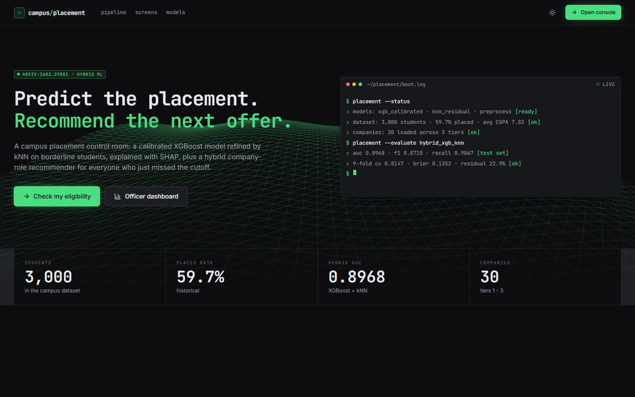  Figure 15: Landing page, dark theme: headline, terminal status panel and counters strip. | 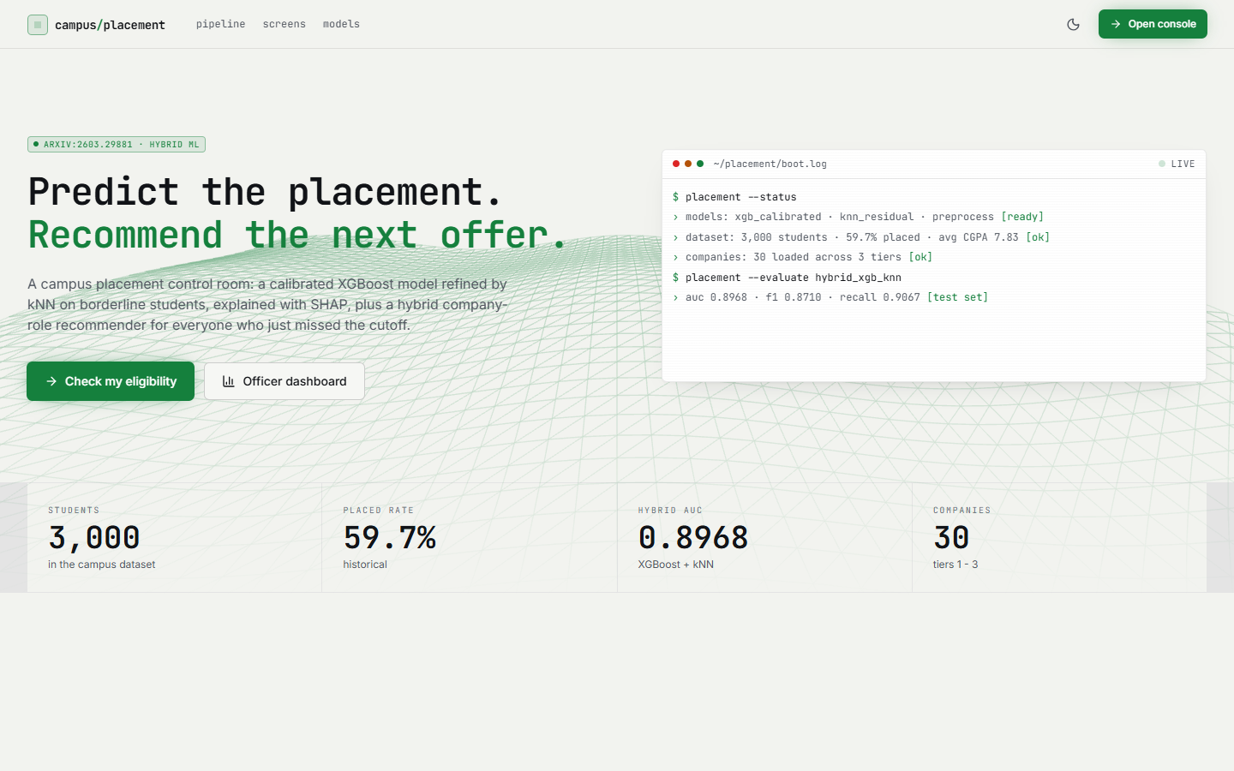  Figure 16: Landing page, light theme (same content).

The page announces the system ("Predict the placement. Recommend the next offer.") and names the base paper (arXiv:2603.29881). The terminal panel prints what the API reports: the models xgb_calibrated, knn_residual and preprocess are ready, the dataset has 3,000 students (59.7 % placed, average CGPA 7.83), 30 companies are loaded across three tiers, and hybrid_xgb_knn scores AUC 0.8968, F1 0.8710 and recall 0.9067 on the test set. These are the figures of the paper rule that uses the true labels (Section 8.5); the page does not say so.

8.2.2 Placement eligibility
Figure 17: Eligibility screen: Microsoft, SDE, CGPA 8.4, aptitude 84, technical 79, one internship, three projects give 22.2 % and NEEDS IMPROVEMENT.
The form on the left holds the student profile; the panel on the right shows the result. At Microsoft (Tier 1, 24.0 LPA, Hyderabad, hiring rate 15 %) the estimated probability is 22.2 %, labelled NEEDS IMPROVEMENT. The cutoff panel shows CGPA 8.4 against 8.2 and aptitude 84 against 82 passing and technical 79 against 82 failing; the model also applies the strong Tier-1 penalty built into the data. The tip "Strengthen DSA + core subjects; build 2+ projects" comes from the technical shortfall.

8.2.3 Company-role recommendations
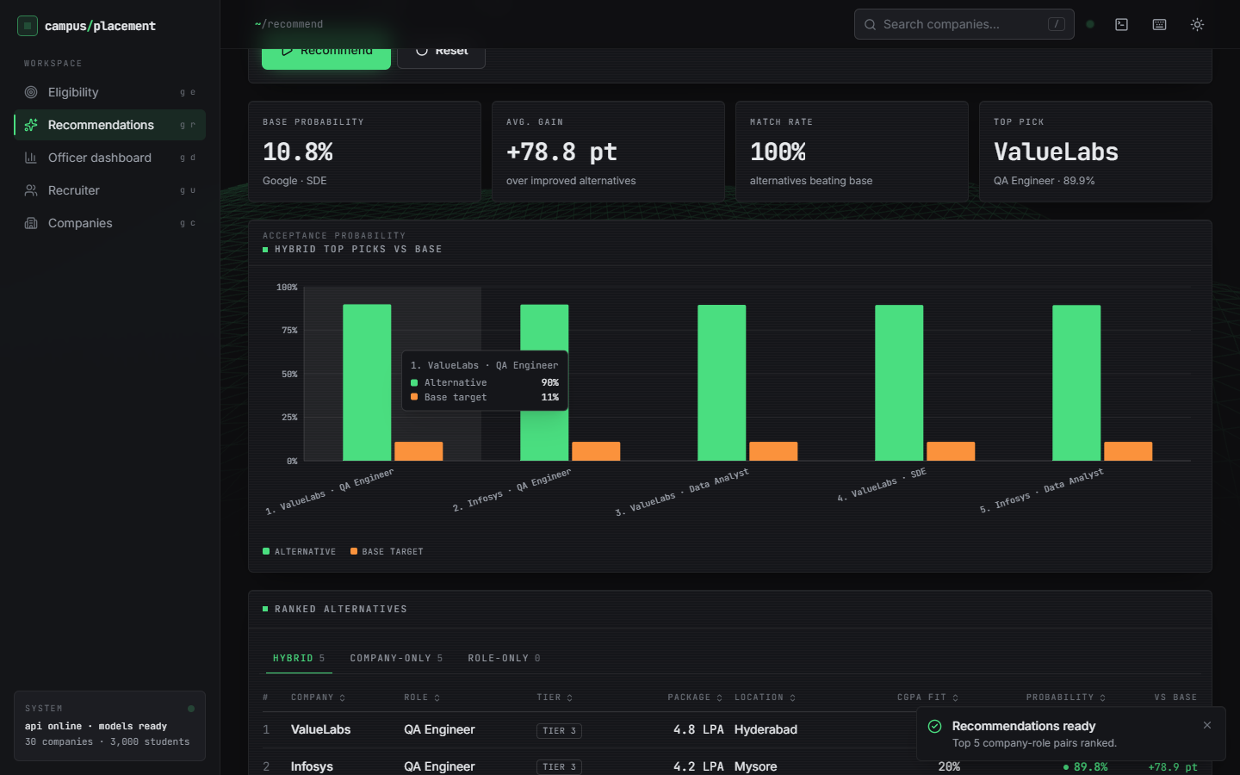
Figure 18: Recommendation screen: base probability 10.8 % (Google, SDE), average gain +78.8 pt, match rate 100 %, top pick ValueLabs QA Engineer 89.9 %.
For a student with CGPA 7.5, aptitude 65 and technical 65 targeting Google as an SDE, the base probability is 10.8 %. The tiles show the base probability, the average gain over improved alternatives (+78.8 percentage points), the match rate (100 %) and the top pick; the chart pairs each of the five hybrid picks with the base. The tabs show the hybrid list (5 items), the company-only list (5) and the role-only list (0). Every pick is a Tier-3 company (ValueLabs, Infosys), a property of the algorithm discussed in Section 8.13.

8.2.4 Officer dashboard
Figure 19: Officer dashboard: counters, model comparison chart, placed rate by branch. | 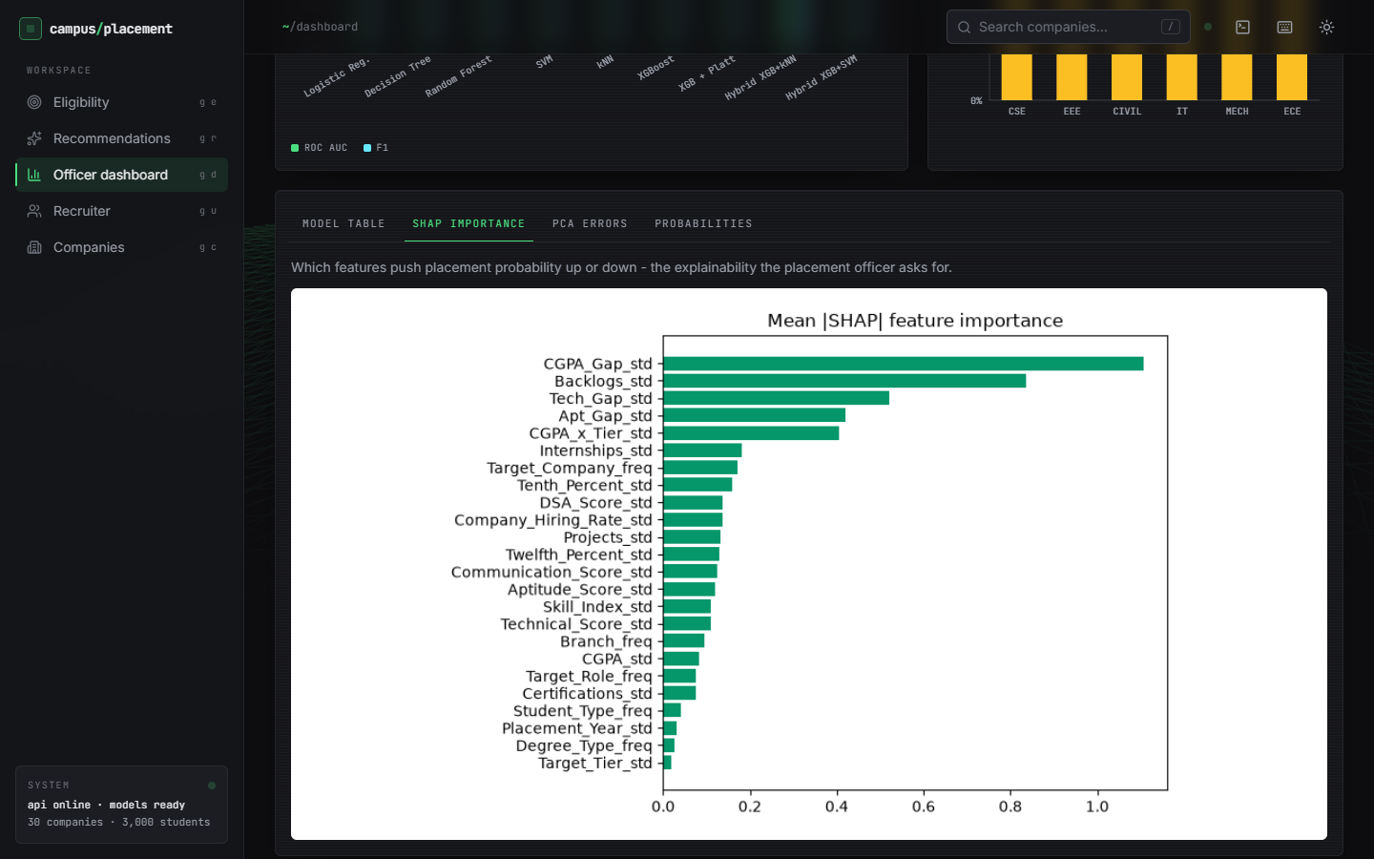  Figure 20: Dashboard SHAP tab: mean absolute SHAP value of all 24 features.

The tiles show 3,000 students, a placed rate of 59.7 % (average CGPA 7.83), the hybrid AUC of 0.8968 with accuracy 84.0 %, and the 9-fold cross-validation accuracy of 0.8147 with Brier score 0.1352 and residual rate 22.9 %. The grouped bars compare ROC-AUC and F1 of the nine shipped models; the placed rate by branch is between 58 % and 61 % because the generator gives branches almost the same chance. The model table marks Logistic Regression as best by AUC (0.9106). The SHAP tab ranks CGPA_Gap, Backlogs, Tech_Gap, Apt_Gap and CGPA_x_Tier first; other tabs show the PCA scatter and the probability histogram.

8.2.5 Recruiter shortlist and companies board
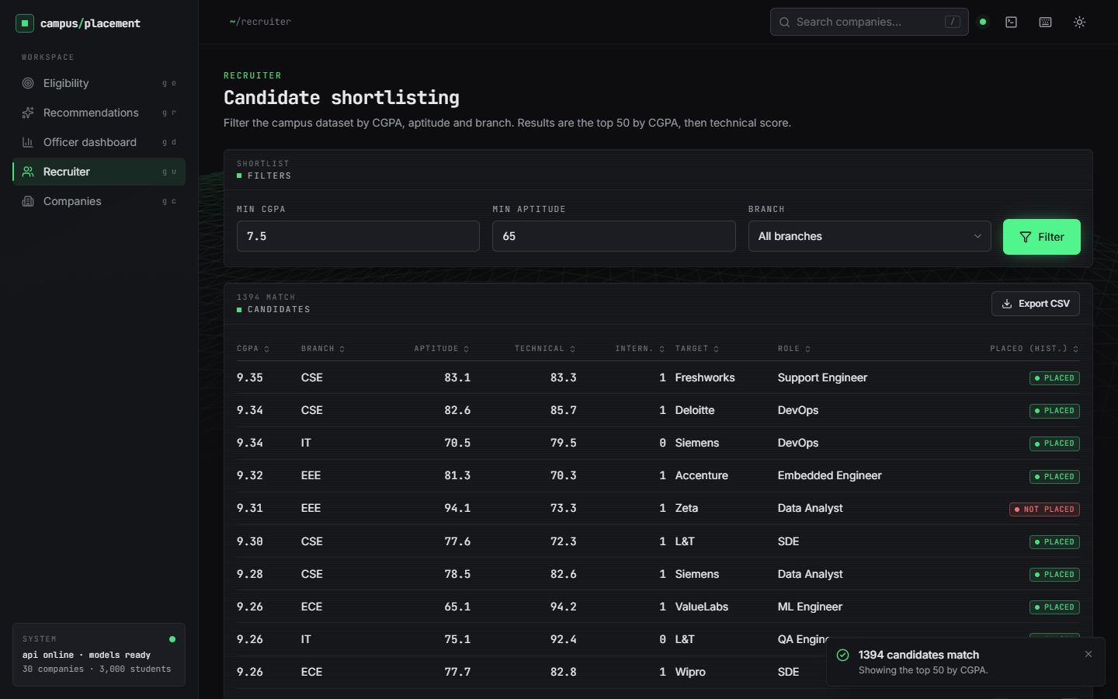  Figure 21: Recruiter screen: CGPA >= 7.5, aptitude >= 65, all branches; 1,394 matches, top 50 shown. | 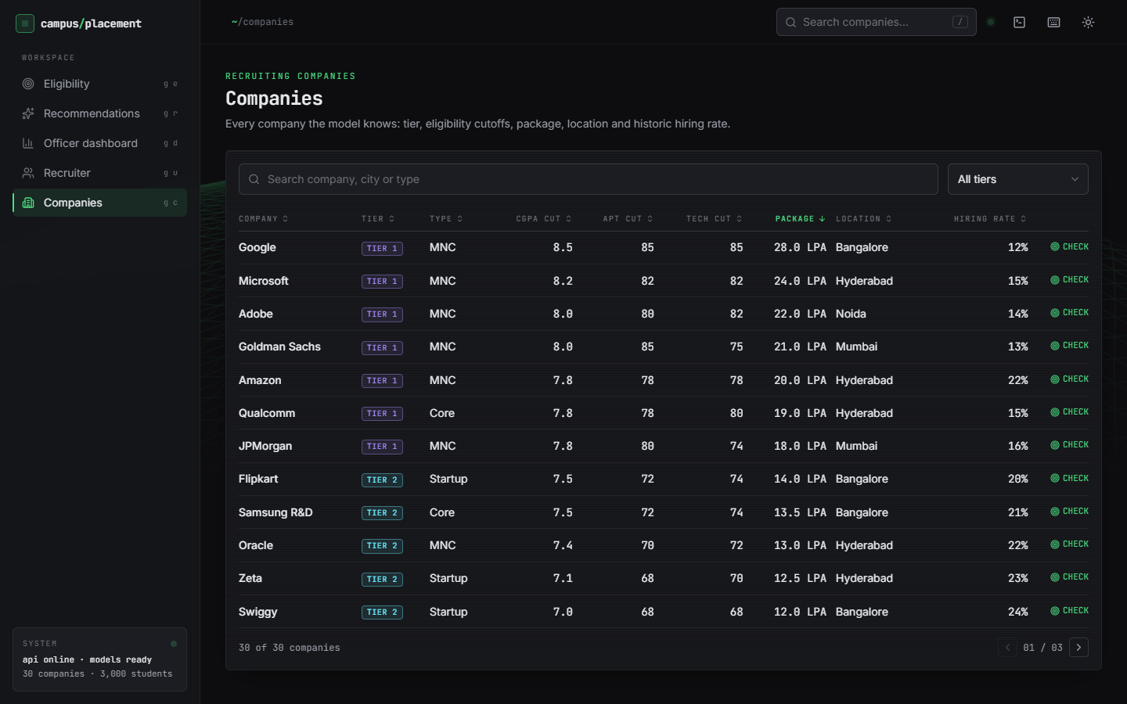  Figure 22: Companies screen: 30 companies with tier, type, cutoffs, package, location, hiring rate (page 1 of 3).

The recruiter sets a minimum CGPA, a minimum aptitude score and a branch; the API returns the number of matches (1,394) and the top 50 by CGPA then technical score, each with the company and role targeted and the historical PLACED or NOT PLACED tag, and an Export CSV button. It is a database-style filter and does not use the model. The companies board lists every company the model knows, searchable by name, city or type and filterable by tier; the cutoffs and packages are invented values that resemble real campus recruiters (Chapter 4).

8.2.6 Command palette and activity log
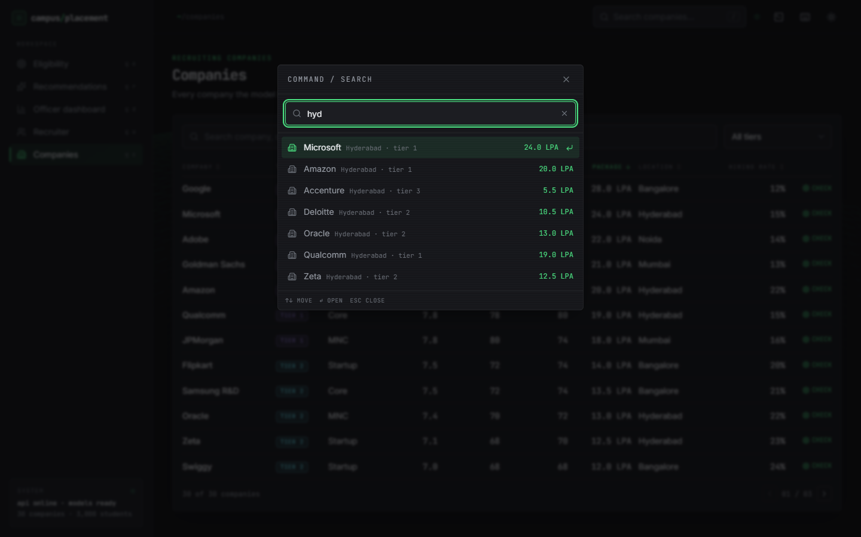  Figure 23: Command palette opened with the slash key and the query "hyd". | 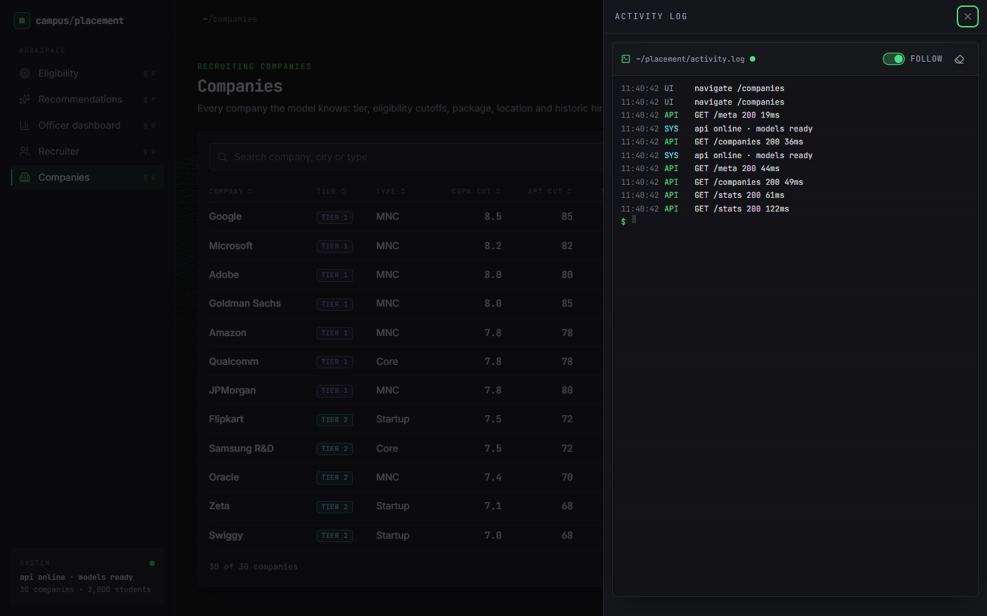  Figure 24: Activity log drawer: UI events and API calls with status and latency.

The palette searches the company list from any screen. The activity log records the real calls of the session (GET /meta 200 19 ms, GET /companies 200 36 ms, GET /stats 200 61 ms), which confirms that the screens are driven by the API.

8.3 Model performance
The table gives all models on the 450 test students (seed 42). The first nine rows are the contents of models/metrics.json; the last two rows evaluate the hybrid under rules that do not use the labels.
Table 45: Test-set metrics, seed 42 (n = 450)
Model | Accuracy | ROC-AUC | F1 | Precision | Recall
Logistic Regression | 0.8289 | 0.9106 | 0.8577 | 0.8498 | 0.8657
Decision Tree | 0.7533 | 0.7506 | 0.7869 | 0.8103 | 0.7649
Random Forest | 0.8067 | 0.8918 | 0.8404 | 0.8267 | 0.8545
SVM (RBF) | 0.8289 | 0.8855 | 0.8597 | 0.8399 | 0.8806
kNN (k = 9) | 0.7978 | 0.8638 | 0.8378 | 0.8020 | 0.8769
XGBoost | 0.8089 | 0.8888 | 0.8396 | 0.8396 | 0.8396
XGBoost + Platt | 0.8067 | 0.8928 | 0.8404 | 0.8267 | 0.8545
Hybrid XGB + kNN (paper rule) | 0.8400 | 0.8968 | 0.8710 | 0.8379 | 0.9067
Hybrid XGB + SVM (paper rule) | 0.8356 | 0.8810 | 0.8650 | 0.8464 | 0.8843
Hybrid kNN, label-free (borderline only) | 0.8089 | 0.8954 | 0.8442 | 0.8204 | 0.8694
Hybrid kNN, serving rule | 0.8089 | 0.8939 | 0.8436 | 0.8227 | 0.8657

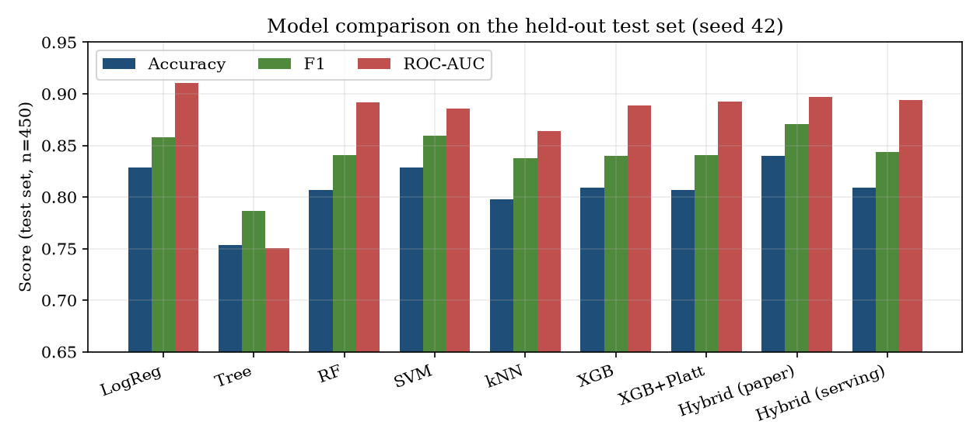
Figure 25: Accuracy, F1 and ROC-AUC of the models on the held-out test set (seed 42).
The Decision Tree is clearly the weakest (0.7533). The other classifiers lie within about three points of each other: Random Forest 0.8067, kNN 0.7978, XGBoost 0.8089, SVM and Logistic Regression 0.8289. Logistic Regression ties the SVM for accuracy and leads every model on ROC-AUC (0.9106); this is the expected result when the labels come from a logistic score. Other measures: the 9-fold cross-validation accuracy of XGBoost on the training split is 0.8147; the Brier score of the calibrated XGBoost is 0.1352; the paper-rule residual set contains 22.89 % of the test rows (103 of 450).

8.3.1 Probability and PCA views
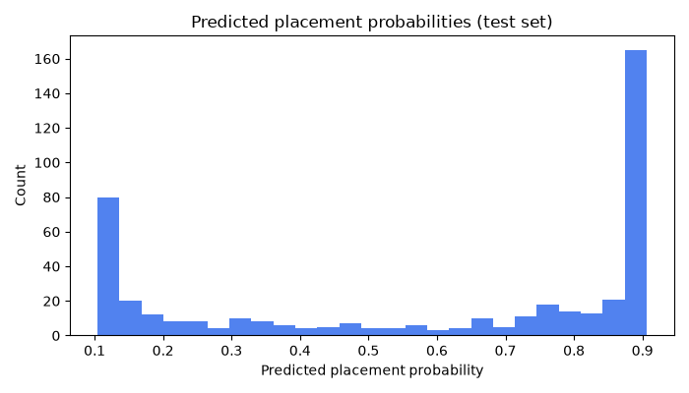  Figure 26: Histogram of predicted placement probabilities on the test set. | 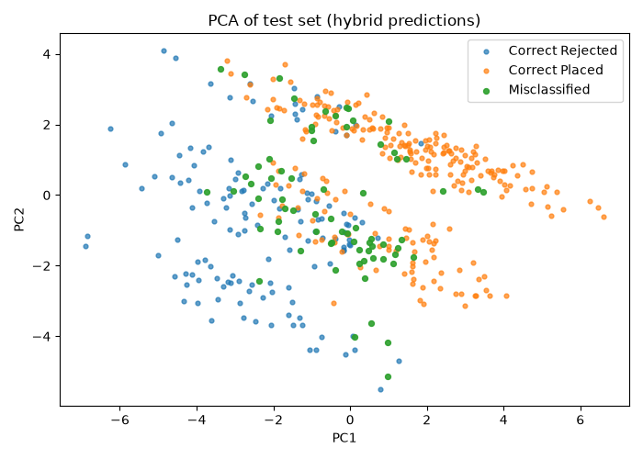  Figure 27: PCA of the test set: correct placed, correct not placed, misclassified.

The histogram is bimodal, with most students near 0 or near 1 and a thin middle: the borderline band 0.4 to 0.6 holds only 31 of the 450 students (6.9 %). In the PCA view the misclassified students lie along the boundary between the two classes, not in a separate cluster, as the base paper also observed for its data.

8.4 Confusion matrices
Table 46: Confusion matrices on the test set (seed 42; rows are the truth, 0 = not placed, 1 = placed)
Model | TN | FP | FN | TP
XGBoost + Platt | 134 | 48 | 39 | 229
Hybrid, paper rule (true labels used) | 135 | 47 | 25 | 243
Hybrid, label-free (borderline band only) | 131 | 51 | 35 | 233
Hybrid, serving rule | 132 | 50 | 36 | 232
Logistic Regression | 141 | 41 | 36 | 232

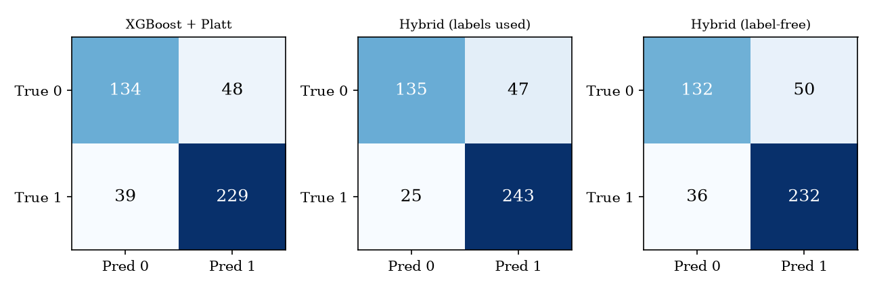
Figure 28: Confusion matrices of calibrated XGBoost, the hybrid with the paper rule, and the hybrid with the serving rule.
Calibrated XGBoost makes 48 false positives (students predicted placed who were not) and 39 false negatives. The paper-rule hybrid removes 14 false negatives and one false positive; the label-free and serving versions change the counts by only a few students (50 false positives and 36 false negatives for the serving rule). For a placement cell, a false negative (a student wrongly told they are not ready) hides an opportunity, and a false positive gives false comfort; the threshold analysis below shows how to trade one for the other.

8.5 The hybrid model: what the gain really is
The hybrid takes the predictions of calibrated XGBoost and replaces those of a residual set R by the predictions of a local model. The base paper [2] defines R as the rows that XGBoost misclassifies or whose probability lies in [0.4, 0.6] (its Equation 1). The first condition needs the true label, so the rule can be evaluated on a test set but cannot be applied to a new student. src/hybrid_model.py follows the paper, and models/metrics.json, the dashboard and the landing page report that version.
Table 47: Why the paper rule cannot be used at serving time (seed 42)
Quantity | Value
Test students | 450
Students XGBoost classifies wrongly | 87
... of which inside the 0.4 to 0.6 band | 15
Students inside the band (all) | 31
Residual set of the paper rule | 103 (87 + 31 - 15)
kNN accuracy on the paper-rule residual set | 30.1 % (XGBoost: 15.5 %)
kNN accuracy on the band rows only | 54.8 % (XGBoost: 51.6 %)

Of the 103 residual rows, 72 are in the set only because XGBoost got them wrong, and a local model that is asked to re-decide rows that are known to be wrong will do better than chance simply because the global model's answer is excluded. kNN is right on 30.1 % of the 103 rows against 15.5 % for XGBoost, but on the 31 rows that a deployed system could actually select the two are close (54.8 % against 51.6 %). The hybrid's accuracy therefore falls from 0.8400 (labels used) to 0.8089 (label-free) and 0.8089 (the serving rule of src/recommend.py: 0.5 p + 0.5 p_kNN inside the band), against 0.8067 for calibrated XGBoost: a difference of one student.
Table 48: Effect of the width of the borderline band (kNN label replaces the XGBoost label; seed 42)
Band | Rows replaced | Accuracy | F1 | ROC-AUC
none (p >= 0.5) | 0 | 0.8067 | 0.8404 | 0.8928
0.45 to 0.55 | 13 | 0.8022 | 0.8379 | 0.8935
0.40 to 0.60 (served) | 31 | 0.8089 | 0.8442 | 0.8954
0.35 to 0.65 | 45 | 0.8067 | 0.8444 | 0.8967
0.30 to 0.70 | 73 | 0.8067 | 0.8455 | 0.8941
0.20 to 0.80 | 133 | 0.8067 | 0.8449 | 0.8886

Widening the band from 0 to 133 replaced rows changes accuracy by at most 0.7 percentage points (0.8022 to 0.8089) and moves ROC-AUC by under 0.01. On this data the local model adds no measurable value. The base paper's accuracy of 0.8723 for its hybrid is built on the same label-driven definition; we did not re-derive its data, so we cannot say how much of it would remain.
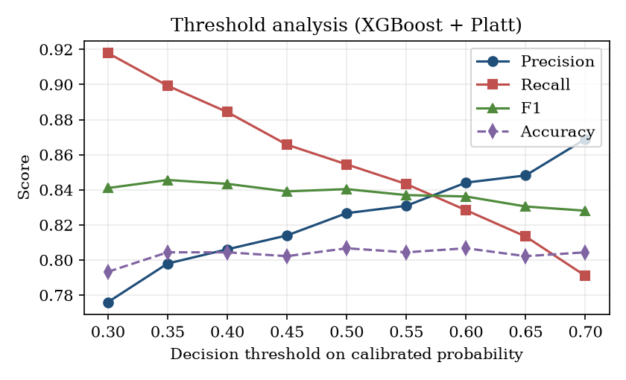
Figure 29: Precision, recall, F1 and accuracy of calibrated XGBoost as the decision threshold moves from 0.30 to 0.70.

8.6 Decision-threshold analysis
The threshold sweep figure at the end of Section 8.5 shows the sweep from 0.30 to 0.70. Accuracy is flat between 0.793 and 0.807 for every threshold, so the threshold does not change how often the system is right. It changes the kind of error: raising the threshold from 0.30 to 0.70 raises precision from 0.776 to 0.869 and lowers recall from 0.918 to 0.791. A placement cell that wants to avoid missing students who could be placed should lower the threshold (0.35 gives recall 0.899 with precision 0.798, F1 0.846); a cell that wants a short, reliable list of ready students should raise it. The served threshold of 0.5 is a reasonable middle and is not tuned.

8.7 Calibration
Platt scaling [4] was applied to XGBoost with three-fold cross-validation. The Brier score [8] improves from 0.1379 (raw) to 0.1352 (calibrated), a gain of about 2 %; Logistic Regression, whose probabilities are calibrated by construction, scores 0.1180, better than both. The mean predicted probability on the test set is 0.5923 against an observed placed fraction of 0.5956. The base paper reports a Brier score of 0.1864 for Platt scaling [2]; the data differ, so the two numbers are not comparable. Calibration matters because the recommendation module ranks alternatives by probability and the user interface shows the probability as a percentage.
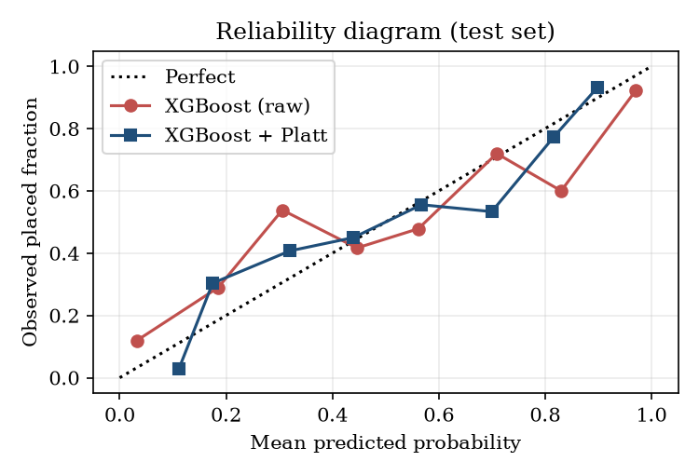
Figure 30: Reliability diagram of raw and Platt-calibrated XGBoost on the test set.

8.8 Stability over five random splits
To see whether the ranking of models depends on one lucky split, the whole pipeline was retrained in memory on five stratified splits (seeds 42, 1, 2, 3 and 4), each with 450 test students. The seed-42 retrain differs from the shipped model by at most 0.011. Values are mean ± standard deviation.
Table 49: Five-seed study (test accuracy, F1, ROC-AUC)
Model | Accuracy | F1 | ROC-AUC
Logistic Regression | 0.8231 ± 0.0194 | 0.8547 ± 0.0157 | 0.9031 ± 0.0109
Decision Tree | 0.7369 ± 0.0205 | 0.7778 ± 0.0172 | 0.7284 ± 0.0220
Random Forest | 0.8004 ± 0.0216 | 0.8376 ± 0.0170 | 0.8825 ± 0.0120
SVM (RBF) | 0.8129 ± 0.0169 | 0.8483 ± 0.0139 | 0.8863 ± 0.0133
kNN (k = 9) | 0.7960 ± 0.0208 | 0.8363 ± 0.0179 | 0.8614 ± 0.0171
XGBoost | 0.8156 ± 0.0178 | 0.8487 ± 0.0159 | 0.8863 ± 0.0121
XGBoost + Platt | 0.8138 ± 0.0115 | 0.8474 ± 0.0118 | 0.8899 ± 0.0127
Hybrid XGB + kNN (paper rule) | 0.8391 ± 0.0154 | 0.8699 ± 0.0132 | 0.8958 ± 0.0100
Hybrid XGB + SVM (paper rule) | 0.8258 ± 0.0170 | 0.8583 ± 0.0144 | 0.8815 ± 0.0168
Hybrid kNN, label-free (borderline only) | 0.8142 ± 0.0180 | 0.8489 ± 0.0159 | 0.8883 ± 0.0137
Hybrid kNN, serving rule | 0.8151 ± 0.0149 | 0.8498 ± 0.0139 | 0.8896 ± 0.0132

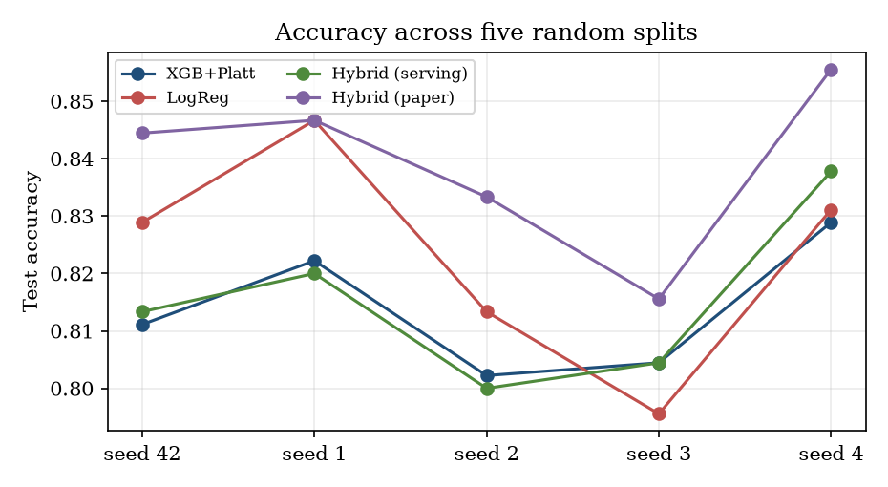
Figure 31: Test accuracy of four models on each of the five random splits.
Four results follow. First, the split-to-split standard deviation is 1.2 to 2.2 points, larger than the gaps between Logistic Regression (0.8231 ± 0.0194), SVM, XGBoost (0.8156 ± 0.0178), XGBoost + Platt (0.8138 ± 0.0115) and the label-free hybrids (0.8142 ± 0.0180, 0.8151 ± 0.0149); these cannot be ranked reliably. Second, the paper-rule hybrid (0.8391 ± 0.0154) is ahead in all five seeds, by 1 to 3 points over calibrated XGBoost, which is what the label dependence predicts. Third, the label-free hybrid is equal to or lower than XGBoost + Platt in four of five seeds and the means differ by 0.0004. Fourth, Logistic Regression has the best mean ROC-AUC (0.9031 ± 0.0109) and the Decision Tree remains clearly last (0.7369 ± 0.0205). The shipped numbers of Section 8.3 are one draw from this spread.

8.9 Explainability: which features matter
Table 50: Mean absolute SHAP value of the eight most influential features (XGBoost, 450 test students)
Rank | Feature | Mean |SHAP|
1 | CGPA_Gap | 1.1239
2 | Backlogs | 0.8833
3 | Tech_Gap | 0.5036
4 | Apt_Gap | 0.3958
5 | CGPA_x_Tier | 0.3878
6 | Tenth_Percent | 0.1707
7 | Internships | 0.1619
8 | Projects | 0.1554

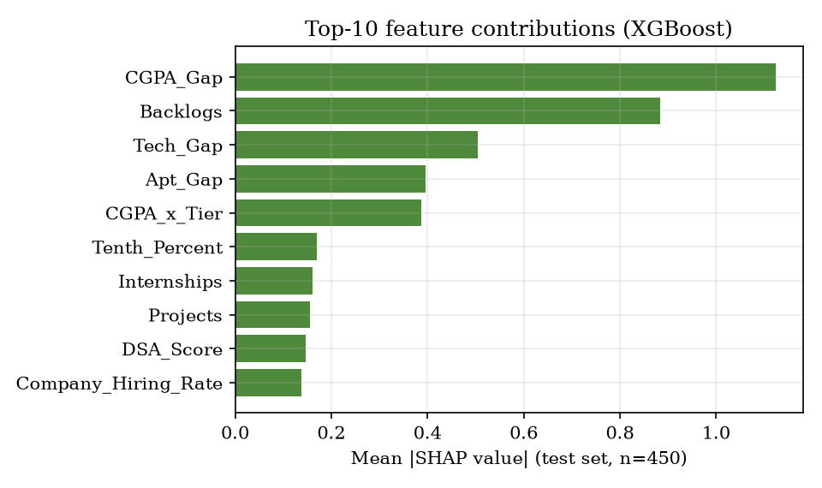
Figure 32: Mean absolute SHAP value of the ten most influential features (retrained XGBoost, test set).
The three gap features (CGPA, technical and aptitude score against the target company's cutoff), the number of backlogs and the CGPA x tier interaction dominate; the raw scores, internships, projects and communication matter much less. This agrees with the dashboard's SHAP chart of the shipped model (Figure in Section 8.2.4), which ranks the same five features first. It is also exactly how the synthetic labels were generated, so it confirms that the model learned the generator and says nothing about what drives real placements. The engineered gap features are the main useful idea of the feature set: they turn a company-independent score into a company-specific distance from the cutoff.

8.10 Recommendation results
The recommendation module was run for 60 test students whom the model rates below 0.5 for their own target company. Table values are model-estimated probabilities; they were not checked against real placements, so they measure how the module redistributes the model's probability, not how many students would be placed.
Table 51: Recommendation results for 60 students rated below 0.5 for their own target
Quantity | Value
Mean base probability (own target) | 0.2219
Students with at least one better alternative in the top 5 | 52 of 60 (86.7 %)
Mean probability of the top-1 alternative | 0.6434
Mean average gain over the improved alternatives | 0.4371 (43.7 percentage points)
Students whose top-1 alternative reaches 0.5 | 39 of 60 (65 %)
Time per recommendation (in process) | mean 3.49 s, p95 6.41 s, max 13.87 s

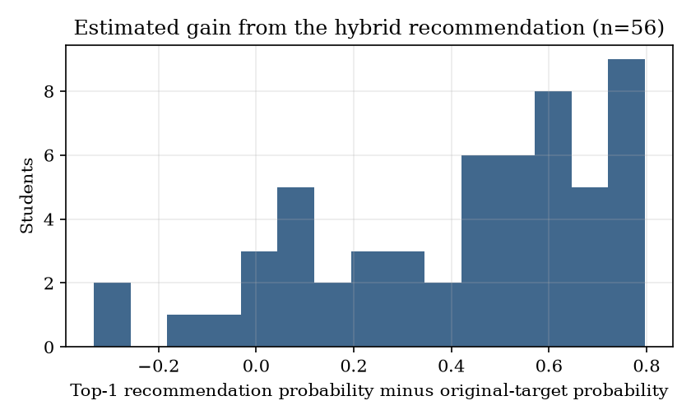
Figure 33: Estimated gain (top-1 alternative minus original target) for the 60 students.
Most students gain a large estimated probability, because a student who is far below a Tier-1 cutoff has a probability near 0.1 there and a probability near 0.9 at an easy Tier-3 company. The base paper reports a mean increase of 65.1 % over all rejected applicants and 0.704 for its hybrid strategy [2]; the definitions and data differ, so the comparison is indicative only. Two features of the module matter in practice: (i) it ranks by probability and so prefers easy companies; (ii) it takes several seconds, as the latency row shows.

8.11 Comparison with the base papers
Two papers are involved. The batch document names the IJETMS paper [1] as the base paper; the code and README are built on the hybrid framework of [2]. The comparison below is stated plainly: the data, the task and the evaluation differ, so no accuracy figure can be called better or worse than a published one.
Table 52: Comparison with the base papers
Aspect | IJETMS placement paper [1] | Hybrid admission paper [2] | This project
Task | Placement prediction | Admission prediction and university-program recommendation | Placement prediction and company-role recommendation
Data | Synthetic, size not stated | 13,000 real GradCafe records, 2021-2025 | 3,000 synthetic students; 30 invented companies
Split | 80:20 | 70/15/15 (9,100 / 1,950 / 1,950) | 70/15/15 (2,100 / 450 / 450)
Models | Logistic Regression, Random Forest, Gradient Boosting | 7 baselines; XGBoost + kNN / SVM hybrid | 6 baselines; calibrated XGBoost; kNN / SVM hybrids
XGBoost accuracy | not reported | 0.7241 | 0.8089
Hybrid accuracy | no hybrid | 0.8723 (XGB + kNN) | 0.8400 with labels; 0.8089 label-free
Brier score (Platt) | not reported | 0.1864 | 0.1352
Explainability | Feature importance, skill-gap analysis | SHAP | SHAP ranking and rule-based tips
Recommendation | None | University, program, hybrid; +65.1 % mean gain | Company, role, hybrid; mean gain 43.7 points (60 students)
Interface | Streamlit; batch CSV, PDF, e-mail | None | Flask, FastAPI and React; recruiter shortlist; no CSV batch, PDF or e-mail

The IJETMS paper contains no accuracy, F1 or AUC value in its results section (it states only the 80:20 split and the three models), so there is nothing numeric to compare with. The accuracies of [2] come from noisy real data in which Logistic Regression reaches only 0.69; ours come from generated data in which it reaches 0.83. That is the main reason our baselines are higher, and it does not indicate a better method. What this project adds to [1] is a company-recommendation module and a dashboard; what it takes from [2] is the framework, with the label dependence of the residual rule made explicit.

8.12 Sample inputs and outputs
Table 53: Sample requests and responses (real API output)
Request | Output
POST /api/predict: CGPA 8.4, aptitude 82, technical 84, communication 75, DSA 80, 3 projects, 1 internship, 2 certifications, 0 backlogs, CSE; Infosys, SDE | probability 0.9032; PLACEMENT READY
POST /api/predict: CGPA 6.2, aptitude 50, technical 45, no internship; Google | probability 0.1212; NEEDS IMPROVEMENT; tips on CGPA below the 8.5 cutoff, aptitude, DSA and an internship
POST /api/predict: CGPA 8.4, aptitude 84, technical 79, 1 internship, 3 projects; Microsoft, SDE (screenshot) | probability 0.222; NEEDS IMPROVEMENT; technical 79 below cutoff 82
POST /api/recommend: CGPA 7.2, aptitude 65, technical 65, target Google SDE, location Hyderabad | base 0.1085; average gain 0.7833; 5 hybrid options; role-only list empty
POST /api/recruiter/shortlist: CGPA >= 8.5, aptitude >= 70, CSE | 138 matches; the 50 with the highest CGPA returned
POST /api/predict with CGPA 14 | HTTP 422 (validation error)

8.13 Success and failure analysis

8.13.1 What works
• The prediction path is fast (median 56 ms over HTTP) and behaves in the expected direction: probability rises with CGPA and falls with backlogs and with a higher company tier.
• Probabilities are reasonably calibrated (mean 0.592 against 0.596 observed), so the percentages shown to a student are not misleading for this data.
• All 46 behaviour checks and the 15-check smoke test pass; invalid input is refused with clear status codes.

8.13.2 What does not work, or is weaker than it looks
• The headline hybrid gain is not deployable. It needs the true label of the student whose probability is being estimated (Section 8.5).
• The recommender steers weak profiles to the easiest companies. The score is the probability, so Tier-3 companies win for any student below a Tier-1 cutoff; package and role fit are ignored. The screenshot shows five Tier-3 picks.
• The role-only list can be empty when the target company is outside the feasibility window; the user sees an empty tab with no explanation.
• Unknown branches and roles are accepted, and recommendation takes seconds because each candidate reloads four model files (Chapter 7).
• Skill-gap tips are fixed rules (below the CGPA, aptitude or technical cutoff; no internship). SHAP is computed for the whole test set, not for the student, so the tip is not an individual explanation of the probability.
• A strong profile is still rated low at Tier 1. CGPA 8.4 at Microsoft gives 22 %: the tier penalty is a property of the generator and cannot be checked against real hiring.

8.13.3 Where the model is most and least certain
Only 6.9 % of test students lie in the 0.4 to 0.6 band, and the model is right on about half of them (51.6 %). Errors outside the band (72 of the 87) are confident mistakes that no borderline rule can reach; they come from the noise (standard deviation 0.8) added to the generating score, which no model can predict.

8.14 Limitations of the results
• The data are synthetic, so no accuracy figure is a claim about real campus placements.
• The labels follow a logistic rule, which favours Logistic Regression and the gap features.
• The test set has 450 students; one student is 0.22 percentage points, so most differences between models are not significant.
• The five-seed study re-splits the same 3,000 students; it measures sensitivity to the split, not to new data.
• The recommendation gains are model-estimated, never verified against outcomes, and the module's latency was measured over 60 students and 8 HTTP calls.
• The comparison with the base papers is qualitative because the datasets differ.

8.15 Objectives versus outcomes
Table 54: Objectives of the batch against what was achieved
No. | Objective | Status | Evidence
1 | Collect student academic records, technical skills, aptitude scores and historical placement outcomes. | Partly met | 3,000 synthetic records and 30 companies were generated; no real placement records exist.
2 | Clean and encode the data and address imbalance between placed and unplaced students. | Partly met | Frequency encoding, standardisation and six engineered features are done; classes are 59.7 % / 40.3 % and no resampling was applied.
3 | Train and compare classifiers to predict placement eligibility for each student. | Met | Six baselines, calibrated XGBoost and two hybrids were trained and compared on one split and over five splits.
4 | Recommend suitable companies by matching student profiles against recruiter requirements. | Met | A hybrid top-5 recommendation with company-only and role-only lists; gains are model-estimated only.
5 | Identify the skill gaps that most reduce a student's placement probability. | Met in part | Rule-based tips from the cutoffs and a global SHAP ranking; no per-student explanation.
6 | Provide dashboards for placement officers and evaluate using accuracy, precision and recall. | Met | Officer dashboard and recruiter shortlist work; accuracy, precision, recall, F1, ROC-AUC and Brier are reported.

Not implemented although described in the batch documents: MySQL storage, logins for students, recruiters and officers, PDF and e-mail reports, batch prediction from a CSV file, matching against job-description requirement vectors, and any real placement data.

CHAPTER 9: CONCLUSION

9.1 Summary
The Smart Campus Placement System estimates the probability that a student is placed at a chosen company and role, tells the student which gaps against the company's cutoffs hold the probability back, recommends company-role alternatives with a higher estimated probability, and gives placement officers and recruiters a dashboard and a shortlist. It adapts the hybrid XGBoost and kNN framework of Heidari Fard and Tabrizi [2] from graduate admissions to campus placement and delivers it as a Flask application and as a FastAPI service with a React interface. Because no real placement data were available, the system was built and evaluated on 3,000 synthetic students and 30 invented companies; this governs how every result in this report must be read.
Figure 34: Accuracy, F1 and ROC-AUC of the models on the held-out test set (seed 42).

9.2 Objectives achieved
Of the six objectives, three were met (training and comparing classifiers, recommending companies, dashboards with evaluation), one was met in part (skill gaps, as cutoff rules and a global SHAP ranking), and two were met only partly (the data are synthetic; encoding was done but no resampling was needed or applied for the 59.7 / 40.3 class split). The table gives the status of each.
Table 55: Objectives and their status
No. | Objective | Status | Basis
1 | Collect student academic records, technical skills, aptitude scores and historical placement outcomes. | Partly met | 3,000 synthetic records; no real placement data
2 | Clean and encode the data and address imbalance between placed and unplaced students. | Partly met | Encoding and scaling done; classes 59.7 / 40.3, no resampling applied
3 | Train and compare classifiers to predict placement eligibility for each student. | Met | Six baselines, calibrated XGBoost and two hybrids; five-seed study
4 | Recommend suitable companies by matching student profiles against recruiter requirements. | Met | Hybrid top-5 with three strategies; gains are model-estimated
5 | Identify the skill gaps that most reduce a student's placement probability. | Met in part | Cutoff rules and global SHAP ranking; no per-student explanation
6 | Provide dashboards for placement officers and evaluate using accuracy, precision and recall. | Met | Officer dashboard, recruiter shortlist; accuracy, precision, recall, F1, AUC, Brier

9.3 Key findings
1. Calibrated XGBoost reaches 0.8067 accuracy, F1 0.8404 and ROC-AUC 0.8928 on 450 held-out synthetic students; Logistic Regression has the highest AUC (0.9106) and ties the best accuracy (0.8289), as expected for labels generated by a logistic rule.
2. The hybrid XGBoost + kNN of the base paper scores 0.8400, but only because its residual set is chosen with the true labels. With the label-free rule it scores 0.8089, one student above XGBoost; over five splits the label-free hybrid (0.8142 ± 0.0180) and calibrated XGBoost (0.8138 ± 0.0115) are indistinguishable.
3. The company-specific gap features (CGPA, technical and aptitude gap against the cutoff) and the number of backlogs carry most of the model's SHAP importance. This reflects how the data were generated.
4. Calibration helps a little (Brier 0.1379 to 0.1352); the accuracy is flat from threshold 0.30 to 0.70, so the threshold trades precision (0.78 to 0.87) against recall (0.92 to 0.79).
5. The recommendation module gives 52 of 60 students rated below 0.5 for their own target at least one better alternative, with a mean estimated gain of 43.7 percentage points; it favours Tier-3 companies and takes 3 to 8 seconds per request.
6. The software is sound for its purpose: all 46 behaviour checks and the 15-check smoke test pass, input is validated, and hostile inputs are refused.

9.4 Practical applications
• A placement cell's planning tool. After training on a cell's own anonymised history, the officer dashboard shows which profile factors and which students are close to the decision boundary, so that training effort can be directed early.
• A student self-assessment. A student can see the probability for a target company and the specific gaps against its cutoffs, and compare alternatives.
• A recruiter's first filter. The shortlist screen narrows a campus list by CGPA, aptitude and branch.
• A teaching case. The project shows the whole cycle of data, features, comparison, calibration, explanation, recommendation and deployment, and shows how to check a published evaluation protocol for leakage.

9.5 Known limitations
The system was not evaluated on real students, so no claim is made about real placement accuracy. The reported hybrid gain depends on the true labels. The recommender can send weak profiles to the easiest companies and is slow. The API has no authentication and accepts unknown categories. Tips are fixed rules. The tests were written by the team and cover behaviour, not real-world performance. The system is a prototype for a placement cell to adapt with its own data, not a validated decision tool, and its output must not be used to decide the fate of a student. The full list is limitations L1 to L14 in the scope and limitations document.

9.6 Lessons learned
• Check what a published evaluation needs at prediction time. The headline gain of a hybrid model vanished when the information that is available at serving time was the only information used. A rule that is defined with the answer in hand needs a label-free twin before it is reported.
• Report the spread, not one draw. On 450 test students and five splits the standard deviation (1 to 2 points) was as large as most differences between models; a single table would have suggested a ranking that does not exist.
• A recommendation that maximises probability is not a good recommendation. Ranking by probability alone sends weak profiles to the easiest companies; the objective must include what the student wants.

CHAPTER 10: FUTURE SCOPE

10.1 Improvements to the models and the data
• Use real data first. Obtain anonymised placement records and recruiter requirements from the placement cell, retrain, and report the accuracy on a temporal split (train on earlier years, test on the latest). This is the single most important missing measurement.
• Train the residual refinement without labels. Learn a classifier that predicts which rows XGBoost gets wrong from features and probability, and apply the kNN or SVM only to those rows; report the gain on held-out data. This replaces the label-dependent rule of [2].
• Re-examine the model choice. Compare gradient boosting with logistic regression, regularised trees and LightGBM [14] on real data, with repeated cross-validation, and test whether the hybrid adds value there.
• Per-student explanations. Compute SHAP values for the student at hand [5] and rank the actions that raise the probability most, instead of the four fixed rules.
• Fairness audit. Check calibration and error rates across branch, gender and school; report differences before the system is used for any decision.

10.2 Additional features
• Better recommendation scoring. Combine probability with package, role fit, location and the student's stated interests; explain why a company is excluded and avoid empty lists.
• Batch prediction from a CSV file, PDF reports and e-mail, as offered by the base paper [1].
• Accounts and roles for students, officers and recruiters, with a student seeing only their own data.
• MySQL storage as named in the batch description, with an officer page to upload placement results and retrain.
• Job-description matching: represent requirements as vectors and match them with skill profiles.
• Skill-improvement planning: turn a gap into a schedule of mock tests and courses and track progress over a term.

10.3 Scalability and deployment
• Cache the loaded artefacts once per process so that a recommendation takes tens of milliseconds, not seconds; score all candidate rows in one vectorised call.
• Pin library versions or export the models to a portable format; add a model registry with version and training-date metadata.
• Container image and reverse proxy with authentication, HTTPS, rate limits and restricted origins before any network use.
• Continuous testing. Run the 46 checks, the smoke test and the experiments script in a CI pipeline on every change, and add browser tests for the main screens.
• Monitoring. Log prediction requests (without personal data), track the distribution of inputs and detect drift when a new batch of students arrives.

10.4 Further research
• Study whether the label-dependence of residual refinement affects other published hybrid classifiers, by re-evaluating them with a label-free selection rule.
• Test counterfactual recommendations: whether a student who improves the recommended gap actually moves in probability, using real longitudinal records.
• Combine placement prediction with salary or package prediction (a regression task) to rank alternatives by expected value and not only by probability.
• Run a user study with students, officers and recruiters to measure whether the dashboard changes how training is planned.

10.5 Suggested roadmap
Table 56: A sequence in which the work above could be done
Phase | Work | Outcome | Effort
1 | Cache loaded artefacts; validate branch and role against the training categories; explain empty lists | Recommendation in tens of milliseconds; no silent unknown categories | Days
2 | Collect anonymised placement history and company requirements from the placement cell; retrain; temporal test | The first real accuracy figure | Weeks, depends on data access
3 | Label-free residual selection; compare with logistic regression and LightGBM [14] | A defensible statement about the value of the hybrid | Weeks
4 | Accounts, roles, MySQL, CSV batch prediction, PDF and e-mail reports | Parity with the base paper [1] and a multi-user deployment | Weeks to months
5 | Per-student explanations, richer recommendation scoring, fairness audit | Advice a student can act on; evidence of equal treatment | Months
6 | Pilot with a placement cell and a user study | Evidence that the tool changes planning | A placement season

REFERENCES
[1] M. Prasanna Kumari, B. Punith, M. Srinath, P. Koushik and Y. Gourav, "Student placement prediction system using machine learning," Int. J. Eng. Technol. Manage. Sci. (IJETMS), vol. 10, no. 3, pp. 47-51, May-Jun. 2026, doi: 10.46647/ijetms.2026.v10i03.008.
[2] M. Heidari Fard and E. Tabrizi, "A hybrid machine learning approach for graduate admission prediction and combined university-program recommendation," arXiv:2603.29881 [cs.IR], Feb. 2026.
[3] T. Chen and C. Guestrin, "XGBoost: A scalable tree boosting system," in Proc. 22nd ACM SIGKDD Int. Conf. Knowl. Discovery Data Mining, San Francisco, CA, USA, Aug. 2016, pp. 785-794.
[4] J. C. Platt, "Probabilistic outputs for support vector machines and comparisons to regularized likelihood methods," in Advances in Large Margin Classifiers, A. J. Smola, P. Bartlett, B. Scholkopf and D. Schuurmans, Eds. Cambridge, MA, USA: MIT Press, 1999, pp. 61-74.
[5] S. M. Lundberg and S.-I. Lee, "A unified approach to interpreting model predictions," in Advances in Neural Information Processing Systems 30 (NIPS 2017), Long Beach, CA, USA, Dec. 2017, pp. 4765-4774.
[6] F. Pedregosa et al., "Scikit-learn: Machine learning in Python," J. Mach. Learn. Res., vol. 12, pp. 2825-2830, Oct. 2011.
[7] T. Cover and P. Hart, "Nearest neighbor pattern classification," IEEE Trans. Inf. Theory, vol. 13, no. 1, pp. 21-27, Jan. 1967.
[8] G. W. Brier, "Verification of forecasts expressed in terms of probability," Mon. Weather Rev., vol. 78, no. 1, pp. 1-3, Jan. 1950.
[9] A. Niculescu-Mizil and R. Caruana, "Predicting good probabilities with supervised learning," in Proc. 22nd Int. Conf. Mach. Learn. (ICML), Bonn, Germany, Aug. 2005, pp. 625-632.
[10] L. Breiman, "Random forests," Mach. Learn., vol. 45, no. 1, pp. 5-32, Oct. 2001.
[11] C. Cortes and V. Vapnik, "Support-vector networks," Mach. Learn., vol. 20, no. 3, pp. 273-297, Sep. 1995.
[12] J. H. Friedman, "Greedy function approximation: A gradient boosting machine," Ann. Statist., vol. 29, no. 5, pp. 1189-1232, Oct. 2001.
[13] J. B. Schafer, J. A. Konstan and J. Riedl, "E-commerce recommendation applications," Data Min. Knowl. Discov., vol. 5, no. 1-2, pp. 115-153, Jan. 2001, doi: 10.1023/A:1009804230409.
[14] G. Ke et al., "LightGBM: A highly efficient gradient boosting decision tree," in Advances in Neural Information Processing Systems 30 (NIPS 2017), Long Beach, CA, USA, Dec. 2017, pp. 3146-3154.
[15] M. H. Baffa, M. A. Miyim and A. S. Dauda, "Machine learning for predicting students' employability," UMYU Scientifica, vol. 2, no. 1, pp. 1-9, Mar. 2023, doi: 10.56919/usci.2123_001.
[16] P. S. Ambili and B. Abraham, "A comprehensive evaluation of employability prediction using ensemble learning techniques," EPRA Int. J. Multidiscip. Res. (IJMR), vol. 10, no. 1, Jan. 2024.
[17] A. Gupta, S. Gupta, P. K. Mall, S. Srivastava, A. S. Saluja, N. Yadav, V. Narayan, M. K. Verma and S. Sriramulu, "ML-CPC: A pathway for machine learning based campus placement classification," J. Electr. Syst., vol. 20, no. 3s, 2024, doi: 10.52783/jes.1521.
[18] A. Pathak, M. Matcha, M. Gopisetti and S. Joshi, "A machine learning framework for predicting student placement outcomes," Ing. Syst. Inf. (ISI), vol. 30, no. 7, pp. 1715-1721, Jul. 2025, doi: 10.18280/isi.300704.
[19] A. D. P. Kumar, V. Kuchhadia, G. Charan, G. Sreeja and N. Pavan, "Predicting student employability using machine learning: A comparative study of classification algorithms," in Proc. Int. Conf. Comput. Sci. Commun. Eng. (ICCSCE 2025), Hyderabad, India, Apr. 2025, pp. 799-812, doi: 10.2991/978-94-6463-858-5_68.
[20] N. V. S. Sanjana, M. Varun, M. Greeshma, S. Ponugupati, M. Gurupriya and G. Ramaswamy, "Revolutionizing university placements: Advanced technologies for streamlined and student-centric ecosystems," in Proc. 1st Int. Conf. Res. Develop. Inf. Commun. Comput. Technol. (ICRDICCT), vol. 2, SCITEPRESS, 2025, pp. 83-88, doi: 10.5220/0013877200004919.
[21] S. K. Thangavel, P. D. Bkaratki and A. Sankar, "Student placement analyzer: A recommendation system using machine learning," in Proc. 4th Int. Conf. Adv. Comput. Commun. Syst. (ICACCS), IEEE, 2017 (authors as listed in the Amrita University publication record).
[22] S. Khandale and S. Bhoite, "Campus placement analyzer: Using supervised machine learning algorithms," Int. J. Comput. Appl. Technol. Res. (IJCATR), vol. 8, no. 9, pp. 358-362, 2019.
[23] C. Romero and S. Ventura, "Educational data mining: A review of the state of the art," IEEE Trans. Syst., Man, Cybern. C, Appl. Rev., vol. 40, no. 6, pp. 601-618, Nov. 2010.
[24] [Unverified] "Student placement package prediction by regression analysis," Int. J. Res. Publ. Rev., 2024 (title, year and venue from the batch survey; not found online).
[25] [Unverified] "Campus placement prediction and analysis using machine learning," Int. J. Res. Publ. Rev., 2025 (batch survey; not found online).
[26] [Unverified] "Predictive analysis of campus placement of student using machine learning algorithms," J. IoT Mach. Learn., 2024 (batch survey; not found online).
[27] [Unverified] "Excelling through placement process," Campus to Corporate, 2025 (batch survey; not found online).
[28] [Unverified] "EduPredict: A machine learning based student placement prediction framework using academic and resume data," ICICAT 2025 (named in archived_base_papers; not found online).

APPENDIX A: IMPORTANT CODE
The listings are copied from the repository (8.ProjectCode) at the state in which the results of this report were measured. They are read from the files when this document is built, so they cannot drift from the code. Only the most important functions are shown; line ranges are given with each heading.

A.1 Feature construction (`src/preprocess.py`, lines 26-55)
Builds the 24 features of one or many (student, company) rows: engineered skill index, hiring rate, interaction and three gaps against the company cut-offs, then frequency encoding and standardisation using maps that are fitted on the training split only (fit=True) and reused everywhere else.
def build_features(df, comp, freq_maps=None, scaler_stats=None, fit=False):
m = df.merge(comp, left_on="Target_Company", right_on="Company", how="left")
out = df.copy()
out["Skill_Index"] = (0.4 * out["Technical_Score"] + 0.3 * out["Aptitude_Score"]
+ 0.15 * out["Communication_Score"] + 0.15 * out["DSA_Score"]) / 100.0
out["Company_Hiring_Rate"] = m["Hiring_Rate"].astype(float).values
out["CGPA_x_Tier"] = out["CGPA"] * out["Target_Tier"] # interaction like Program x QS Rank
out["CGPA_Gap"] = out["CGPA"] - m["CGPA_Cutoff"].astype(float).values
out["Apt_Gap"] = out["Aptitude_Score"] - m["Apt_Cutoff"].astype(float).values
out["Tech_Gap"] = out["Technical_Score"] - m["Tech_Cutoff"].astype(float).values

if fit:
freq_maps = {c: (out[c].value_counts(normalize=True).to_dict()) for c in FREQ_COLS}
scaler_stats = {}
for c in NUM_COLS + EXTRA_NUM:
mu, sd = out[c].mean(), out[c].std() + 1e-9
scaler_stats[c] = (mu, sd)

for c in FREQ_COLS:
mp = freq_maps[c]
out[c + "_freq"] = out[c].map(mp).fillna(0.0)

for c in NUM_COLS + EXTRA_NUM:
mu, sd = scaler_stats[c]
out[c + "_std"] = (out[c] - mu) / sd

feat = [c + "_std" for c in NUM_COLS + EXTRA_NUM] + [c + "_freq" for c in FREQ_COLS]
X = out[feat].values.astype(float)
return X, feat, freq_maps, scaler_stats

A.2 Calibration and the residual hybrid (`src/hybrid_model.py`, lines 93-122)
Platt scaling of XGBoost, the residual set of the base paper (note that its first term uses the true test labels yte), and the replacement of residual predictions by the kNN and SVM models.
# --- calibration: Platt (sigmoid) like paper Table 6 ---
base_xgb = models["xgb"]
calib = CalibratedClassifierCV(base_xgb, method="sigmoid", cv=3)
calib.fit(Xtr, ytr)
pxgb = calib.predict_proba(Xte)[:, 1]
pred_xgb = (pxgb >= 0.5).astype(int)
brier = float(brier_score_loss(yte, pxgb))
print(f"calibrated XGB brier={brier:.4f}")
results["xgb_calibrated"] = metrics(yte, pred_xgb, pxgb)

# --- hybrid residual refinement ---
# R = misclassified OR prob in [0.4, 0.6] (Eq.1 paper)
residual_mask = (pred_xgb != yte) | ((pxgb >= 0.4) & (pxgb <= 0.6))
print(f"residual rate on test: {residual_mask.mean():.3f}")

knn_res = KNeighborsClassifier(n_neighbors=9, weights="uniform")
knn_res.fit(Xtr, ytr) # local model trained globally, applied locally (paper Fig.8)
svm_res = SVC(kernel="rbf", probability=True, random_state=SEED)
svm_res.fit(Xtr, ytr)

def hybrid(pred_base, prob_base, local_pred):
out = pred_base.copy()
out[residual_mask] = local_pred[residual_mask]
# for AUC use blended prob: keep base prob except residuals use local prob
return out

pknn = knn_res.predict(Xte)
psvm = svm_res.predict(Xte)
prob_knn = knn_res.predict_proba(Xte)[:, 1]
prob_svm = svm_res.predict_proba(Xte)[:, 1]

A.3 Serving-time prediction (`src/recommend.py`, lines 70-79)
The deployable form of the hybrid rule: only the borderline band is blended with the kNN probability, because the true label is not known when a student is scored.
def predict_for(profile, company_row, role):
pre, xgb, knn, comp = load_artifacts()
X = _row_features(profile, company_row, role, pre)
p = float(xgb.predict_proba(X)[0, 1])
# residual refinement: if borderline, blend with kNN (paper Fig.8)
if 0.4 <= p <= 0.6:
pk = float(knn.predict_proba(X)[0, 1])
p = 0.5 * p + 0.5 * pk
return round(p, 4)

A.4 Company-role recommendation: filters and scoring (`src/recommend.py`, lines 81-111)
def recommend(profile, top_k=5, min_package=None, prefer_location=None):
"""Three strategies like paper Table 7: Role-only, Company-only, Hybrid."""
pre, xgb, knn, comp = load_artifacts()
base_company = profile.get("target_company")
base_role = profile.get("target_role", "SDE")
base_p = 0.0
if base_company and base_company in comp["Company"].values:
brow = comp[comp["Company"] == base_company].iloc[0]
try:
base_p = predict_for(profile, brow, base_role)
except Exception:
base_p = 0.0

cands = []
for _, row in comp.iterrows():
# --- feasibility filters (paper Sec 3.11) ---
gap = abs(profile["cgpa"] - row["CGPA_Cutoff"])
if gap > delta_max_cgpa(row["Tier"]):
continue
if profile["aptitude"] < row["Apt_Cutoff"] - 15:
continue
if profile.get("backlogs", 0) > 2 and row["Tier"] == 1:
continue
if min_package and row["Package_LPA"] < min_package:
continue
prox = max(0.0, 1 - gap / delta_max_cgpa(row["Tier"])) # GPA_Proximity Eq.
roles = list(dict.fromkeys([base_role, "SDE", "Data Analyst", "QA Engineer"]))
for role in roles:
try:
p = predict_for(profile, row, role)
except Exception:

A.5 The prediction endpoint (`backend/main.py`, lines 188-201)
@app.post("/api/predict")
def predict(body: PredictIn):
row = _company_row(body.target_company)
profile = body.model_dump(exclude={"target_company", "target_role"})
profile.update(stype="Regular", year=2026)
try:
p = predict_for(profile, row, body.target_role)
except Exception as e: # the model code raises plain exceptions for unseen values
raise HTTPException(422, f"Prediction failed: {e}")
return {"placement_probability": p, "eligible": bool(p >= 0.5),
"label": "PLACEMENT READY" if p >= 0.5 else "NEEDS IMPROVEMENT",
"company": row["Company"], "role": body.target_role,
"company_detail": json.loads(row.to_json()), "tips": _tips(profile, row)}

APPENDIX B: INSTALLATION AND USER GUIDE

B.1 Requirements
• Windows PC. The build machine was an Intel Core i5-12500 (6 cores, 12 threads) with 15.7 GB of memory and no GPU (these are the machine's figures, not stated minimums).
• Python 3.10 or newer on the PATH (the project was built with Python 3.14.7) and Node.js 20 or newer.
• A current browser; the interface was captured in Chrome.
• An internet connection for the first installation (Python packages and the front-end packages are downloaded).

B.2 Installation and start
1. Open the project folder 8.ProjectCode and double-click run.bat. It creates .venv, runs pip install -r requirements.txt if packages are missing, trains the models if models\xgb_calibrated.pkl does not exist, runs npm install in frontend, then starts both servers.
2. The backend runs in its own window at http://localhost:8405 (interactive documentation at /docs) and the front end in another at http://localhost:5405, which run.bat opens in the browser.
3. To stop, close the two server windows. The ports are read from .env (BACKEND_PORT, FRONTEND_PORT); run.bat copies .env.example to .env if it is missing.
Manual start in two terminals: .venv\Scripts\python.exe -m uvicorn backend.main:app --port 8405 and cd frontend then npm install (first time) and npm run dev. A production build of the interface is made with npm run build and served with npm run preview on port 5405. The original Flask application starts with python app.py and opens at http://127.0.0.1:5000.

B.3 Retraining the models (optional)
python src/generate_dataset.py # writes data/companies.csv and data/placement_dataset.csv (seed 42)
python src/preprocess.py # fits the encoders and writes models/preprocess.pkl
python src/hybrid_model.py # trains, calibrates, writes models/*.pkl, metrics.json and static/*.png

Retraining overwrites the files in models/ and static/. A fresh run with the installed library versions can differ from the shipped metrics.json by up to about 0.01 in any metric.

B.4 Using the screens
Table 57: User guide
Screen (route) | How to use it
Landing (/) | Shows the dataset size, placed rate, hybrid AUC and the 30 companies. Check my eligibility and Officer dashboard open the main screens.
Eligibility (/predict) | Choose a company and role, enter the profile (scores 0-100, CGPA 0-10, counts) and press Run prediction. The result card shows the probability, the label, the profile against the company cut-offs and tips. Reset restores the defaults.
Recommendations (/recommend) | Enter a profile, optionally a target company, role and preferred location, and press Recommend. Read the base probability, average gain, match rate and top pick, then the tabs Hybrid, Company-only and Role-only.
Officer dashboard (/dashboard) | Four tiles, a model comparison chart, placed rate by branch and tabs for the model table, SHAP importance, PCA errors and probabilities.
Recruiter (/recruiter) | Set minimum CGPA, minimum aptitude and branch and press Filter. The table shows the top 50 by CGPA with the total number of matches; Export CSV saves the returned rows (at most 50) as shortlist.csv.
Companies (/companies) | Search by name, city or type, filter by tier, sort any column, page through 30 companies; Check opens the eligibility screen for that company.

Keyboard. / opens the command palette (search a company or jump to a screen), g e, g r, g d, g u and g c go to Eligibility, Recommendations, Officer dashboard, Recruiter and Companies, g l opens the activity log of the session's API calls, and ? shows the shortcut help. The sun/moon button switches between dark and light themes and the choice is remembered.

B.5 Running the tests and measurements
python scripts/smoke_test.py # 15 live API checks (backend must be running on 8405)
python scripts/edge_tests.py # 46 unit / integration / functional / validation / security checks + latency
python scripts/run_experiments.py # confusion matrices, five-seed study, band and threshold sweeps, SHAP, recommender gain
python scripts/make_diagrams.py # the design diagrams
python scripts/capture_screens.py # screenshots (needs both servers and Playwright)

B.6 Troubleshooting
Table 58: Common problems
Symptom | Fix
"Could not reach the placement API" | The backend is not running on port 8405. Start it as in B.2.
ModuleNotFoundError: pyarrow | The pickled company table needs it: .venv\Scripts\python.exe -m pip install -r requirements.txt.
Port already in use | Change BACKEND_PORT or FRONTEND_PORT in .env and restart both servers.
Models missing or incompatible after a library upgrade | Run the three retraining commands in B.3.
Recommendation takes several seconds | Expected: the four model files are reloaded for each candidate (about 5 s per request).
Scripts using localhost are slow | Use 127.0.0.1 in scripts; on this machine localhost added about 2 s per request.

APPENDIX C: ADDITIONAL SCREENS
These captures complement Chapter 8. All were taken at 1440x900 pixels from the running application with the 3,000-student dataset and the trained models loaded.
Figure 35: Landing page, light theme: hero text, live boot log, and the counters read from the API (3,000 students, 59.7% placed, hybrid AUC 0.8968, 30 companies).
Figure 36: Landing page, dark theme (the default): the same content with the theme switched.
Figure 37: Companies board: the first page of 30 companies sorted by package, with tier, type, CGPA, aptitude and technical cut-offs, package, location and hiring rate.
Figure 38: Command palette after typing "hyd": companies located in Hyderabad with tier and package; Enter opens the selected company.
Figure 39: Activity log drawer: real API calls of the session with their status codes and durations (for example GET /stats 200 in 122 ms).

